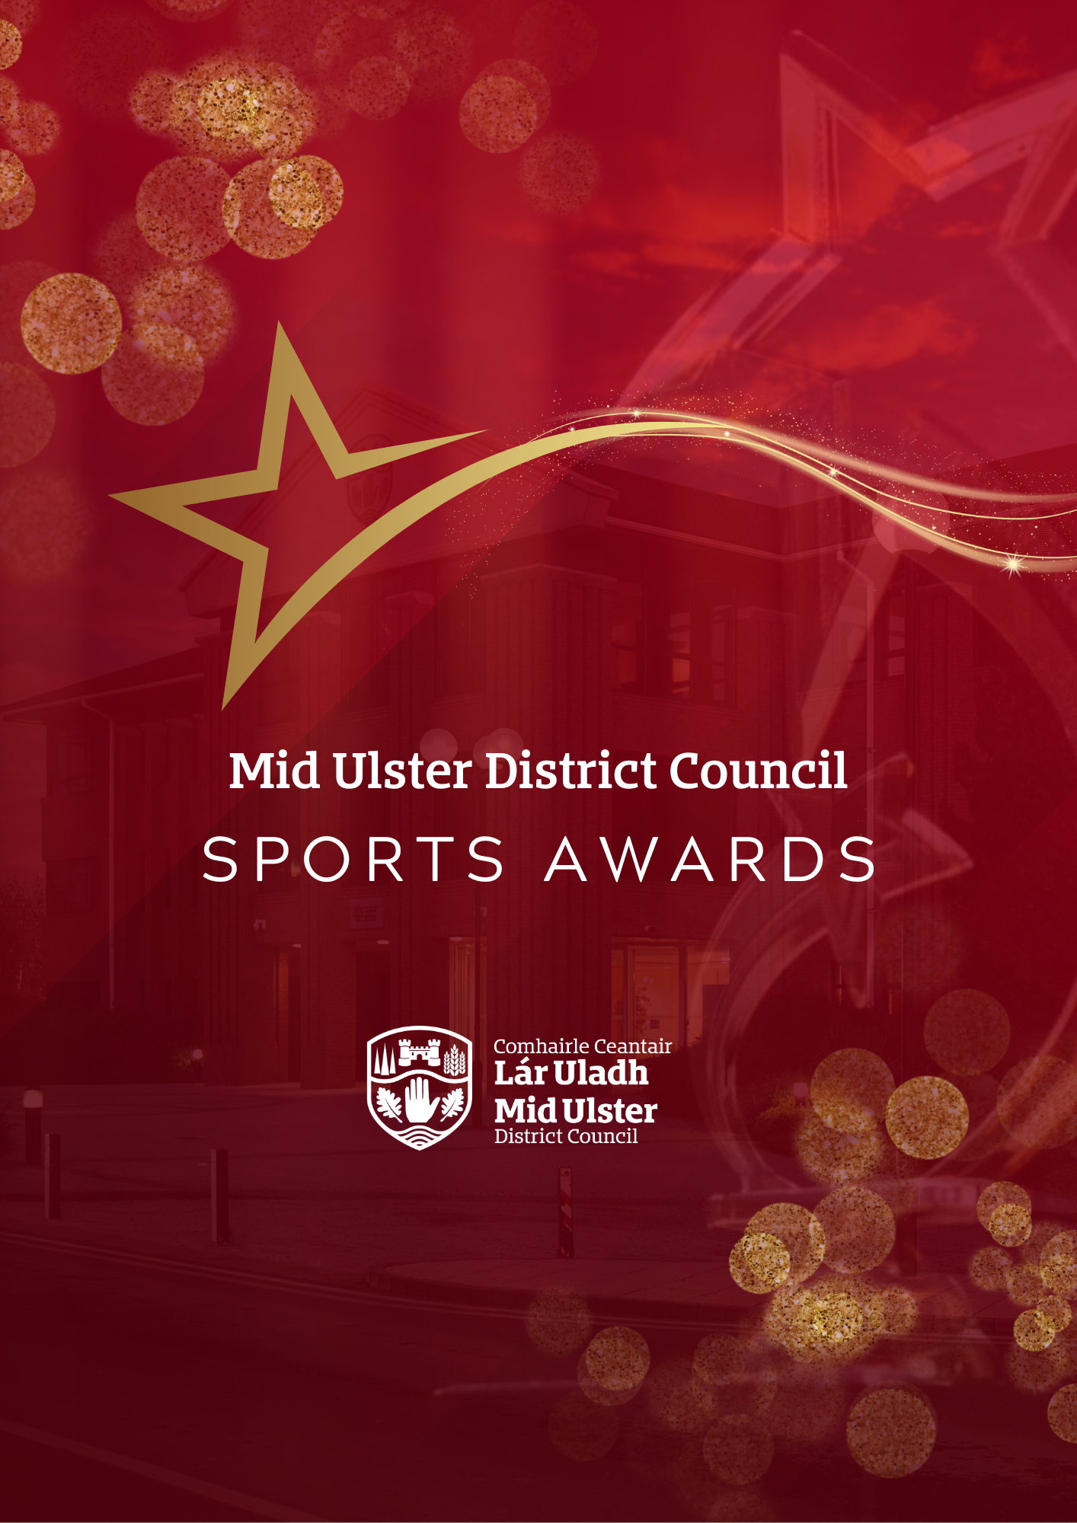

T

Guidance Notes
Mid Ulster District Council
Sports Awards 2025

Guidance Notes for
Mid Ulster Sports Awards 2026

AWARD CATEGORIES

CATEGORY | DESCRIPTION
Sports Person of the Year Award | This award recognises a high achieving sports person (over 18). The Sports Person of the Year should have achieved at a high level, show strong leadership, set a good example, and uphold high behavioural and sporting standards. They should go above and beyond in support for, and participation in, their sport. Nomination forms should include details of all sporting achievements, including competitions and honours at club, county, regional, national, and international levels. The form should include an indication of the nominee’s strong leadership, going above and beyond, level of commitment to their sport (training schedule, dedication), opportunities taken to develop and other contributions to roles such as mentor, coach, or club ambassador.
Young Sports Person of the Year Award  (18 and under) | This award recognises a high achieving sports person (18 and under). The Young Sports Person of the Year should have achieved at a high level, show strong leadership, set a good example and uphold high behavioural and sporting standards. They should go above and beyond in support for, and participation in, their sport. Nomination forms should include details of all sporting achievements, including competitions and honours at club, county, regional, national, and international levels. The form should include an indication of the nominee’s strong leadership, going above and beyond, level of commitment to their sport (training schedule, dedication), opportunities taken to develop and other contributions to roles such as mentor, coach, or club ambassador.
Sports Person of the Year Award (Disability) | This award recognises sports people with a disability. Nomination forms should include details of all sporting achievements, including competitions and honours at club, county, regional, national, and international levels.  The form should include an indication of the nominee’s level of commitment to their sport (training schedule, dedication), challenges that have been overcome, opportunities taken to develop and other contributions to roles such as mentor, coach or club ambassador.
Team of the Year Award | This award recognises a successful sports team of the year in terms of performance and achievement. Nomination forms should specify the achievements of the team during the year, including any standout individual achievements, obstacles overcome and excellent co-operation in working towards a shared goal. Teams may have achieved excellence at club, county, regional, national, or international level.
Youth Team of the Year Award (18 and under) | This award recognises a successful youth sports team (18 and under) of the year in terms of performance and achievement. Nomination forms should specify the achievements of the team during the year, including any standout individual achievements, obstacles overcome and excellent co-operation in working towards a shared goal. Teams may have achieved excellence at club, county, regional, national, or international level.
Club of the Year Award | This award recognises success in all areas of a club. The nomination form should highlight how the club has succeeded in performance and achievement, leadership, participation, sustainability and development and connection with the wider community. The Nomination Form should include details of a Club’s achievements in terms of teams and individuals, the range of demographics, level of activity, any new innovate developments, commitment to the continuous development of members, coaches, volunteers and opportunities for non-players and non-members to participate.
Coach of the Year Award | This category recognises unpaid coaches who have made an outstanding contribution to coaching. This can be either through getting more people involved in local sport, or by working with athletes at a high level and achieving club or athlete success working with potential recognition at national/international level.  Nomination forms should include details of the level and range of achievements, progress and development and commitment to coaching e.g. hours, mentoring, support provided.
Volunteer of the Year Award | This category recognises Volunteers who have given an invaluable contribution with their sport as an administrator, coach or official. A volunteer is described as someone who  does not get paid for their services but may be reimbursed for out-of-pocket expenses. Nomination forms should include details of the progress and development this volunteer has brought to the club and the range of achievements it has resulted in.
Unsung Hero of the Year Award | This category recognises an unsung hero. The Unsung Hero award celebrates volunteers who make a positive impact in their community by enabling participation in grassroots sports. This person has achieved great things yet is not normally celebrated or recognised.  Nomination forms should include details of the level and range of contributions to club life and connections with the wider community.
Sports Photo of the Year Award | This category recognises the Sports Photo of the Year. Taken by an amateur photographer, whose photo celebrates a single unedited photo that captures the passion, intensity, and emotion of sport at its finest. The defining moment in time tells a powerful story of determination, triumph and the spirit of competition.  Nomination forms should include details of the event.

RETURN OF NOMINATIONS  Nominations can be made online at: midulstercouncil.org/awards  If you are unable to submit an online nomination, you should contact the officer listed below.  Hard copy applications WILL NOT be accepted unless you have obtained prior permission from the officer below.  For more details on the Sports Awards you can contact:  Steven McElhatton  Email: Steven.mcelhatton@midulstercouncil.org  Phone: 03000 132 132  Entries must be received by 12 noon on the 16th October 2026, applications after this date WILL NOT be accepted. |  | ASSESSMENT PROCESS  Assessment will be carried out by the panel using a standard assessment process. Criteria for submitting an application to any category are as follows:  STAGE 1 – ELIGIBILITY CHECK  All nominations will be checked against criteria at Appendix 1 – this is a Pass or Fail on 4 areas (5 areas for Sports Photo) . All areas must be a pass in order to proceed to Stage 2 (assessment).  STAGE 2 – ASSESSMENT  Applications deemed eligible from Stage 1 will proceed to Stage 2 and will be scored against criteria specific to the Award Category they have been nominated to.  Answers will be scored based on the scoring matrix provided in Appendix 2.

APPENDIX 1
STAGE 1 – ELIGIBILITY CHECK

Name of Group/Individual:

Category:

CRITERIA | Eligible? (Tick or X  or N/A)
In the case of the “individual” category, self-nominations will not be accepted, nor will nominations from immediate family members.

All nominees must participate and/or reside within the Mid Ulster District Council area.

Nominations are confined to performance/achievements between 1st October 2025 - 30th September 2026.

The nominee must be involved in a sport whose governing body is recognised by Sport Northern Ireland, Sport Ireland, or UK Sport.

Eligible to proceed to stage 2? Yes/No (delete as appropriate)

APPENDIX 2
STAGE 2 – BASIC SCORING CRITERIA FOR RESPONSES

ASSESSMENT | SCORE
An excellent response which exceeds the general ethos and requirements as outlined in the award category description in a very comprehensive manner | 5
A good response which meets the general ethos and requirements as outlined in the award category description in a comprehensive manner | 4
A satisfactory response but lacking sufficient details and supporting evidence on some aspects | 3
Minimal / poor information or inappropriately provided | 2
The applicant failed to address the question | 1

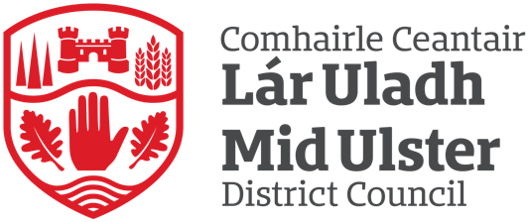
For Sports Photo of the Year only
APPENDIX 3
STAGE 1 – ELIGIBILITY CHECK

CRITERIA | Eligible?  (Tick or X or N/A)
In the case of this “individual” category, self-nominations will be accepted, or nominations from immediate family members.
All nominees must participate and/or reside within the Mid Ulster District Council area.
Nominations are confined to performance/achievements between 1st October 2025 - 30th September 2026.
Amateur photographers only.
The photo must be unedited
Eligible to proceed to stage 2? Yes/No (delete as appropriate)

STAGE 2 – BASIC SCORING CRITERIA FOR RESPONSES

ASSESSMENT | SCORE
An excellent photo which exceeds the general ethos and requirements as outlined in the award category description in a very comprehensive manner | 5
A good photo which meets the general ethos and requirements as outlined in the award category description in a comprehensive manner | 4
A satisfactory photo but lacking sufficient details and supporting evidence on some aspects | 3
Minimal / poor photo or inappropriately provided | 2
The photo failed to address the question | 1

