
ASD Friendly
Information Pack
Cookstown Leisure Centre
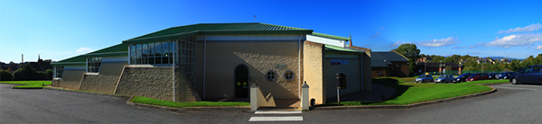
Cookstown Leisure Centre
A guide to your visit
This guide explains what you can expect before arriving, during your visit and when leaving Cookstown Leisure Centre.

Welcome to Cookstown Leisure Centre
A clear guide to help you plan and enjoy your visit.
We understand that visiting a leisure centre can sometimes feel overwhelming for people with Autism Spectrum Disorder (ASD). This guide has been designed to help visitors understand what to expect before arriving, during their visit, and when leaving the centre.
Our aim is to provide a safe, welcoming and inclusive environment where everyone can enjoy physical activity, recreation and community participation.
Cookstown Leisure Centre staff have received training from Autism NI to ensure that we are autism aware and able to provide additional support, if needed.
ABOUT THE CENTRE
Facilities | Additional facilities
25m Swimming Pool | Soft Play
Learner Pool | Cubbie
Flume / Slide | Reception Area
Health Suite | Viewing Areas
Fitness Suite / Gym | Accessible Toilets
Spin Studio | Accessible Changing Facilities
Meeting Rooms | Accessible Car Parking
Sports Hall
Every area may have different sounds, lighting levels and activity levels.

Before Your Visit
Planning ahead can help make your visit more comfortable.
It may help to:
- Visit our website for opening times.
- Look at photographs of the facility before arriving.
- Discuss the visit using a visual schedule.
- Bring any comfort items that support your visit.
- Wear comfortable clothing.
- Bring headphones or ear defenders if required.
WHAT TO BRING FOR SWIMMING AND THE HEALTH SUITE
- Swimwear
- Towel
- Goggles (optional)
- Water bottle
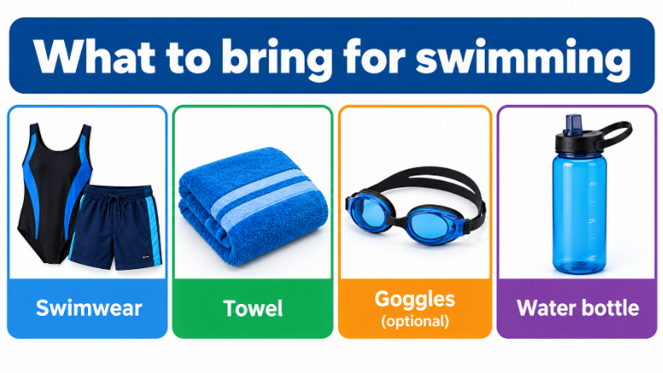
WHAT TO BRING FOR THE GYM OR CLASSES
- Comfortable sports clothing
- Trainers
- Water bottle
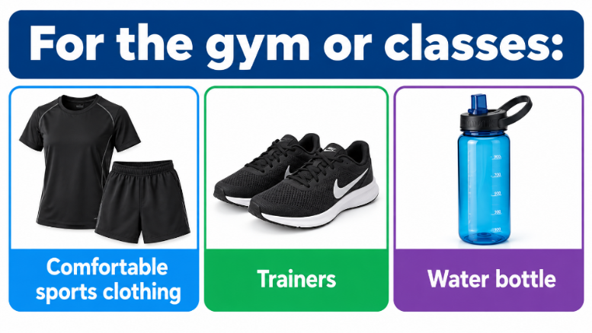

Arriving at Cookstown Leisure Centre
On arrival to Cookstown Leisure Centre, you will be able to park near the main entrance. Accessible parking spaces are available in the main car park closest to the building and along the road to the bottom car park. The car park can sometimes be busy and noisy.
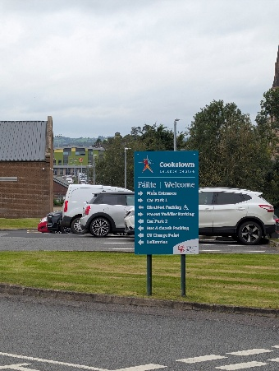 | 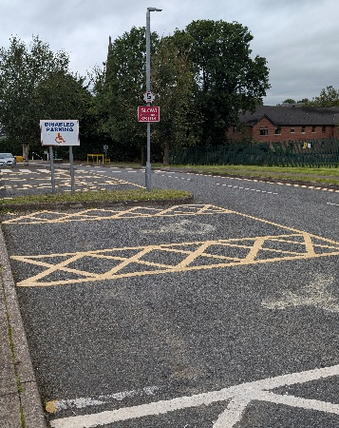
Additional parking information and signage is available around the site. Staff can assist if you need help finding an accessible parking space.
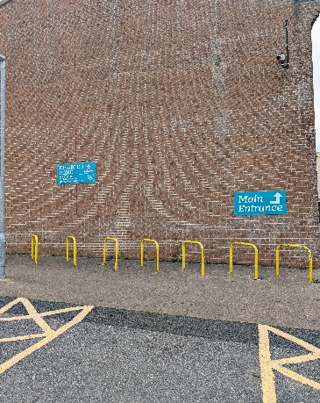
Accessible parking signage
ENTERING THE BUILDING
When you enter the doors will open automatically. You will see reception and be greeted by a member of our reception team. You may hear conversations, phones ringing and background music. There may also be queues during busy periods.
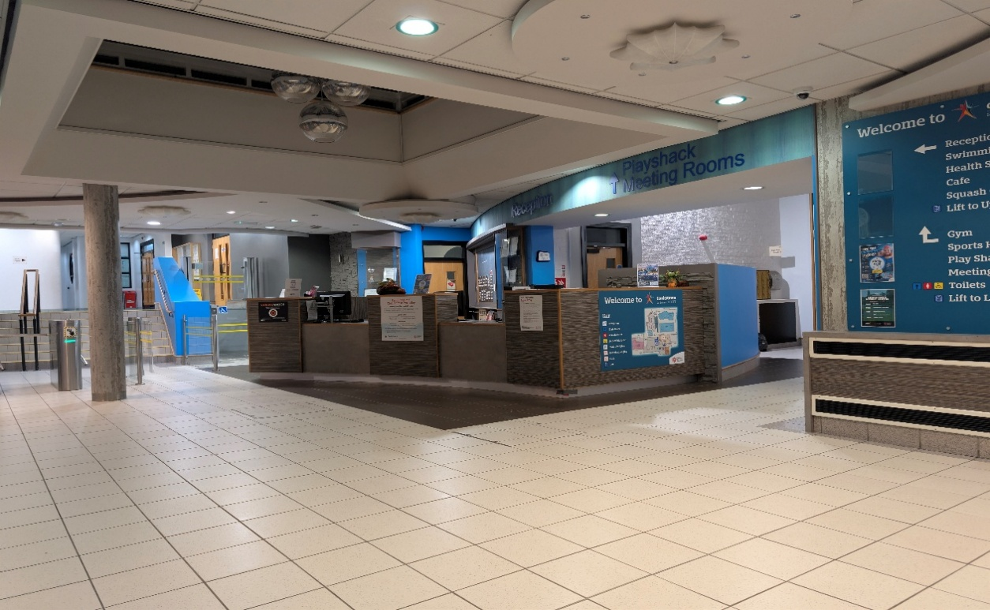
Reception foyer

Reception Area
At reception you may be asked for your name or membership band so we can register your visit and book your chosen activity. Members have the option to book and register their visit via the Kiosk; our reception team will be able to help if required.
- You can ask staff for help at any time.
- You may receive a wristband or ticket to gain entry to the gym.
- You can use the self-service kiosk to check in for your activity.
If you feel anxious
You can tell a member of staff. A suggested phrase is: “I have autism and would appreciate some assistance.”

JAM CARD
To support your visit, our customer service team are trained to recognise the JAM Card to discreetly let us know you may need additional time.
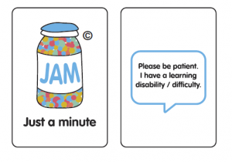
JAM Card

Finding Your Way Around
Site maps, lifts and staff support can help you move around the building.
SITE MAPS
While in the centre you will see site maps that can help you find your way around the building. Staff will be happy to assist you with directions if needed.
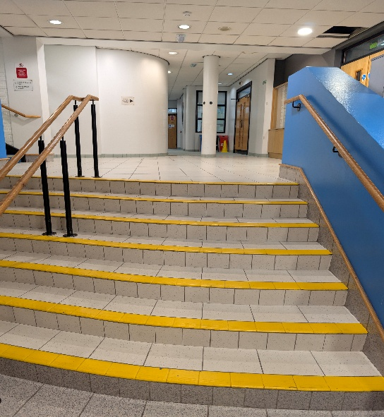 | 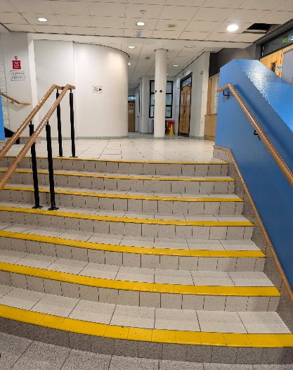
LIFTS AND POOLPOD
There are lifts within the building for each level for your use if you require them on your visit and a PoolPod for pool access. Staff will be happy to assist you if needed.
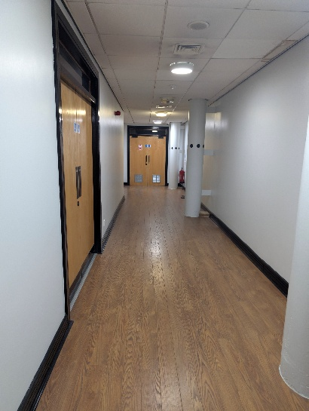 | 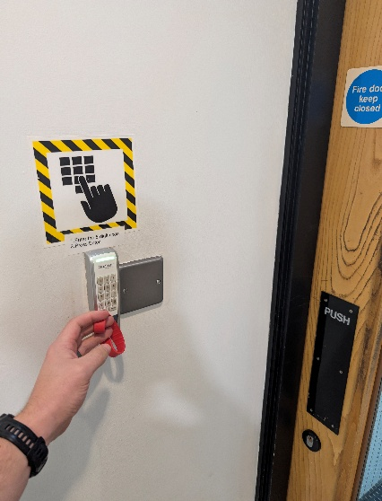
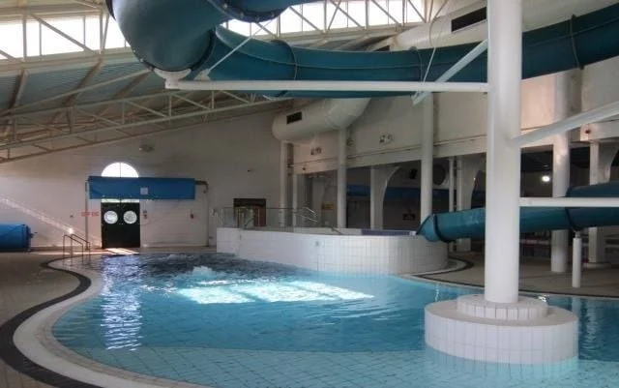
Pool access area

Sensory Information
A quick reference to some of the sights, sounds and physical sensations you may experience.
Sensory area | What you may experience | Examples in the centre | Helpful support
Sounds | People talking, children playing, pool activities, whistles, gym equipment, hand dryers and public announcements. | Reception, pool activity, instructors/lifeguards, gym and shared spaces. | Headphones or ear defenders may help. Music is turned down during ASD Friendly sessions.
Things you may see | Bright lighting, digital screens, people moving around, sports activities and swimming lessons. | Leisure activities, signage, equipment and people using shared areas. | Look at photographs before arriving and use a visual schedule.
Things you may feel | Warm temperatures near the pool, cooler circulation areas, water splashes and different floor textures. | Pool areas, changing areas and circulation routes. | Bring comfort items and take time out if needed.
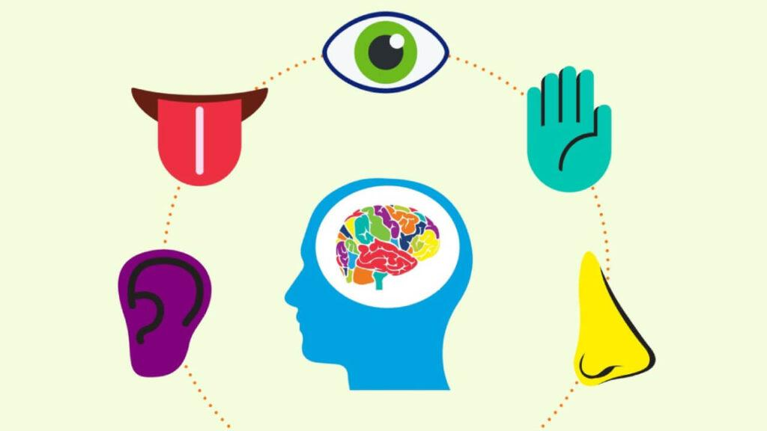
Sensory information
Remember
Every visit can be different. If you need assistance or a quieter space, speak to a member of staff.

Swimming Pool Visit
HOW TO GET TO THE CHANGING VILLAGE
- Follow signs to the changing area.
- Enter the correct changing area.
- Change into swimwear.
- Store belongings safely.
- Shower if required.
- Walk carefully to poolside.
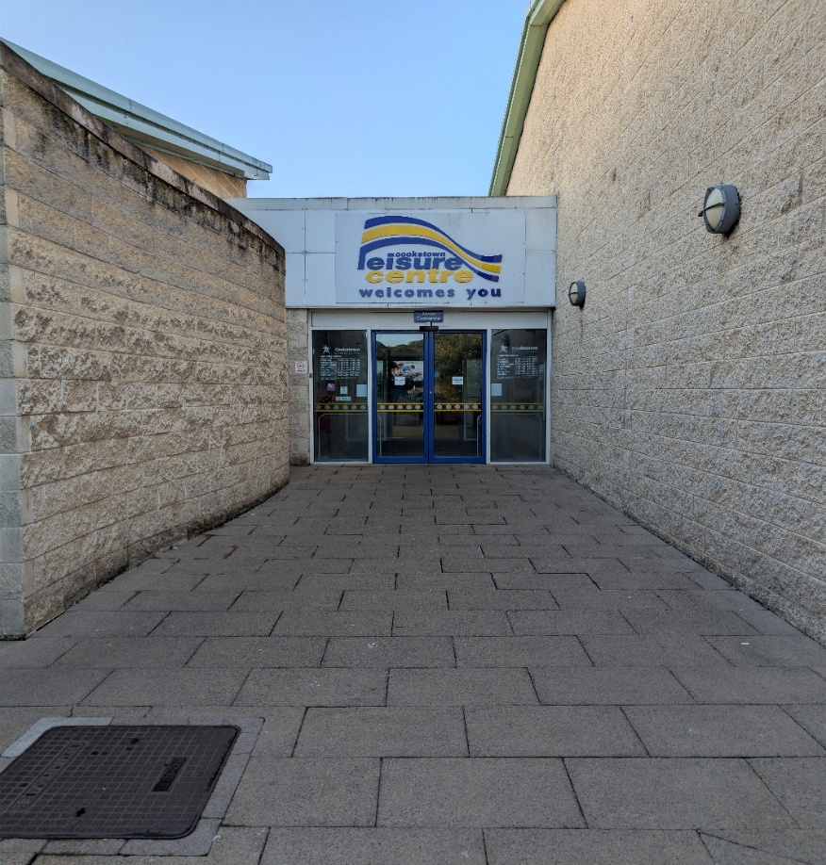
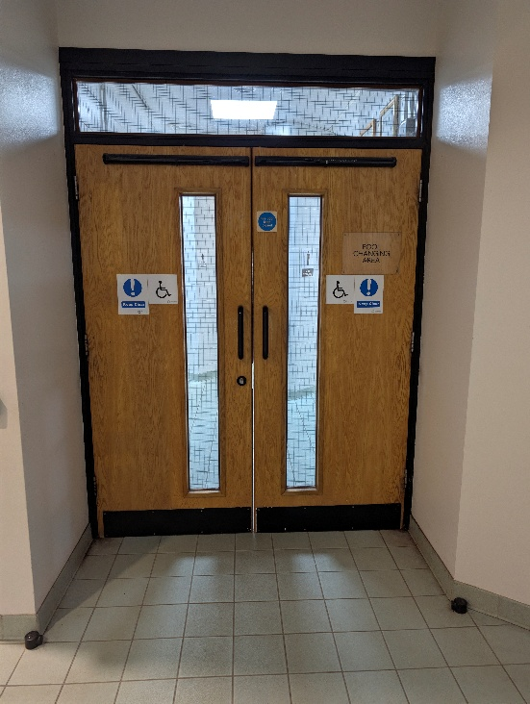 | 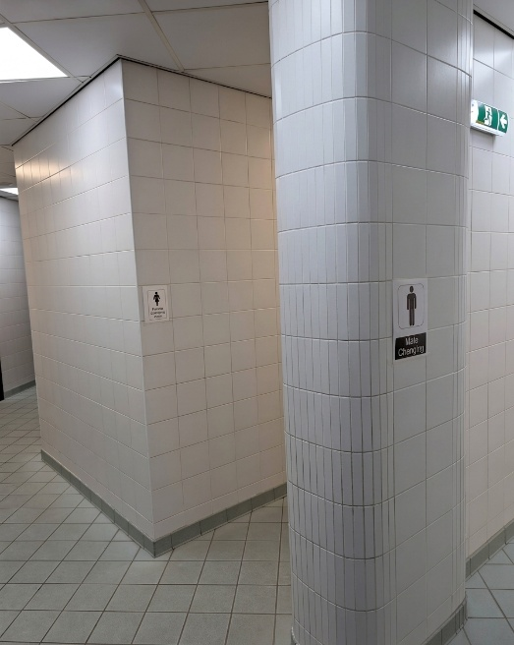
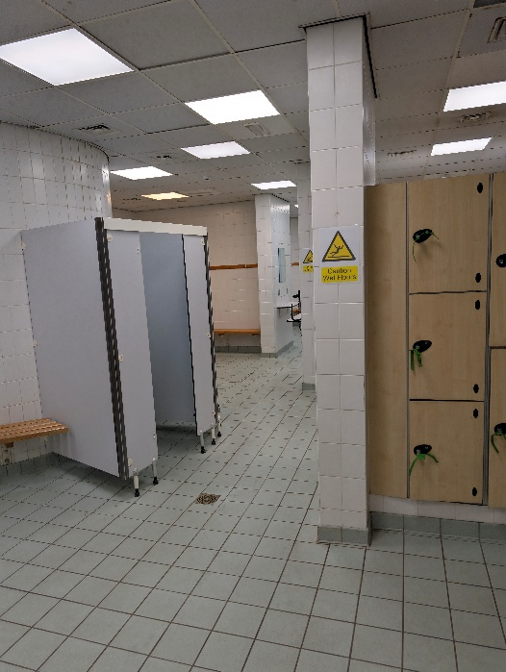 | 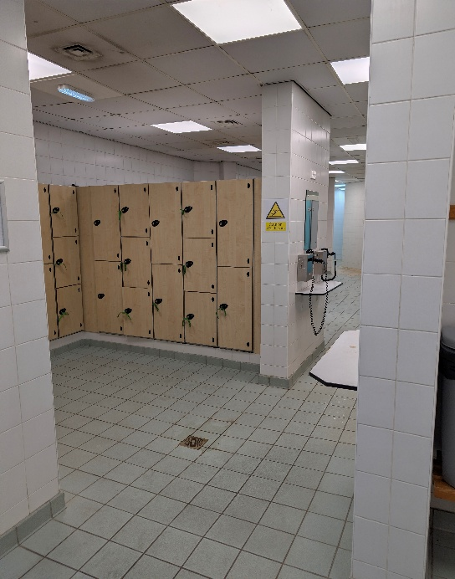
POOLSIDE RULES
- Walk at all times.
- Listen to lifeguards.
- Stay within designated swimming areas.
- Follow pool safety rules.
WHAT TO EXPECT IN THE POOL
- Water movement and splashing.
- People swimming in different directions.
- Swimming lessons or organised sessions.
- Lifeguards observing from poolside.
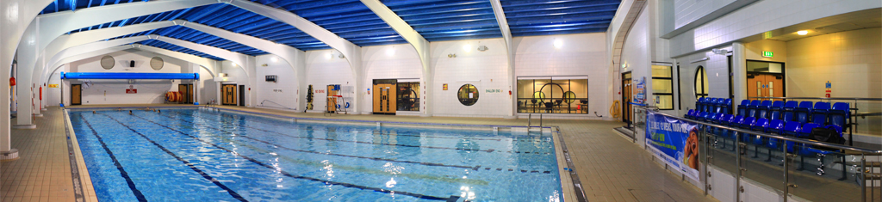
Main pool

Health Suite Visit
HOW TO GET TO THE HEALTH SUITE AND CHANGING AREA
- Follow signs to the changing area.
- Enter the correct changing area.
- Change into swimwear.
- Store belongings safely in the locker provided.
- Shower if required.
- Walk carefully to the Health Suite area.
 | 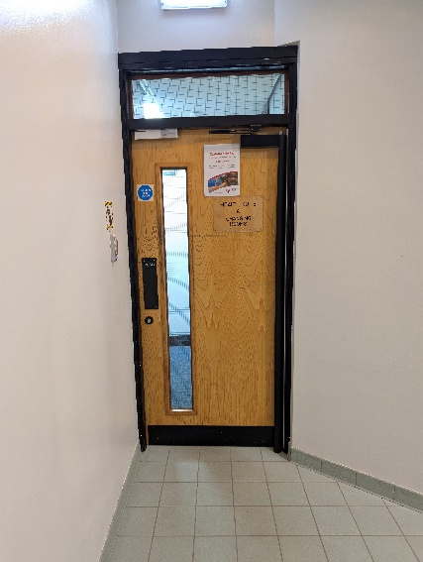
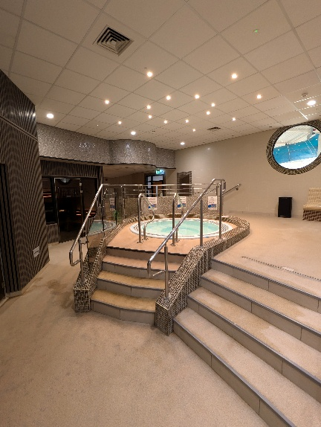 | 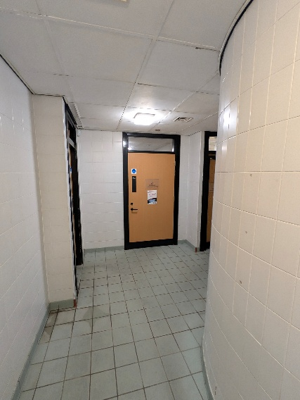
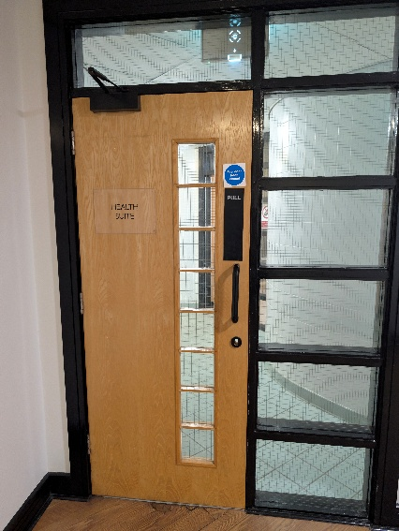 | 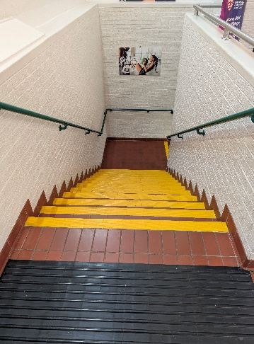
WHAT TO EXPECT IN THE HEALTH SUITE
- Spa Pool – can be loud and noisy when jets are running.
- Sauna – dry heat.
- Steam Room – wet heat.
- Heated loungers.
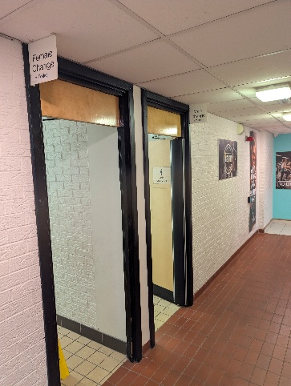
Health Suite area

Gym Visit
ENTERING THE GYM
Staff can explain how the equipment works and an induction is required on your first visit.
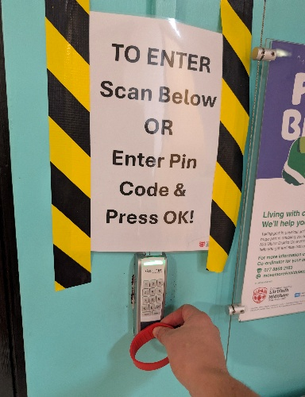 | 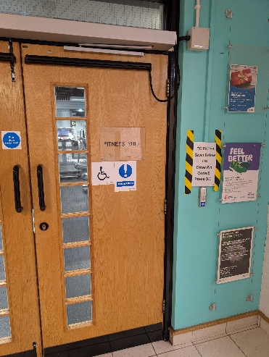
YOU WILL SEE
- Treadmills
- Exercise bikes
- Rowing machines
- Weight machines
- Free weights
YOU MAY HEAR
- Music (our music system will be turned down during ASD Friendly sessions).
- Equipment operating.
- Staff instructions.
- People exercising.
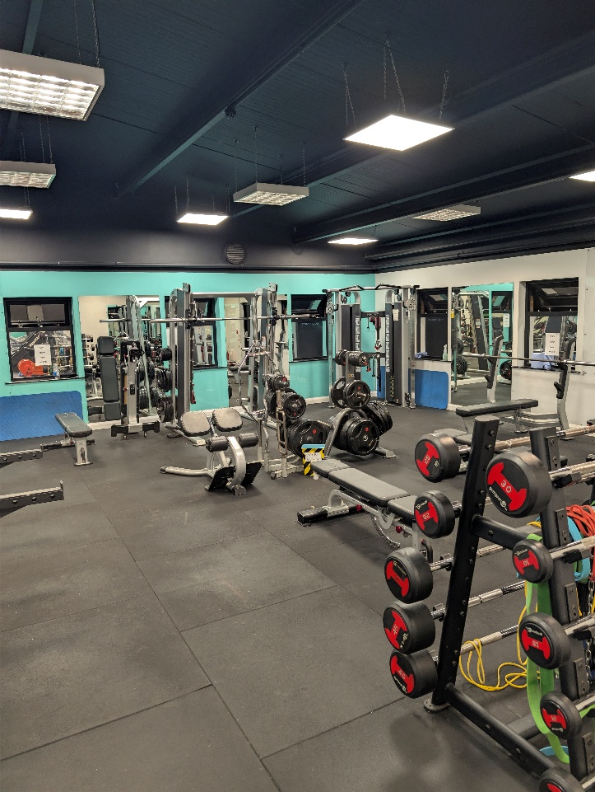
Gym area

Attending an Exercise Class
Classes can be booked online or via reception.
Within Cookstown Leisure Centre exercise classes are ran daily and can be booked online or via reception.
Important sensory information
Both types of classes based in the Sports Hall or in the Spin Room will have loud music. Spin classes will also contain flashing lights.

Virtual Spin Classes can be set up for your use which can have both the volume and level of lighting adjusted for a more comfortable experience.
SPORTS HALL CLASSES
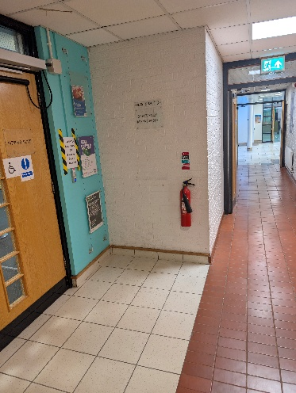 | 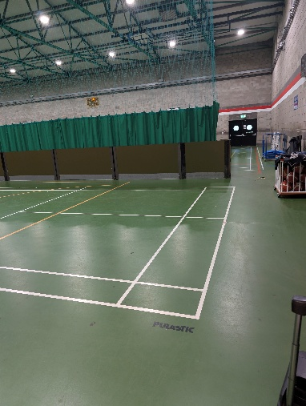
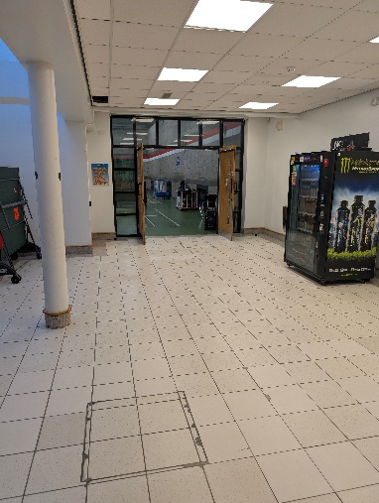 | 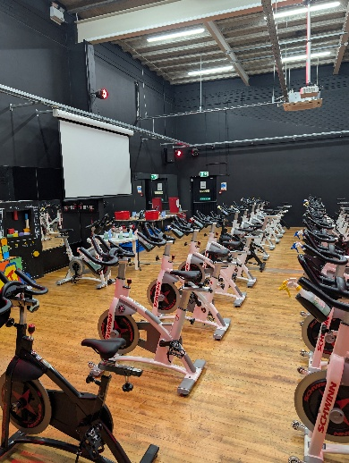
Class instructors can assist with any questions before class to make your experience as comfortable as possible.
SPIN CLASSES
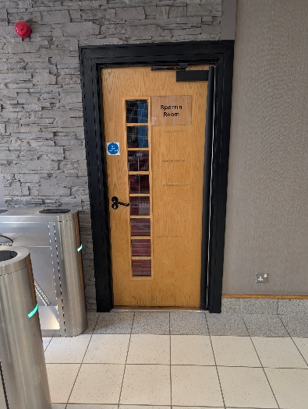 | 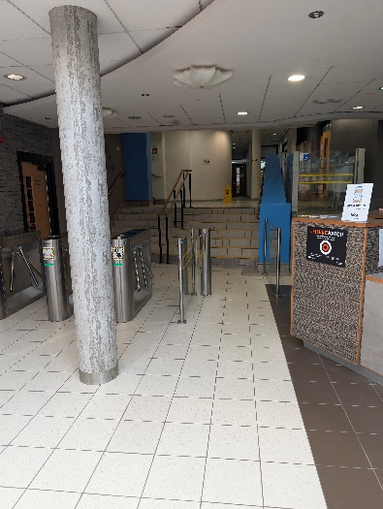
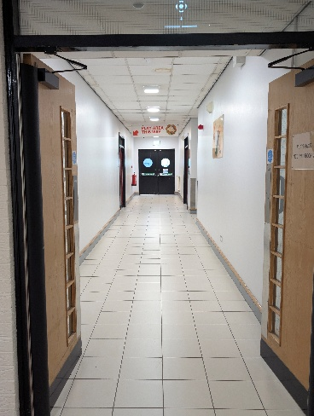 | 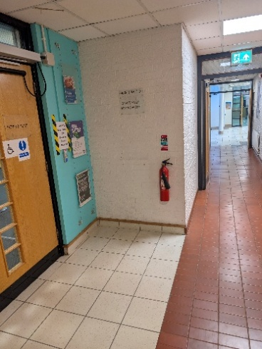
Class instructors can help adjust bikes before class to provide a safe experience.

Soft Play Visit
You can book in for a session in our Soft Play area via reception or online.
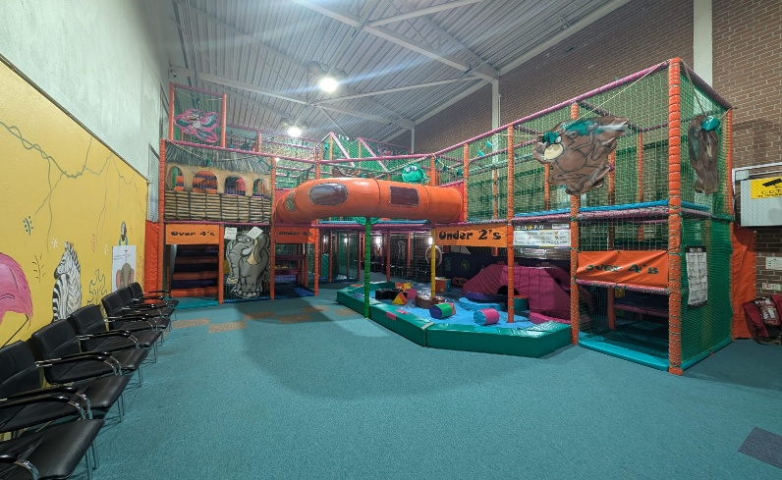
Soft Play
YOU WILL SEE
- Soft balls
- The Soft Play frame
- Slides
- Tables and chairs
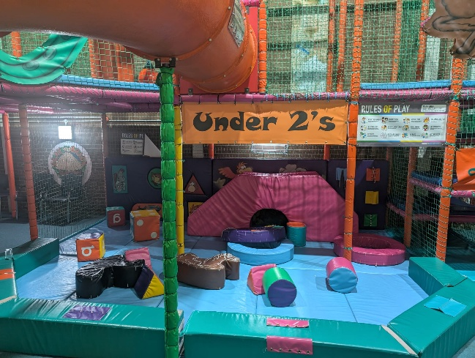 | 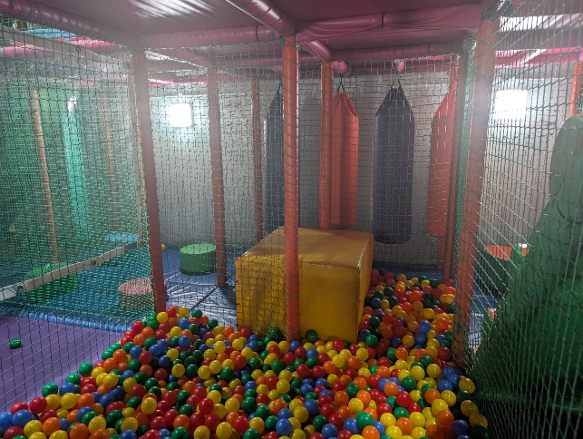
YOU MAY HEAR
- Music
- Kids playing
- Staff instructions
- People talking
- Kids shouting
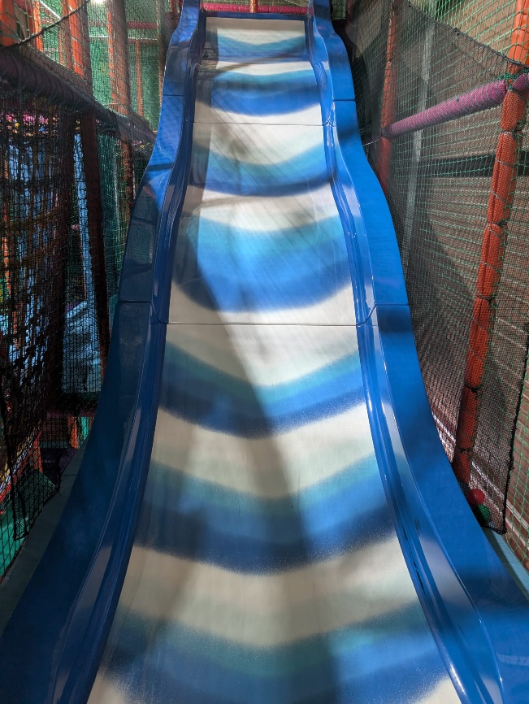
Freefall slide

Soft Play Rules
- Strictly no adults on the play frame.
- No children over 145cm.
- All children must be accompanied by a parent or guardian at all times.
- Balls must remain in the ball pit.
- Shoes must be removed before entering the frame; socks must be worn.
- Food and drinks must not be consumed within the play frame.
- All accidents must be reported to reception so that a first aider can be summoned.
- Jewellery, ties, neck cords, hard or sharp items or clothing such as belts with buckles are not permitted into the play area.
Sensory consideration
Soft Play can be a busy and noisy environment. If you need support or a quieter space, speak to a member of staff.

Cubbie
A dedicated sensory-regulation space within Cookstown Leisure Centre.
Cubbie is an early-intervention sensory-regulation solution that enables organisations to support more people sooner, minimise disruption, and keep individuals engaged in everyday life.
Cubbie provides staff with a safe, structured, evidence-based regulation tool that works from universal wellbeing through to complex, individual need.
Unlike a traditional sensory room, Cubbie combines personalised sensory programmes, usage data, and embedded occupational therapy (OT) expertise, helping organisations deliver the right support, at the right time, in the right place, and at the right level of need.
Designed as a blank canvas, Cubbie uses sensory portraits® and targeted support to adapt to an individual’s unique sensory needs, creating an experience that’s just for them. It can be used before, during and after dysregulation, meaning individuals can be back to their day within 15 minutes.
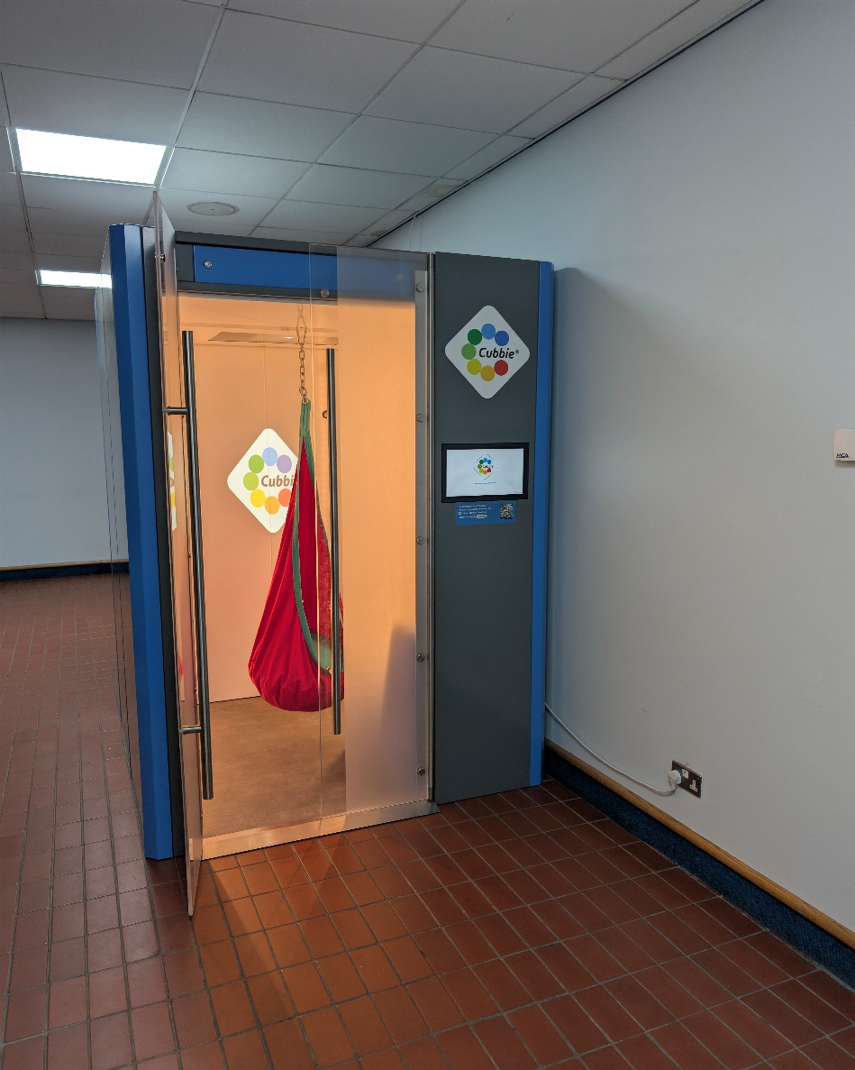
Cubbie sensory-regulation space
Ask our team
If you would like to know more about Cubbie or whether it may be suitable for your visit, speak to a member of staff.

Quiet Space and Feedback
QUIET SPACE
If you begin to feel overwhelmed and wish to take time out on your visit to the leisure centre, inform a member of staff who will direct you to our designated Quiet Space. This will allow you to take time to regulate.
You can ask for support
You do not need to wait until you feel overwhelmed. Speak to a member of staff at any point during your visit if you need assistance.

FEEDBACK
We welcome feedback from visitors, families, carers and support organisations to help us continue improving accessibility and inclusion at Cookstown Leisure Centre.
Thank you
Thank you for visiting Cookstown Leisure Centre. We hope you enjoy your experience.

USEFUL REMINDERS
- Visit our website for opening times.
- Look at photographs of the facility before arriving.
- Discuss the visit using a visual schedule.
- Bring any comfort items that support your visit.
- Wear comfortable clothing.
- Bring headphones or ear defenders if required.

