
ASD Friendly
Information Pack
Dungannon Leisure Centre
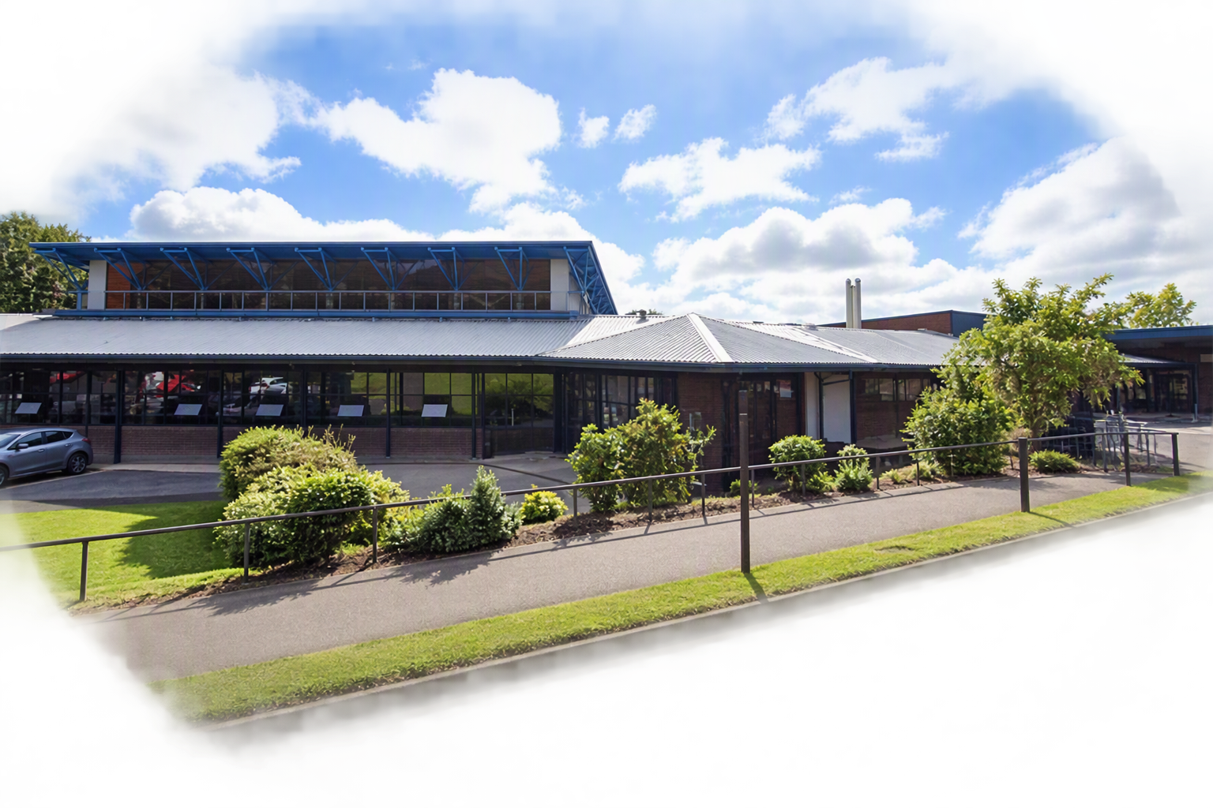

Dungannon Leisure Centre

A guide to your visit
This guide explains what you can expect before arriving, during your visit and when leaving Dungannon Leisure Centre.

Welcome to Dungannon Leisure Centre
A clear guide to help you plan and enjoy your visit.
We understand that visiting a leisure centre can sometimes feel overwhelming for people with Autism Spectrum Disorder (ASD). This guide has been designed to help visitors understand what to expect before arriving, during their visit, and when leaving the centre.
Our aim is to provide a safe, welcoming and inclusive environment where everyone can enjoy physical activity, recreation and community participation.
Dungannon Leisure Centre staff have received training from Autism NI to ensure that we are autism aware and able to provide additional support, if needed.
IN THIS GUIDE
- About the centre
- Before your visit
- What to bring
- Changing Places
- Arriving and reception
- Sensory information matrix
- Swimming pool visit
- Gym visit
- Quiet Space and feedback
About the Centre
Dungannon Leisure Centre offers a range of facilities. Different areas may have different sounds, lighting levels and activity levels.
Facilities | Additional facilities
25m Swimming Pool | Reception Area
Learner Pool | Viewing Areas
Fitness Suite / Gym | Accessible Toilets
Spin Studio | Accessible Car Parking
Meeting Rooms | Accessible Changing Facilities
Sports Hall
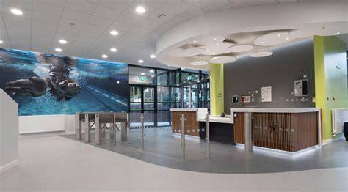

Before Your Visit
Planning ahead can help make your visit more comfortable.
Before you arrive, it may help to check opening times, look at photographs of the centre, talk through the visit using a visual schedule, and bring any comfort items that support you.

Check opening times | Visit our website for opening times.
Look at photographs | Look at photographs of the facility before arriving.
Use a visual schedule | Discuss the visit using a visual schedule.
Bring comfort items | Bring any comfort items that support your visit.
Wear comfortable clothing | Choose clothing that feels comfortable.
Bring headphones if required | Bring headphones or ear defenders if required.
What to bring
For swimming
- Swimwear
- Towel
- Goggles (optional)
- Water bottle
- Change for your locker/hairdryer (Lockers £1 refundable / Hairdryers 20p non-refundable)

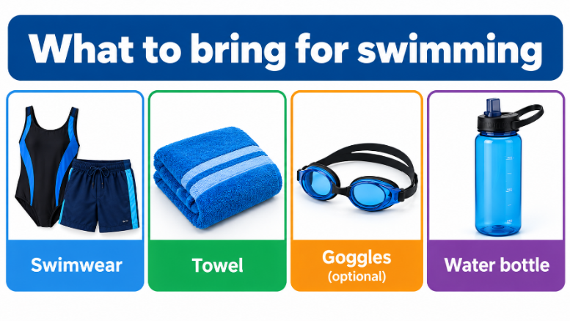

For gym or exercise classes
- Comfortable sports clothing
- Trainers
- Water bottle
- Change for your locker/hairdryer (Lockers £1 refundable / Hairdryers 20p non-refundable)

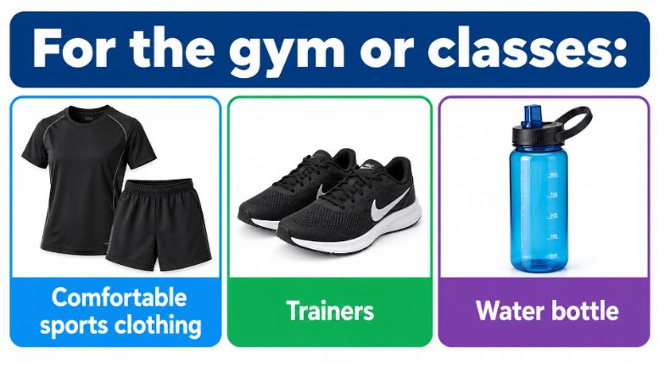

Changing Places
There are Changing Places facilities should you have any additional toilet or changing needs. They are wheelchair accessible and provide plenty of space.
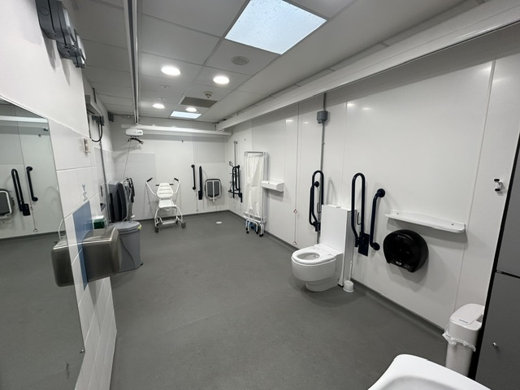
Changing Places facility
Planning your visit
If you have questions about access or facilities before your visit, contact the leisure centre team for assistance.

Arriving at Dungannon Leisure Centre
On arrival, you can park near the main entrance. Accessible parking spaces are available at the front of the building and to the side, adjacent to the main road. The car park can sometimes be busy and noisy. Additional spaces are available by entering the grounds via the Killymeal Road.
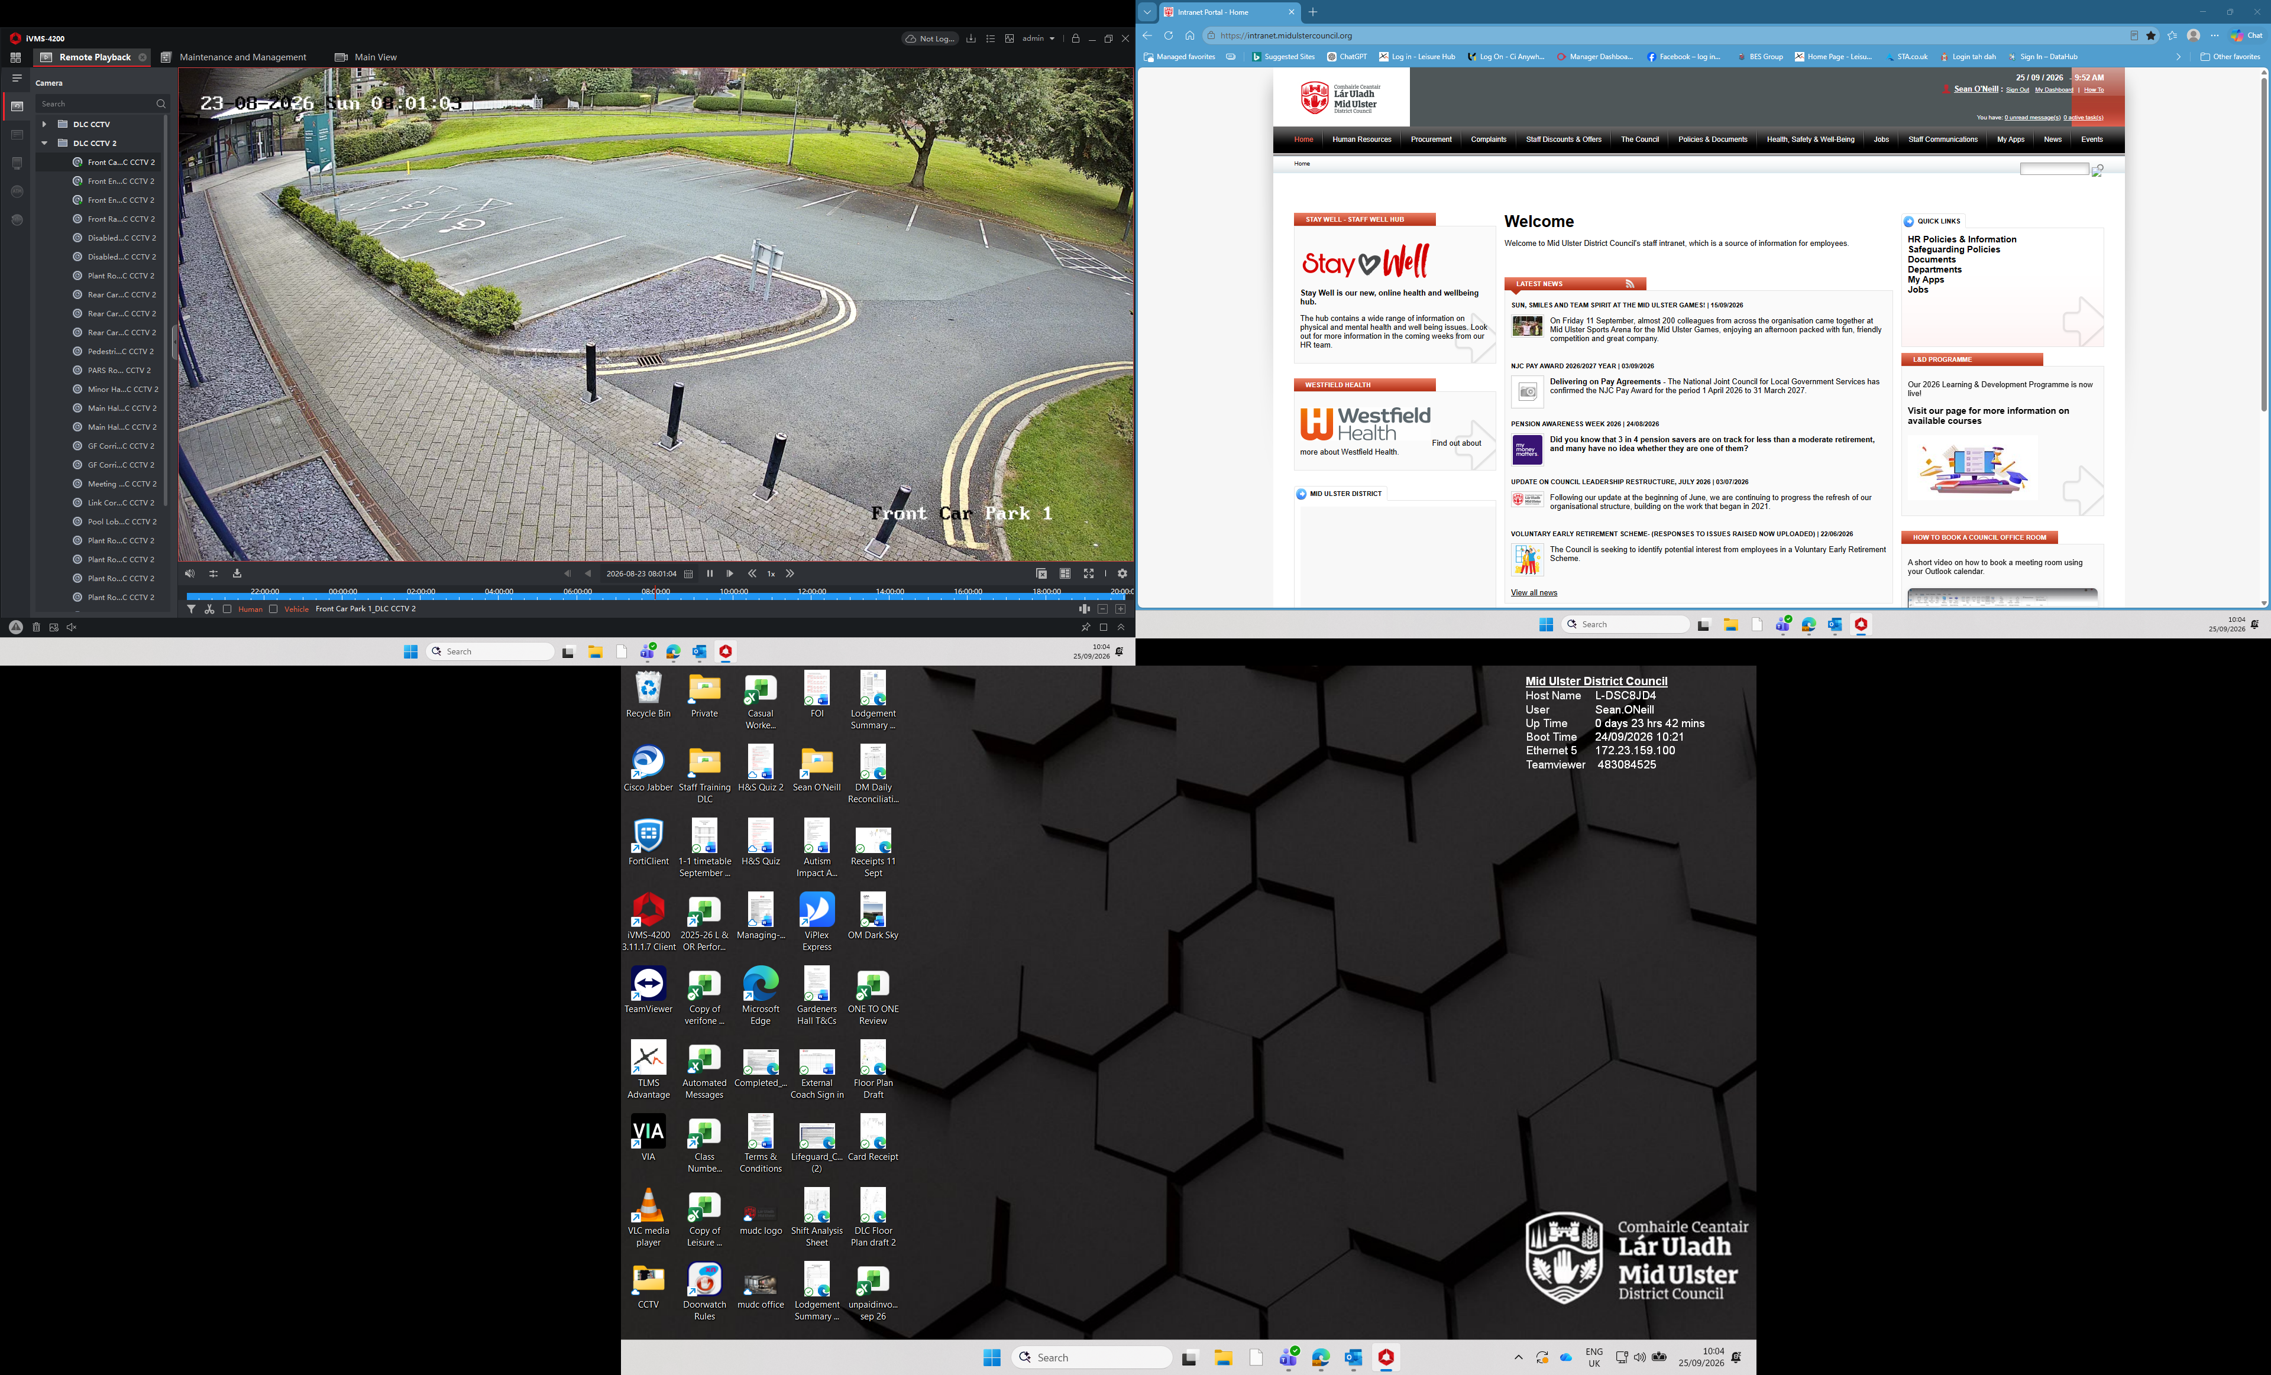

ENTERING THE BUILDING
When you enter, the doors will open automatically. You will see reception and be greeted by a member of our reception team. You may hear conversations, phones ringing and background music. There may also be queues during busy periods.
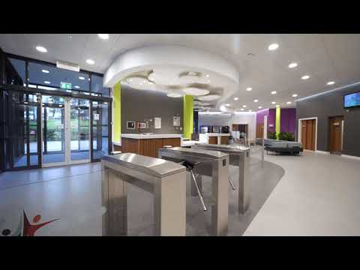
Reception Area
At reception, you may be asked for your name or membership band so we can register your visit and book your chosen activity. Members can book and register their visit via the kiosk. Our reception team will be happy to help if required.
- You can ask staff for help at any time.
- You may receive a wristband or ticket to gain entry to the gym.
- You can use the self-service kiosk to check in for your activity.
If you feel anxious
You can tell a member of staff. A suggested phrase is: “I have autism and would appreciate some assistance.”

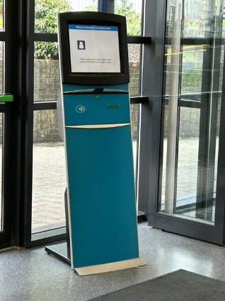
Self-service kiosk
JAM CARD
Our customer service team are trained to recognise the JAM Card. It can discreetly let staff know that you may need additional time.
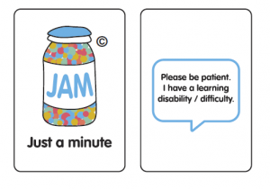
JAM Card

Sensory Information Matrix
A quick reference to some sights, sounds and physical sensations you may experience.
Sensory area | What you may experience | Examples in the centre | Helpful support
Sounds | Talking, children playing, pool activities, whistles, gym equipment, hand dryers and announcements. | Reception conversations and phones; pool activity; instructors or lifeguards; gym equipment. | Headphones or ear defenders may help. Music is turned down during ASD Friendly gym sessions.
Things you may see | Bright lighting, digital screens, people moving around and organised activities. | Sports activities, swimming lessons and people using shared spaces. | Look at photographs before arriving and use a visual schedule.
Things you may feel | Warm or cool temperatures, water splashes and different floor textures. | Warmth near the pool, cooler circulation areas, water movement and splashing. | Bring comfort items and take a break if needed.
Busy areas and support | Queues, increased activity or unexpected changes may feel difficult. | Reception and shared leisure areas may be busier at peak times. | Ask a staff member for help. Staff can direct you to the designated Quiet Space.

Remember
Every visit can be different. If you need assistance or a quieter space, speak to a member of staff.

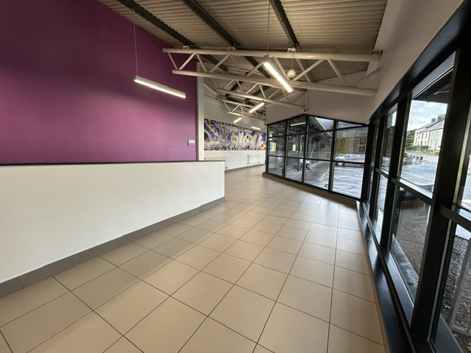
Swimming Pool Visit
HOW TO GET TO THE CHANGING VILLAGE
- Follow signs to the changing area.
- Choose an available changing cubicle.
- Change into swimwear.
- Store belongings safely.
- Shower if required.
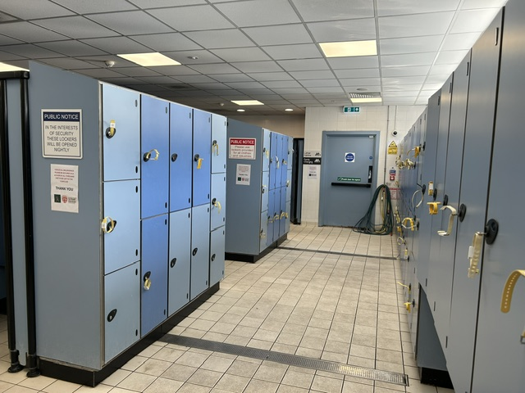
- Walk carefully to poolside.
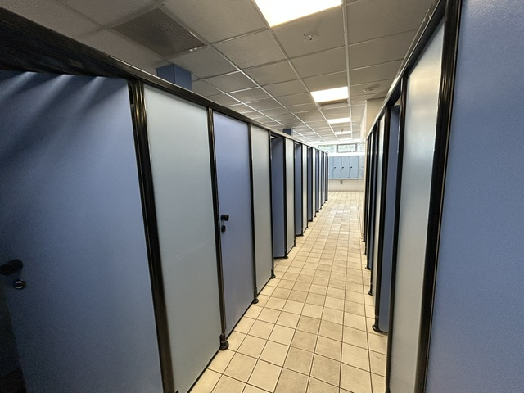

POOLSIDE RULES
- Walk at all times.
- Listen to lifeguards.
- Stay within designated swimming areas.
- Follow pool safety rules.

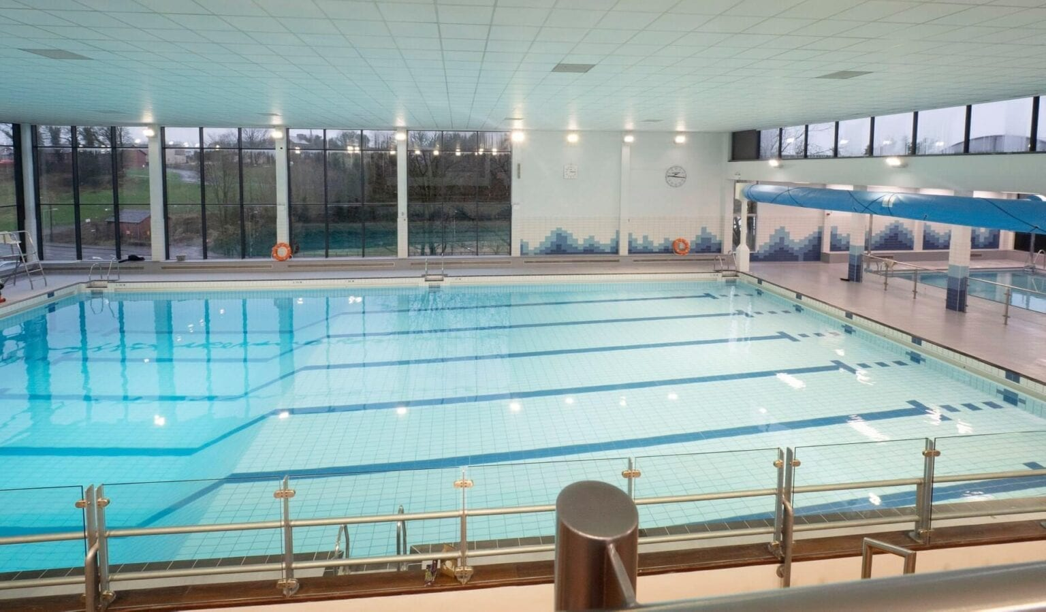
WHAT TO EXPECT IN THE POOL
- Water movement and splashing.
- People swimming in different directions.
- Swimming lessons or organised sessions.
- Lifeguards observing from poolside.

25m swimming pool

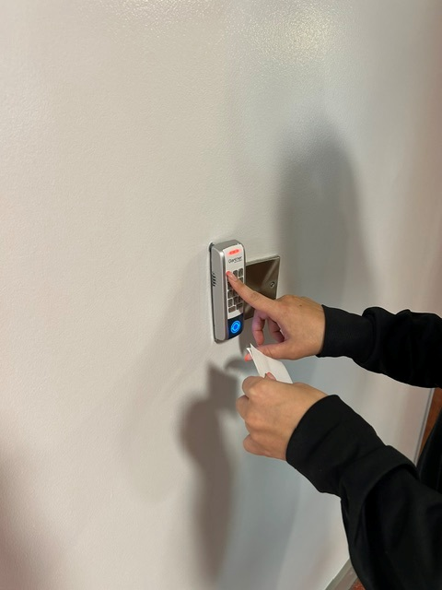
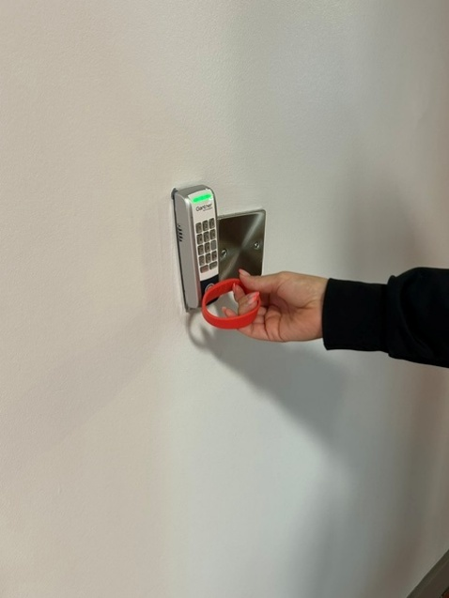
Gym Visit
ENTERING THE GYM
Present your membership band to the reader or input the 5-digit code
displayed on your receipt. Staff are available to help if required.

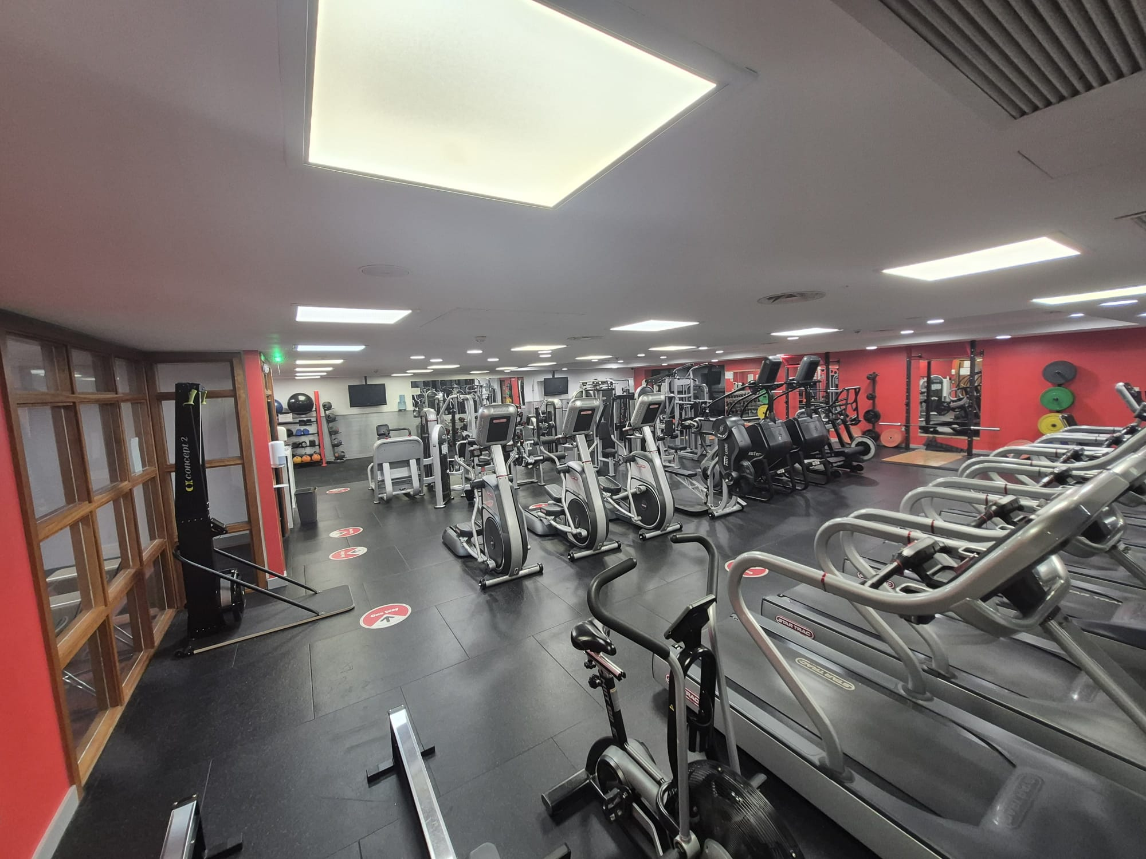
Fitness suite / gym
YOU WILL SEE
- Treadmills
- Exercise bikes
- Rowing machines
- Weight machines
- Free weights
YOU MAY HEAR
- Music. The music system will be turned down during ASD Friendly sessions.
- Equipment operating.
- Staff instructions.
- People exercising.
Staff members will be available to explain how the equipment works when you complete a short induction.

Attending an Exercise Class

Classes can be booked online or via reception.

Dunganon Leisure Centre exercise classes are on daily and can be booked online or via reception.

Important sensory information

Both types of classes based in the Sports Hall or in the Spin Room will have loud music. Spin classes will also contain flashing lights.

Virtual Spin Classes can be set up for your use which can have both the volume and level of lighting adjusted for a more comfortable experience.

Quiet Space and Feedback
QUIET SPACE
If you begin to feel overwhelmed and wish to take time out during your visit, inform a member of staff. They will direct you to the designated Quiet Space, where you can take time to regulate.
You can ask for support
You do not need to wait until you feel overwhelmed. Speak to a member of staff at any point during your visit if you need assistance.

FEEDBACK
We welcome feedback from visitors, families, carers and support organisations to help us continue improving accessibility and inclusion at Dungannon Leisure Centre.
Thank you
Thank you for visiting Dungannon Leisure Centre. We hope you enjoy your experience.

Email: leisure@midulstercouncil.org

