**easy read**



**Mid Ulster**

Age Friendly

Strategic Plan

**2023-2026**

**Our Plan for an Ageing Community**

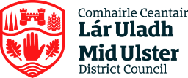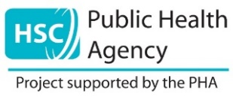

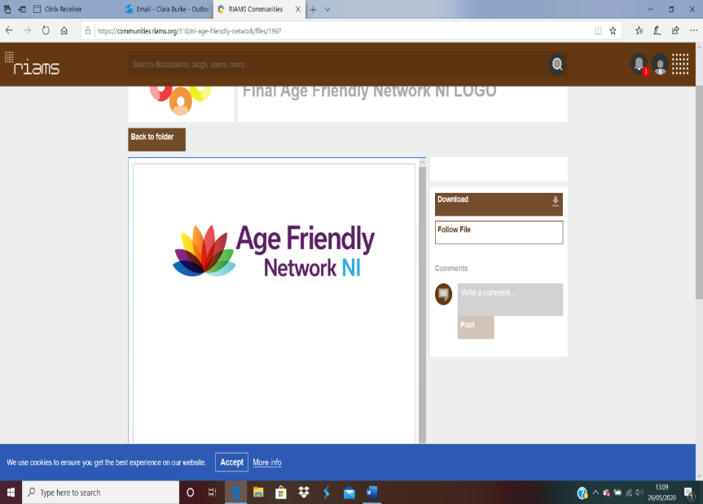

**What is in the plan**

* **Age Friendly Strategic Plan Introduction…………….Page 3**
* **Age Friendly Profile- Mid Ulster………………………..Page 4**
* **Steps taken by the Council to date 2017-2022………Page 5**
* **Age Friendly Links- Community Plan…………………Page 6**
* **Age Friendly 8 Key Themes with actions…………….Page 7**
* **Theme 1: Outdoor Spaces Buildings………………………….Page 7**
* **Theme 2: Transport……………………………………………….Page 8**
* **Theme 3: Housing…………………………………………………Page 9**
* **Theme 4: Social Participation…………………………………..Page 10**
* **Theme 5: Respect and Social Inclusion………………………Page 11**
* **Theme 6: Civic participation and Employment……………..Page 12**
* **Theme 7: Communication and Information………………….Page 13**
* **Theme 8: Community and Health Services………………….Page 14**
* **Implementation Structure……………………………….Page 15**

**Age Friendly strategic Introduction**



Mid Ulster District Council have been engaging with residents over the age of 50 from April 2022 – December 2022 to find out how it feels to grow older in their communities and what matters most to them with improvements for the future.

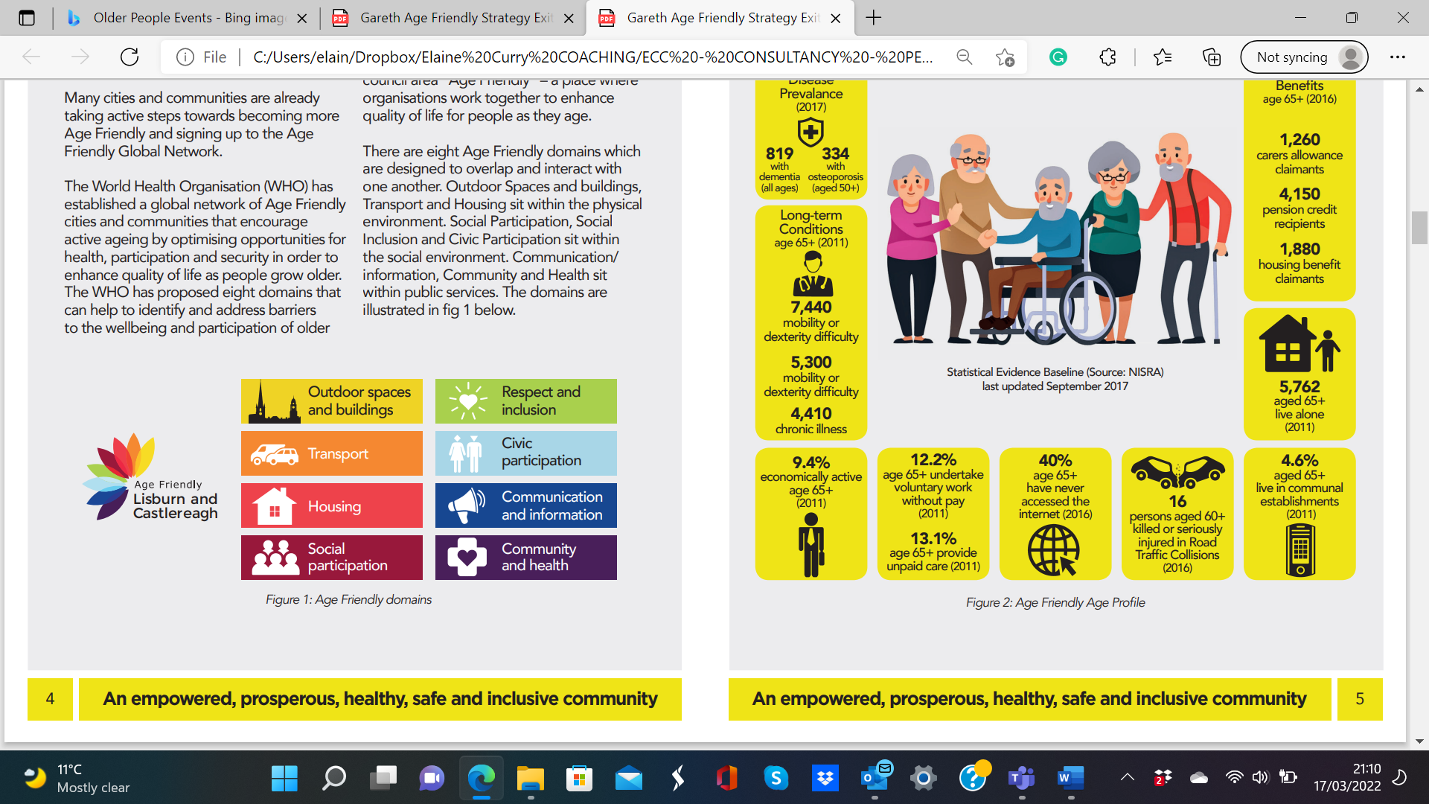

The findings from engagement with 400+ people have informed actions to enhance the Age Friendly environment over the next three years, looking at key actions covering the 8 Age Friendly themes.

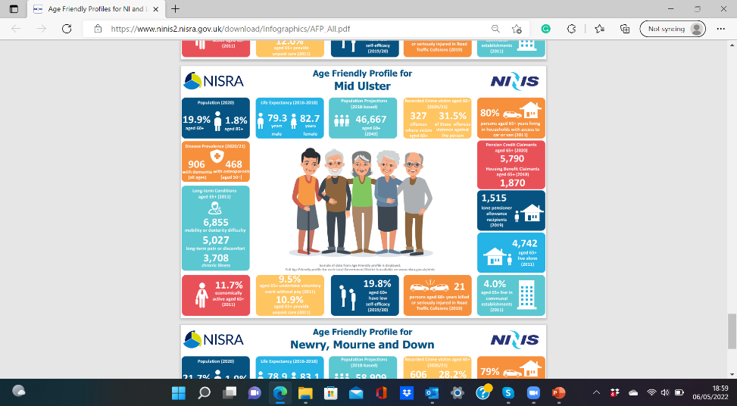

Mid Ulster District Council is fully aware we have an ageing population meaning that the demographic profile will change significantly over the next 10-20 years. We aim to be better prepared to support older people and future generations.

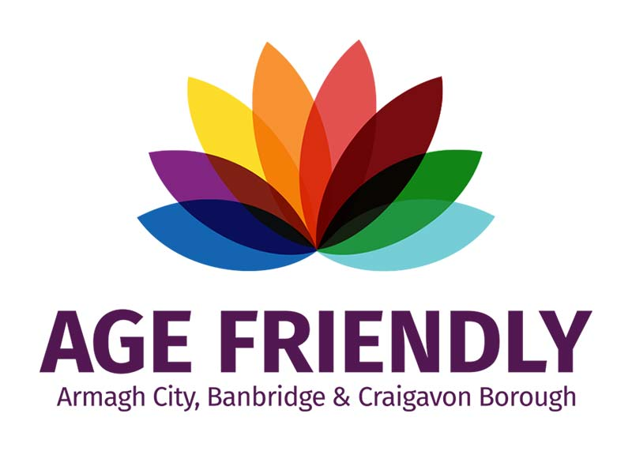

An age-friendly community is one in which people of all ages can live healthy and active lives and where everyone is treated with respect, regardless of their age. As we all live longer, there are huge opportunities to create vibrant communities.

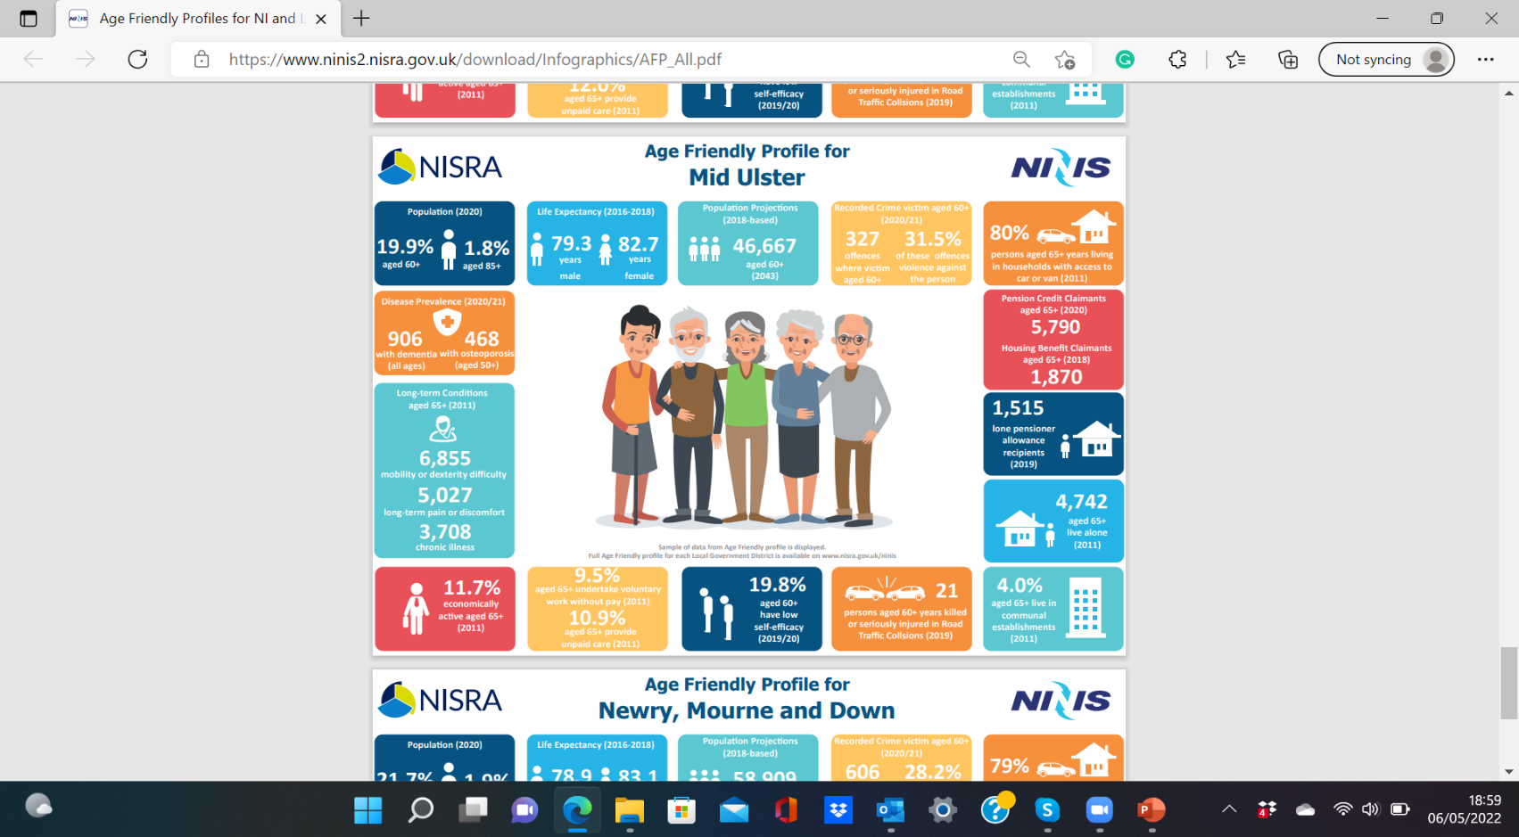**Age Friendly Profile - mid ulster**

***Figure 2: Age Friendly Profile*** [***www.nisra.gov.uk/ninis***](http://www.nisra.gov.uk/ninis)[***https://www.ninis2.nisra.gov.uk/download/Infographics/AFP_All.pdf***](https://www.ninis2.nisra.gov.uk/download/Infographics/AFP_All.pdf)

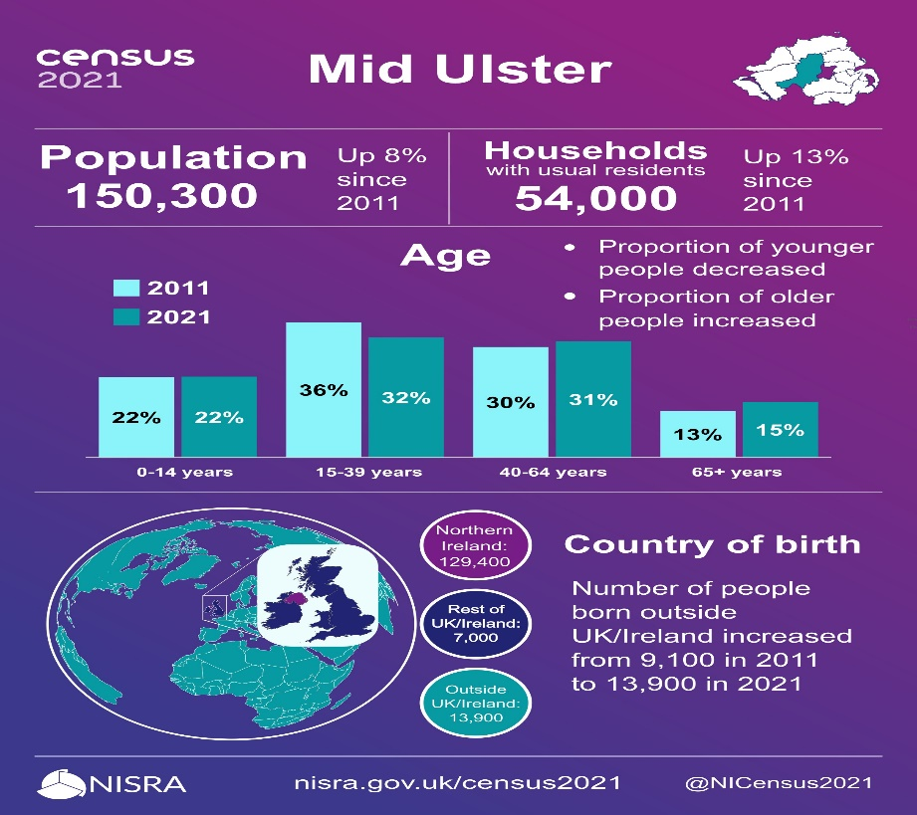

***Figure 3: Census 2021 Mid Ulster data nisra.gov.uk/census2021***

In 2020, the estimated population of Mid Ulster was 148,528

19.9% of the population of Mid Ulster were aged 60+ years (29,557). 1.8% were aged 85+ (2,673). With the total population over 60 is 32,230.

The population of Mid Ulster aged 60+ is expected to rise to 46,667 by 2043.

**Steps taken by Council To date 2017-2022**

Over the past 5 years Mid Ulster Council have been working hard to support older people with care, connections and wellbeing.

**Age Friendly LINKS - COMMUNITY PLAN**

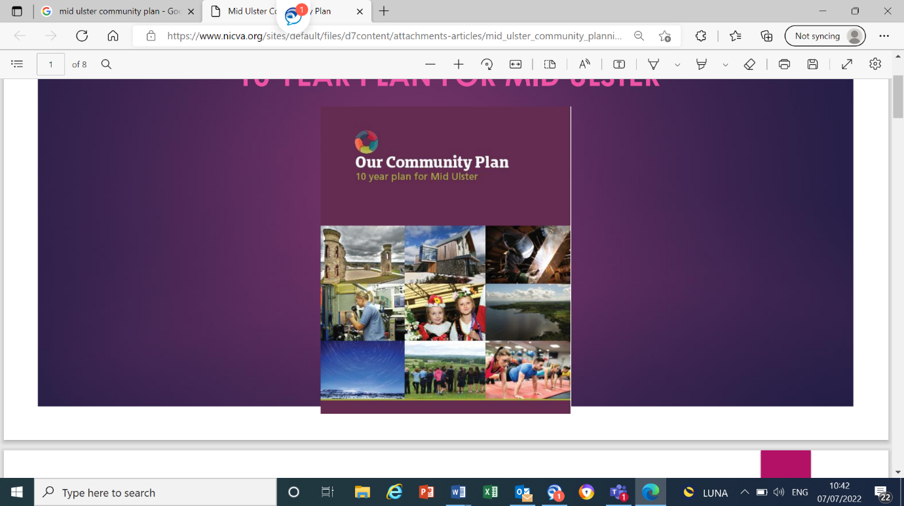

The Community plan, alongside the Age Friendly plan, will build on the solid foundation of the existing relationships, partnerships, programmes already in place.

The Age Friendly plan will link to the community plans outcomes as it highlights that an ageing population is an important issue to address.

With the purpose of community planning being to improve how public services work together, with local people, to plan and deliver better services. Age Friendly will be a relevant way of working to gain positive outcomes for the Council’s population in future years, linking to the current eight Age Friendly themes ensuring that everyone will benefit.

This easy read version of the Age friendly plan tells you our vision and what we plan to do.

**Our Vision:**

**Mid Ulster is an age-friendly district where older people are valued, engaged and supported to live healthy, active, fulfilling lives.**

**Age Friendly 8 key themes with actions**

**Theme 1: Outdoor Spaces Buildings Action Plan**

We plan to increase infrastructure to support an age-friendly community, with increased access to Mid Ulster community areas and green spaces, both town and rural, that the public enjoys.

**Suggested Actions:**

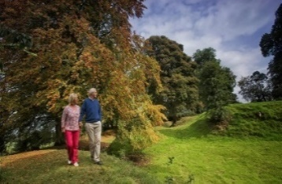

Encourage and promote more access to outdoor spaces – recreation, leisure, parks, chatty benches and chatty cafes.

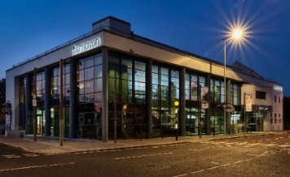

Develop a set of age-friendly design guidelines and business charters for our district that will evolve over time.



Promote Accessibility apps and websites and recognition of Age Friendly awards to places to promote accessibility.



Promote anti-littering programmes of education, awareness raising and enforcement.

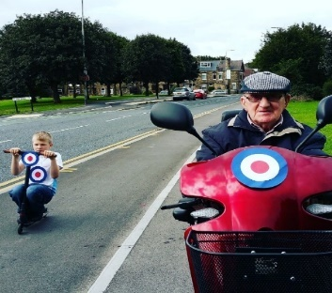

Explore options to improve accessibility along pavements and roads e.g. Awareness raising and signage.

**Theme 2: Transport Action Plan**

We plan to **i**ncrease partnership working to ensure better transport options and for improved accessibility, equality and safety.

**Suggested Actions:**

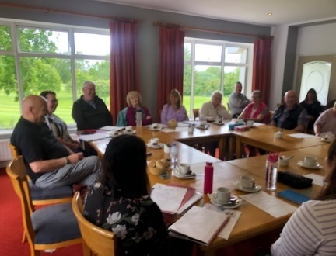

Engage with decision makers to maintain community transport services; improving the reliability, accessibility and affordability of transport within town, rural areas and hospital settings.

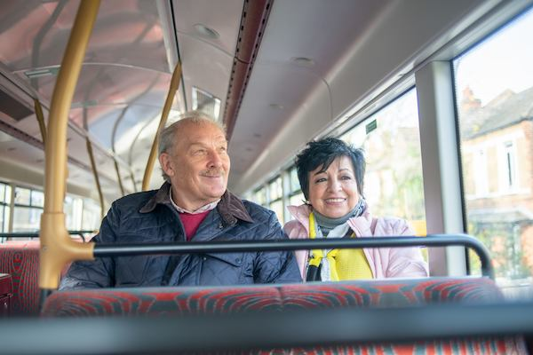

Promote smart passes and community transport, volunteer driver schemes with good news stories promoting services and easy to read timetables.

Promote Shopmobility and GObility services and increase referrals from healthcare professionals across Mid Ulster, including NHSCT and SHSCT.

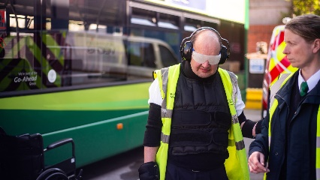

Promote Age Friendly Awareness Training to all transport providers.

**Theme 3: Housing Action Plan**

We plan to give older people more choices to live independently and safely within their homes.

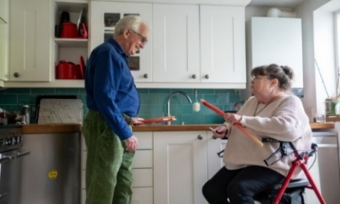**Suggested Actions:**

Scope and promote the opportunities for people to remain independently at home in a safe, warm and affordable environment as they age well in their own homes.

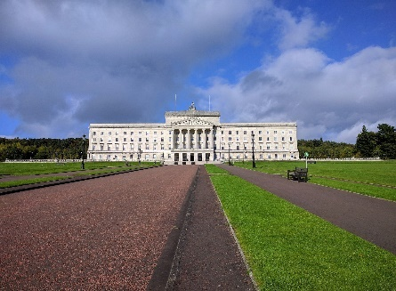

Lobby government to support home grant schemes that enable people to live independently in a safe, warm and affordable home.

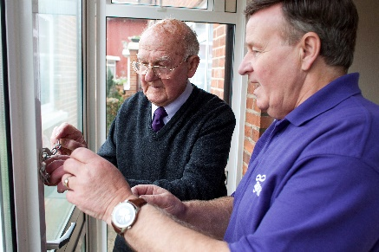

Maintain a Good morning call and Home maintenance service for those in need.

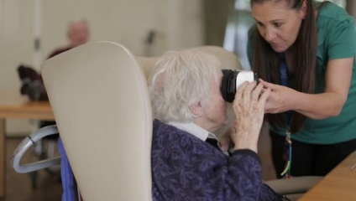

Promote Dementia Friendly assisted technology and safety measures with Herbert Protocol and PSNI.

**Theme 4: Social Participation**

We plan to increase social participation, addressing loneliness and isolation by connecting older people to services and their local communities.

**Suggested Actions:**

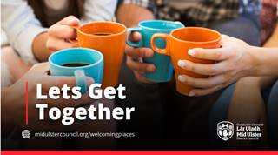

Develop more Chatty places – Warm, friendly chat areas, promoting libraries providing services for older people such as reading newspapers aloud, a cup of tea etc.



Increase Age Friendly Promotion, i.e: social media/ newsletter to highlight current activities, organisations, and good news stories.

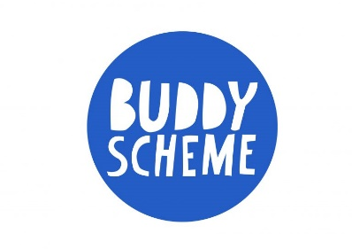

Encourage the development of buddy schemes to support involvement in local activities and community groups.

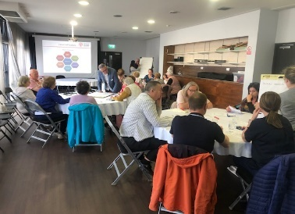

Promote training for staff who work in the community, the voluntary and educational sectors.



Ensure better access to affordable services and activities that are age appropriate with convenient times and locations.

**Theme 5: Respect and Social Inclusion Action Plan**

We plan to increase opportunities to support and promote active ageing, removing barriers to older people to ensure they are more respected, valued and included.

**Suggested Actions**

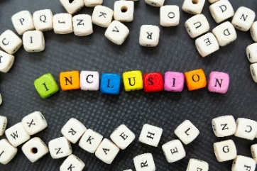

Develop an Age Friendly Older People’s Forum to consult on policies and inclusion.

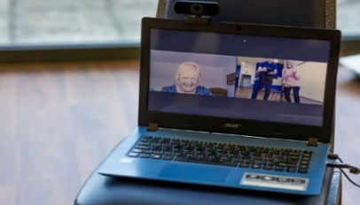

Connect and support people to participate in digital training and digital inclusion programmes.



Promote a positive image of people ageing well, appreciating diversity, and having recognition awards/ events to inspire others.

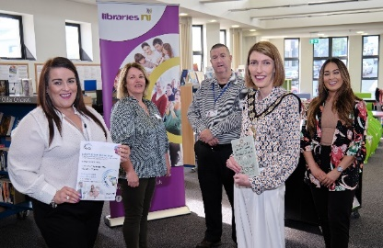

Promote Positive Ageing Month each October with District-wide engagement opportunities online and face-to-face with positive ageing grants.

**Theme 6: Civic participation Action Plan**

We plan to increase employment support, financial well-being and volunteering opportunities, ensuring older people have vital roles in their communities.

**Suggested Actions**

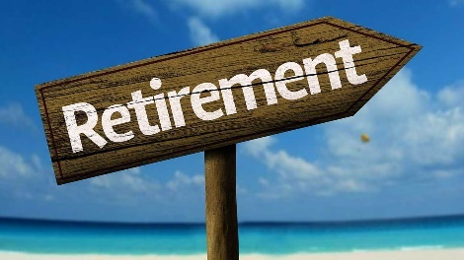

Support people to plan for a better later, i.e. Produce Retirement packs for 50+, and promote volunteering opportunities.

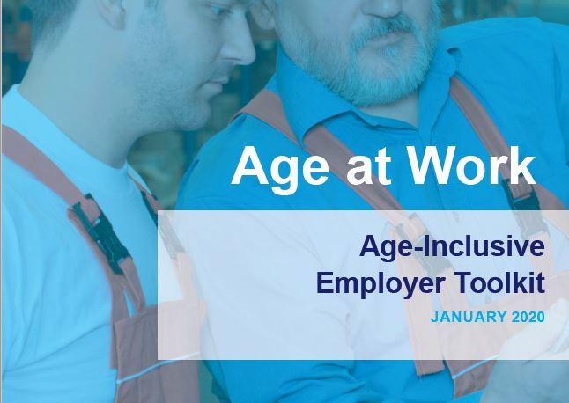

Encourage businesses to prioritise Age Friendly planning and retain an older workforce, i.e. Age NI Age @ Work Mid-Career reviews, age friendly training and policies to support roles.

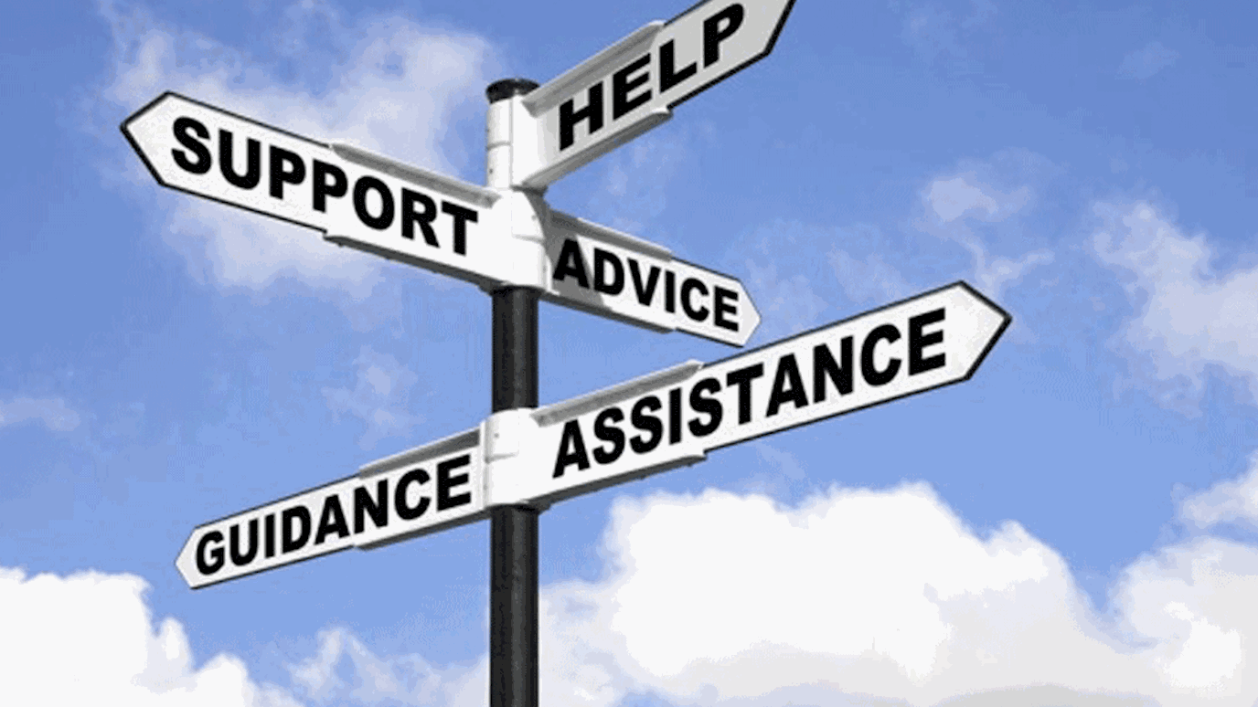

Promote cost-of-living, benefit uptake and financial well-being workshops i.e. Make the Call pop-up clinics.

**Theme 7: Communication and Information Action Plan**

We plan to have an effective communication system to ensure older people have the information, advice and support they need to claim their rights and entitlements and access services.

**Suggested Actions**

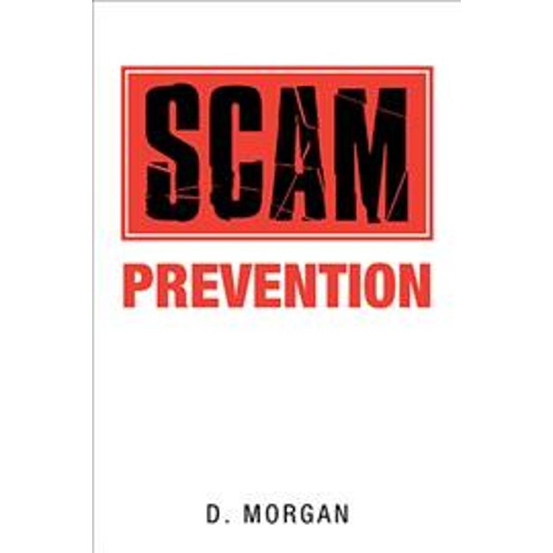

Provide online sessions such as Pension advice, and TV Licensing Scam Awareness talks.



Develop an Age Friendly newsletter with essential contacts, linking to Mid Ulster District Council website.



Develop one-stop shops for people to access information i.e. Rural areas information roadshows.



Connect and support people to access information, including digital training, digital inclusion programmes and promoting digital champions.



Encourage organisations to produce Age Friendly documents, including funding applications.

**Theme 8: Community Support & Health**

We plan to help people stay well and feel good for longer by connecting and ensuring good access to community and healthcare services to live independent and healthy lives.

**Suggested Actions**

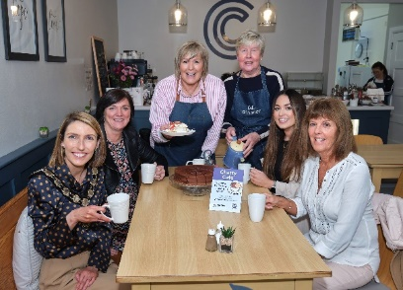

Build and maintain relationships with all service providers to share support and increase referrals, i.e., meals on wheels, luncheon clubs and food banks.

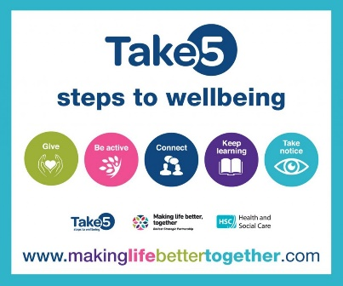

Identify and promote good mental health and well-being programmes and support. Mental Health Community Ambassadors, Take 5 Programme, Safer U App, Scam Wise and Action Mental Health workshops.

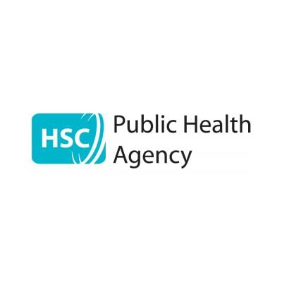Share information on health issues, relevant services, development opportunities regarding nutrition, diabetes, sleep routines and public health messages.



Raise awareness and promoting Better Connected Fitness sessions and walking groups online and at leisure centres.

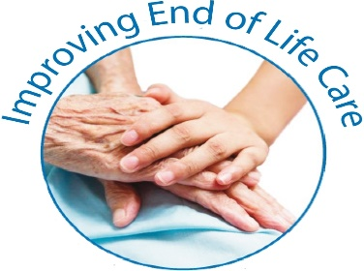

Support and raise awareness around End-of-Life Care.

**IMPlementation Structure**

By working together with all stakeholders and interested parties, we can all do our part to ensure that the Mid Ulster District is a great place to grow older.

* *Purple – already in place*

*Green – needs developed over the next 3 years*

**Mid Ulster District Council Community Plan 2017-2027**

**Age Friendly Co-ordinator**

**Health & Wellbeing Group**

**AGE FRIENDLY ALLIANCE (Steering Group)**

**Age Friendly Older Persons Forum**

**Cross departmental internal task groups & leads for Age Friendly action plan**

**Mid Age Well Partnership**