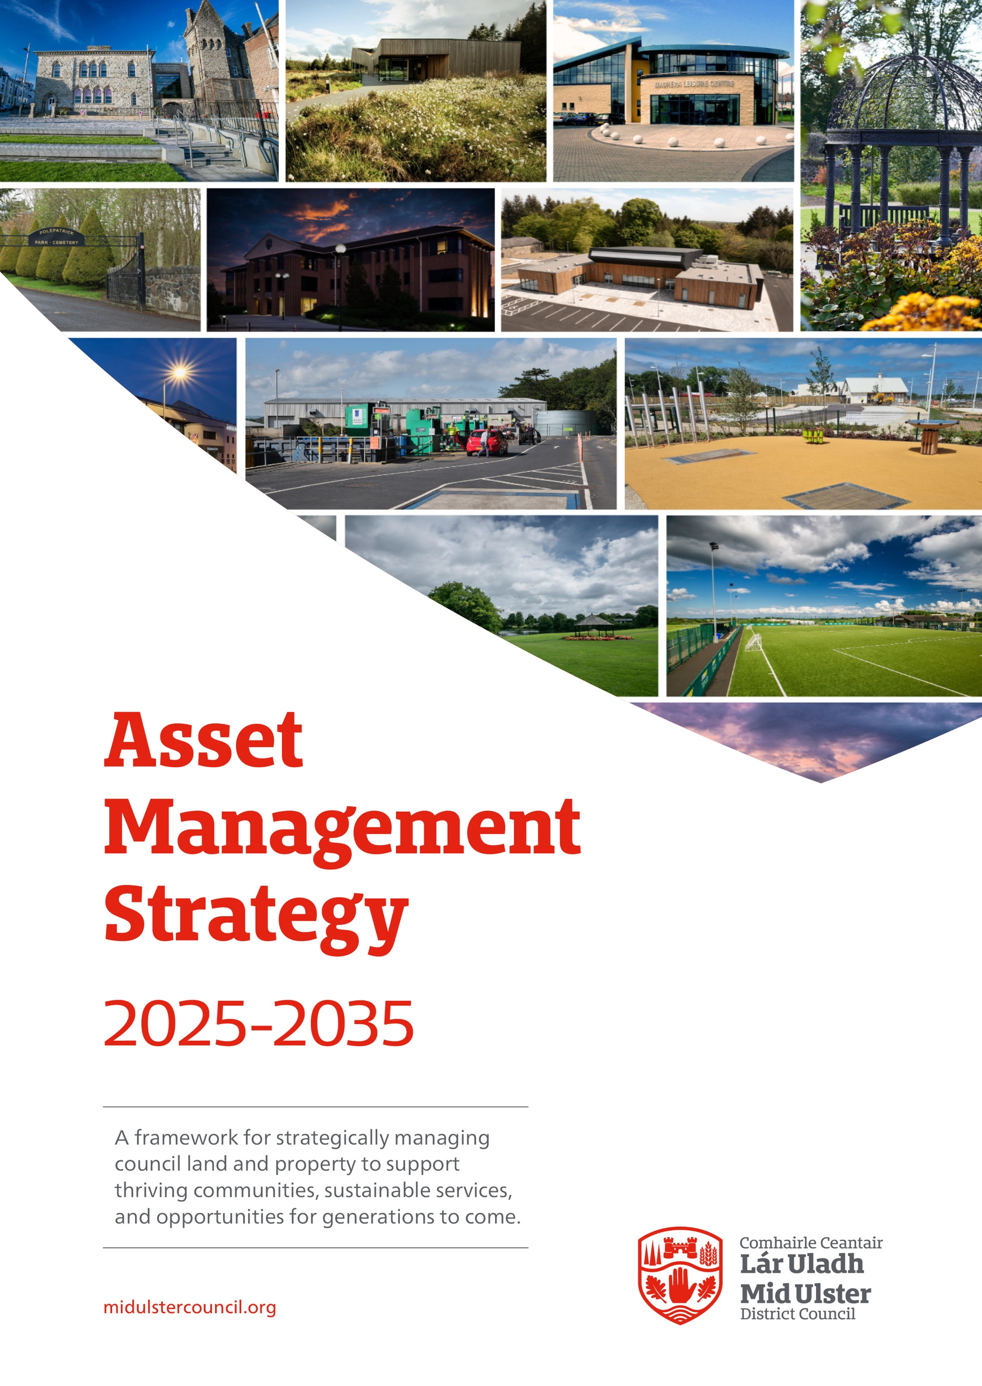

Contents
Page

Foreword 3
Executive Summary 4

1 Strategic Context 5
1.1 Introduction 5-6
1.2 Strategic Asset Management 7-10
1.3 Our Money 11

- Governance To Support Delivery 12
2.1 Asset Management Strategy 12
2.2 Asset Management Policies 12
2.3 Asset Management Lead 13-14
2.4 Multi-Disciplinary Approach to Asset Management 15
2.5 Challenging Our Assets 16
2.6 Measuring our Performance 16-17
2.7 Maintaining our Assets 17
2.8 Working with Partners 18

3 Developing Asset Management Capability 19
3.1 Develop an Asset Register 19
3.2 Benchmarking of Assets 19
3.3 Develop Risk Management Capability 19-20

4 Conclusion 20

5 Appendices 21-25
5.1 Appendix 1 - Nine Components of good Asset Management
5.2 Appendix 2 - Land and Property Governance Arrangements
5.3 Appendix 3 - Asset Management Policies
5.4 Appendix 4 - The development of an Asset Management Plan (AMP)

FOREWORD

As Chair of the Council, I am pleased to introduce our Asset Management Strategy, a key document that sets out how we will manage, maintain, and make the most effective use of our land and property assets.
Our assets, ranging from community facilities and parks to operational buildings and investment properties, play a vital role in supporting the delivery of quality public services and in enabling the social, economic and environmental wellbeing of our district. How we plan for, invest in and utilise these assets will shape not only the way services are delivered today, but also the opportunities available to future generations.
This strategy provides a clear framework for making informed, transparent decisions about our assets ensuring they are sustainable, efficient and aligned with our Community Plan and Corporate Plan priorities. It reflects our commitment to prudent financial management, environmental responsibility and long-term value for our residents.
Through effective asset management, we will continue to support service delivery, enable regeneration and foster collaboration with our partners for the benefit of the entire district.

Councillor Frances Burton, Chair, Mid Ulster District Council
Executive Summary

This strategy sets out the methodology as to how Mid Ulster District Council will actively review, manage and transact land and property going forward. This will make sure the assets held reflect public service demand and broader strategic and community need.

This strategy is written having regard to current statutory and corporate priorities and requirements in order to ensure that all property dealings meet best practice, as described by the RICS, CIPFA and NIAO/SIB. It is intended to facilitate rational decision-making based on identified corporate priorities and to act as a practical tool to assist Council:

- In making its investment decisions
- In maintaining and improving its assets
- In increasing the cost effectiveness and value of its portfolio
- In promoting transformation and development in asset management
- In listening and responding to customers and property users
- In promoting Environmental Sustainability in how we manage and use our assets.
The strategy sets out the approach to the preparation of a detailed Asset Management Plan(s) that, with the help of service partners, will define the Estate in terms of emerging service priorities going forwards.

Outcomes are therefore:

- A system of governance that is understood by all and improves the current decision-making processes.
- Development of policies around land and property assets.
- Ensure that there are clearly defined responsibilities and mechanisms for all property matters.
- Ensure resources are focused on retaining, investing in and maintaining only those land and property assets that directly support the delivery of public services or broader civic outcomes.

1.0 Strategic Context

1.1 Introduction

The primary responsibility of Mid Ulster District Council is to serve the public interest. The Council is committed to the growth and development of the district for the betterment and benefit of all its citizens. This is particularly evident through the provision of public services and the provision and management of public sector land and property assets.

Through the development of an Asset Management Strategy, Mid Ulster District Council will ensure that resources are focused on retaining, investing in and maintaining only those land and property assets that contribute directly to supporting the delivery of its public services and wider civic outcomes. As a result, this will require that Council actively manages its land and property assets to ensure that the assets held reflect public service demand and broader strategic and community need.

This approach to Asset Management ensures that Council resources are focused specifically on what matters most, for example the Mid Ulster District Community Plan objectives and the associated outputs relating to the economy of our towns, villages and small settlements, the health and wellbeing of our citizens and the care of the environment.

It is important to note that given current and future levels of austerity facing local authorities, coupled with the transformation of how Council’s will be expected to deliver services moving forward, our land and property assets represent a significant resource at the disposal of the Council that can assist in supporting cost effective Council service delivery and assist in creating and delivering more social and economic value moving forward.

Council recognises that the effective and efficient use of its extensive property estate is fundamental to delivering exemplary public services and that an effective strategy including detailed asset management planning is key to achieving this in order to preserve its financial and social value for future generations.

Fundamental to this principle is the Council’s desire for prudent resource management to ensure long term financial stability, sustainability and value for money. As part of this the Council has taken the decision to develop an Asset Management Strategy which takes a strategic approach to corporate resource planning.

The Council is committed to:

- Focusing on excellence and ensuring that all property assets are configured through a structured framework to provide a long-term plan for developing and maintaining the estate effectively to facilitate its overarching strategies and business requirements to meet current and future organisational needs,

- Seeking to use its assets, acquire new assets or release assets as appropriate, in order to achieve the strategic objectives, set out in key strategies (the Community Plan and Corporate Plan) supported by the relevant Council Strategies underpinning these objectives,

- Work with the public and third sector partners to achieve opportunities to deliver ‘joined up’ services from shared property assets.

This document describes the Council’s strategic approach to realising the ambitions for its land and property assets, complimenting and aligning with the Mid Ulster District Council’s Community Plan 2017-2030 and the Council’s Corporate Plan 2024-2028. In addition to the aforementioned strategic documents, the following key strategies are referenced:

- Draft Local Development Plan 2030
- Mid-South West Regional Economic Strategy
- Digital Transformation Strategy
- Economic Development Plan 2015-2020
- Tourism Development Strategy to 2017- 2021
- Off Street Car Park Strategy & Action Plan 2018
- Parks and Play Strategy 2020-25
- Outdoor Recreation Strategy 2020-25
- Pitches Condition Survey and Strategy 2023-28
- Arts and Culture Strategy 2017-22
- Capital Programme
- Medium Term Financial Plan
The approach promoted within this strategy is one of partnership, whereby the Council is challenged, not only to use its own assets to the maximum benefit of the community, but to act as facilitator in encouraging others, both within the public sector and private sector, to use their assets collaboratively, to the benefit of the community being served.

The document will be subject to periodic review and updating.

1.2 Strategic Asset Management

Strategic Asset Management provides an over-arching strategy to rationalise the Council’s estate, identify redevelopment opportunities, identify surpluses, coordinate, plan and devise the optimal re-use or disposals in respect of land and property in a comprehensive manner.

The Asset Management Strategy ensures that focus is maintained on our main priorities for managing, maintaining and developing our assets over the next ten years. The strategy informs policies enabling us to develop action plans, agree priorities and make decisions to meet our longer-term objectives.

This strategy will become a cornerstone of our financial and service planning and will support delivery of the Medium-Term Financial Plan whilst ensuring compliance with our Capital Programme. The Strategy will be reviewed and updated periodically to ensure our land and property assets fully support the Council’s Corporate Plan, by contributing to our key objectives for property asset management in accordance with our emerging Asset Management Policies. This will be achieved through the following:

- Embed a culture of innovation that maximises best use of appropriate technologies that support new ways of working and protects the environment; utilising available finance to support implementation and meet the objectives of Climate Change.

- Drive efficiency through the management of our land and property assets, ensuring they provide the right space, in the right place and on the best terms. This also includes income generation and overall social value from the property portfolio.

- Manage our property portfolio effectively using best practice, adopting clear policies and action plans to meet our strategic goals; developing clear reporting processes to involve and inform decision-making.

- Deliver our services in a customer-focused way, working with those who share our values and behaviours.

- Maximise regeneration and growth through effective procurement and linking public sector requirements with regeneration opportunities.

- Keep our properties safe, dry and secure through the implementation of a well-managed, rigorous compliance regime; repairs and renewals programme with clear maintenance planning and efficient facilities management.

Strategic Asset Management will be based on two key aspects, namely:

- Strategic Drivers: These are sourced from the Council’s Corporate Plan and The Mid Ulster Community Plan and typically define what is important to council at a strategic level, incorporating the themes of Service Delivery; Leadership for Partnership and Local Growth; Being the Best Council Possible. The Strategic Drivers will also take account of regional priorities, including; equality; sustainability; rural proofing in the delivery of our services, focusing on key themes of: Economic Growth, Infrastructure, Education and Skills, Health and Wellbeing and vibrant and Safe Communities.

- Delivery Themes: these typically consider the way in which Strategic Asset management will be expressed or realised in practice and should, for example, address matters such as: investment; divestment; performance; improvement; partnering; and maintaining services as illustrated below:

Fig 1.2 Strategic Asset Management Drivers

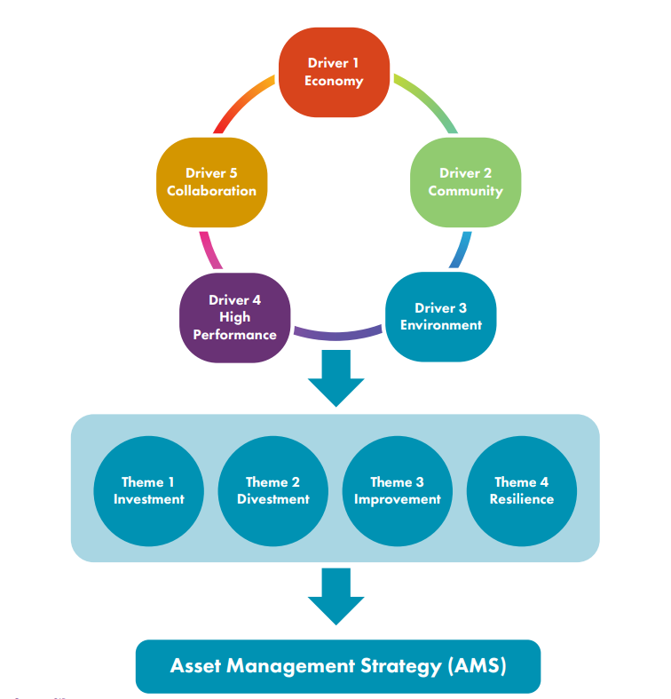

Source: Northern Ireland Audit Office and Strategic Investment Board (2021), A Strategic Approach to the Use of Public Sector Assets Good Practice Guide for Local Government in Northern Ireland.

Mid Ulster District Council’s approach to asset management focuses upon nine core components as described in the Local Government Auditor’s Report 2019 and NIAO Good Practice Guide for Local Government in NI (see appendix 1). These are required for the creation of modern and responsive asset management practices as we enter a new era of public service delivery, namely:

- The creation of an Asset Management Strategy (AMS)
The Asset Management Strategy (AMS) sets the direction for change and improvement within Council and describes the way Council- owned and leased land and property assets will be utilised to support service delivery and wider Mid Ulster District Council civic outcomes. The AMS essentially acts as a bridge between Council’s land and property assets and the Council’s Corporate Plan and corporate objectives and ensures that Council’s land and property assets are worked and configured to support the delivery of the long-term corporate objectives of Mid Ulster District Council.

- The creation of an Asset Management Plan (AMP)
The Asset Management Plan (AMP) is a multi-year plan that describes how the Asset Management Strategy will be implemented across all assets. The AMP will focus on delivery over a three - five-year period and act as the bridge between the Asset Management Strategy (AMS) and operational delivery and will clearly identify how and when change will be implemented.

Both the AMS and the AMP will be supported by appropriate governance processes to aid delivery and which will include:

- The development of Asset Management Policies
Appropriate operating policies and associated standards and guidance will be developed specifically relating to land and property matters. The agreed Asset Management Policies will be made available to all staff and will be periodically reviewed and updated to ensure appropriateness, relevance and compliance with statute.

- The identification of an Asset Management Champion
The Asset Management Champion will be a senior Officer identified as having responsibility for managing and optimising the value derived from land and property assets. The value derived from land and property assets is both financial and non-financial. The Asset Management Champion will have responsibility for effecting change and improvements within the asset base, in addition to managing the performance of the asset portfolio.

- Adoption of a Multi-Disciplinary Approach
Mid Ulster District Council’s Asset Management will draw upon Legal, Financial, GIS, Audit and Risk, Capital Projects, Property Service and facility Management expertise. The Asset Management Strategy and Asset Management Plan will align with the Mid Ulster Corporate Plan and Mid Ulster Community Plan.

- The establishment of an Internal Challenge Function within Council

All Council asset holdings will be regularly challenged at a Senior Executive Team level and through the established Council Audit & Risk Committee, to ensure they are correctly configured and support the delivery of public services and civic outcomes.

All of the above will be delivered through the establishment of:

- A comprehensive and detailed Mid Ulster District Council Asset Register
Given the importance of Council being accountable for all its lands and property assets, the Asset Register will be actively maintained, and have improved capability to inform information requests from the public, describing all land and property assets owned, leased and occupied by Mid Ulster District Council.

- The creation of Benchmarking and Performance Management Functions
Appropriate measures and metrics will be developed to assist in the assessment of the Council Estate in terms of use and sustainability. Aspirations through effective benchmarking include:

- Reduced energy consumption and increased efficiency
- Reduction in average annual maintenance spend
- Effective utilisation
- Reduction in carbon footprint etc.

This benchmarking will be undertaken in-house and supported by external experts when required.

- The development of an Asset Risk Management processes
Asset risks will be identified and managed/mitigated in line with the implementation of the Council’s Asset Management Plan (AMP). As budget pressures increase and asset portfolios age, combined with the need to do more with less, the financial, functional and legal risks inevitably increase. Therefore, the risk management processes will link to and inform the investment decision-making process. Investment in Council assets will be considered based on the risk to achieving corporate and civic objectives and not merely on the condition of the assets, immediate costs and long-term liabilities.

  - Our Money

This strategy supports delivery of the Medium-Term Financial Plan whilst ensuring compliance with Council’s Capital Programme and external funding opportunities (e.g. Levelling Up, Small settlements, Growth Deal, PEACE Programme, etc). It is designed to ensure we prioritise where and how we spend the money to maximise the benefit to our communities and meet the challenges of the next 10 years. It is important to note that our capital investment provides leadership and attracts further inward investment. This helps the local economy and community to grow and thrive so that every pound invested by the Council generates additional social value (economic, environmental, health and wellbeing) benefits. We actively support a circular economy and sustainability by working with local businesses and small to medium enterprises within the District.

2 Governance To Support Delivery

2.1 Asset Management Strategy

The key objectives of the AMS are to ensure that:

- The estate portfolio is an appropriate size from which to deliver Council services and is financially sustainable.

- Building assets are in the right place and are affordable to meet the needs of the Council and support service delivery in the most efficient way possible.

- The investment portfolio is well managed and provides adequate and appropriate return on capital employed.

- Where there is evident rationale, Council supplement the investment portfolio to increase net income in support of Council’s revenue streams.

- That building assets are fit for purpose, well maintained and the cost of occupation and the environmental footprint is minimised.

- To work with partners to maximise the efficient occupation of the Public Sector Estate.

2.2 Asset Management Policies

Significant resources are invested in evaluating detailed and complex matters relating to land and property assets within Council. Decisions relating to land and property matters are complex, costly and come with significant financial and reputational risk.

Therefore, the Council will develop and maintain Asset Management Policies, covering asset management considerations. Asset Management Policies will aim to: reduce risk; aid delivery; bolster governance; improve efficiency and ensure that decisions relating to land and property assets are transparent and consistent.

The Asset Management Policies will consider matters such as:

- Acquisition of Land and Property.
- Disposal of Land and Property.
- Rental of Council Land and Property.
- Valuation Services.
- Asset performance.
- Sustainability.
- Risk management; etc.

The Policies will aim to ensure that:

- There is a mechanism in place to assess the rationale for retention by the Council of the asset that forms part of the Council’s estate portfolio. The Council will only retain an asset that is used to deliver services or for which there is a clearly defined reason to retain the asset, e.g. the investment estate or lands held for development opportunities. In this case there will be a statement recorded on the asset register that will be reviewed periodically in conjunction with holding departments to ensure assets are still held for their recorded purpose or to identify any proposed change of use.

- Unless a demonstrable reason for retention is provided, steps will be taken to declare the property surplus to requirements and will therefore be made available for disposal as a surplus asset in line with Council policy and disposal of public sector assets.

This will allow the Council (senior officers and members) to operate with confidence to support active asset management.

The Asset Management Policies will be implemented on a cross-departmental basis, to ensure that decisions are integrated into wider corporate decision-making and corporate resource planning. Similarly, a multi-disciplinary approach will be adopted, drawing together legal, financial and technical considerations. The Asset Management Policies will be reviewed and updated on a regular basis, to ensure compliance with good practice and relevant legislation.

The Asset Management Policies will detail the role of the Asset Management Champion. Asset management practices work most efficiently if managed through a well-co-ordinated internal governance structure. Therefore, a single senior officer will have overall responsibility for the performance of the asset base and associated outcomes. Collaboration between the Asset Management lead and the wider Council Directorates is identified in Figure 2.4.

2.3 Asset Management Lead

The Asset Management Lead (Asset Management Champion) will provide leadership in relation to asset management practices. This individual will be thought of as the in-house ‘corporate landlord’ who has overall responsibility and authority (subject to appropriate oversight from elected Members etc.) for ensuring the correct assets are retained and are organised and maintained to support corporate and civic priorities.

The Strategic Director of Environment has been identified to fulfil this function and to have responsibility for managing and optimising the value derived from the Council’s land and property assets, and achieving the outcomes and actions as stipulated in the Asset Management Strategy and Asset Management Policies. The Asset Management Champion will also assist in the management and balance between investment in new assets versus investment in existing assets, which is increasingly important as we face the implications of the net-zero carbon agenda and ageing asset portfolios which carry significant inherent liabilities. These considerations are outlined in Figure 2.3.

Figure 2.3 The Investment Hierarchy

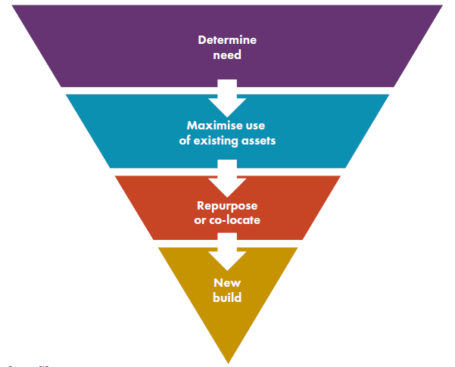

Source: Northern Ireland Audit Office and Strategic Investment Board (2021), A Strategic Approach to the Use of Public Sector Assets Good Practice Guide for Local Government in Northern Ireland.

2.4 Multi-Disciplinary Approach to Asset Management

All disciplines within the Council that deal with asset management activities in their daily roles will be co-ordinated, consistent, and aligned with the Councils objectives. This multi-disciplinary approach to asset management, through SET will deliver a collaborative approach to Council estate planning and management.

Figure 2.4 Collaboration with the Asset Management Champion
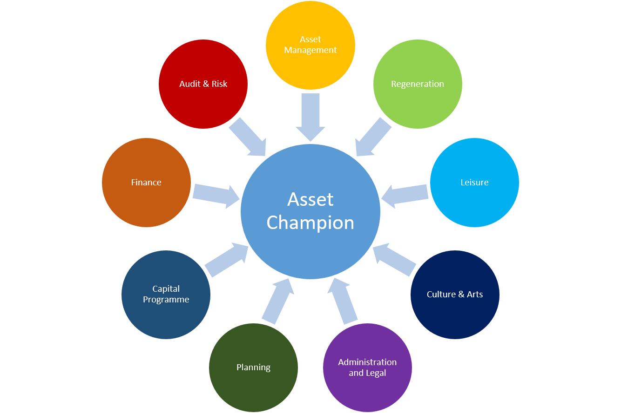

Source: Northern Ireland Audit Office and Strategic Investment Board (2021), A Strategic Approach to the Use of Public Sector Assets Good Practice Guide for Local Government in Northern Ireland.

2.5 Challenging Our Assets

A key role for the Assessment Management Policies and the Asset Management ‘Challenge Function’ is to consider two main aspects.

- To periodically challenge the approach taken by the Council towards each individual land and property asset, asking the following questions:
  - Why do we have this asset?
  - Is it good value for money?
  - Are others better placed to provide this asset?
  - When will we need to replace this asset?
  - Will the replacement be different?
  - How will we fund the repair or replacement?
  - Is this asset financially efficient?
  - Does this asset create long terms financial liabilities?
  - Is this asset a legal, financial, environmental or operational risk?
  - Is this asset carbon efficient?
  - Could the asset be used differently to support a social or economic need?

- The second is the use of existing internal audit functions to challenge the use of land and property assets. This will provide assurance that assets are being held and maintained to an appropriate standard.

2.6 Measuring our Performance

To manage our assets effectively and efficiently we will monitor how they are performing. These performance measures covering utilisation, energy efficiency and performance, cost and income will be considered at facility level as part of the Asset Management Policies monitoring and feeding into the Asset Challenge process.

Mid Ulster District Council own a substantial and varied land and property portfolio predominantly located within the district. It includes commercial property, leisure facilities, depots, car parks, public conveniences and assets leased to community organisations.

The table below summaries existing land and property assets.

Category of Asset | No of Sites*
Civic Offices, Visitor Centres & Community Buildings | 29
Recycling Centre, Amenity Sites, Depots & Landfill | 26
Leisure Centres/Sports & Recreation Buildings | 34
Play Areas, Parks & Open Green Spaces | 141
Forests, Walks & Trails | 50
Picnic Areas/Laybys | 27
Caravan Parks | 3
Playing Fields, Pitches (Grass/3G/Astro Turf/Shale), Golf Courses & Bowling Greens | 37
Off Street Car Parks | 20
Water Recreation Sites (Inc. Marinas/Loughs/Waterways) | 20
Historic/Old Burials Grounds& Cemeteries | 44
Public Toilets | 20
Development Lands | 31
 | 482

*Under review and subject to change

To date a multidisciplinary approach to asset baselining has been undertaken involving Property, GIS, Legal, Finance, Internal Services, etc. It has identified over 480 assets. The majority of assets are owned some are leased, and the remainder are licensed or have other legal status.

As the way we deliver services changes, our assets need to adapt to support the Council as it moves forward. We will continue to invest in our assets to ensure we provide services fit for the future and to maximise benefit to the people and businesses within the district.

In support of maximising value for money, in relation to the maintenance and day-to-day running of our buildings, contributory processes are embedded within the Asset Management Strategy. These processes ensure that capital works are prioritised appropriately through a more structured approach to planned maintenance, based on evidence from building condition surveys, and in alignment with operational priorities of those services in occupation. Additionally, the Asset Challenge process ensures that the future of those buildings not providing best value are reviewed appropriately before financial decisions are made on them.

2.7 Maintaining our Assets

Our five key aims for Building Maintenance management approach are:

1. To ensure our buildings are safe and secure for the people who use them;
2. To allocate funding to projects that will achieve the maximum positive impact;
3. To achieve an efficient balance between planned and reactive maintenance work;
4. Achieving maximum efficiencies in the way we procure building maintenance work and
5. Consider the Environmental sustainability of our asset base.

We will identify our priorities by conducting a rolling programme of condition surveys which will aim to understand maintenance requirements over a period of ten years, with aspirations to complete lifecycle condition surveys on selected assets to cover a period of 25 years. We will develop a planned Maintenance Programme which will enable a better-informed decision-making approach, maximising efficiencies by planning over a longer term, rather than reacting to emergencies as they happen.

2.8 Working with Partners

We will work closely with other public sector organisations across the District to explore opportunities to reduce premises costs and ensure assets work better for our communities and customers.

We will continue to explore opportunities for partnership working with both public and private sector bodies and agencies to ensure successful delivery of the Asset Management Strategy.

3 Developing Asset Management Capability

This section of the Assessment Management Strategy outlines the actions the Council will take to deliver asset management capability for the efficient and effective management of the Council Asset portfolio.

3.1 Develop an Asset Register

The Council will develop an Integrated Asset Management Solution and this will assist with the following:
- Key facts and figures instantly available to help service internal and external information requests;
- Accurate datasets to support area planning and community development planning;
- Improved risk management and assurance activities;
- Improved transparency and public accountability;
- A new tool to support public sector, private sector and third sector collaboration;
- A database to support the delivery of broader digital enablement and co-ordinated management of assets;
- A platform for managing and analysing all future land and property data (or attributes)
- The ability to have the asset register readily available and have improved capability to
inform information requests from the public.

3.2 Benchmarking of Assets

Benchmarking is key to good asset management, as it provides organisations with clear evidence on how their assets are performing against best practice and other organisations.

Appropriate measures and metrics will be developed to assist in the assessment of the Council Estate, and to identify what actions might be appropriate to optimise the portfolio. Aspirations through effective benchmarking include:

- Reduced energy consumption and increased efficiency
- Reduction in average annual maintenance spend
- Effective utilisation
- Reduction in carbon footprint etc.

This benchmarking will be undertaken in-house and supported by external experts when required and as funding allows.

3.3 Develop Risk Management Capability

Land and property assets come with a multitude of financial, legal and operational risks. Managing and monitoring such risks are vital, as failure to do so in a timely manner can lead to compounded problems over time, which could lead to mounting costs.

The risk management process has an important role to play in informing the investment decision-making process. Investment should be targeted based on the risk to achieving the Councils objectives and not merely on the condition of the assets.

The most basic and important step towards managing asset risks is the development of asset management capability that we can start to implement the processes, systems, tools and techniques associated with managing land and property assets. This will be achieved through simple actions, such as, periodic condition surveys to help manage and minimise operational and health and safety risks. Through a rolling programme of surveys, Council will aspire to evaluate assets at least once every five years to ensure that they remain fit for purpose, subject to funding for third party expertise.

Conclusion

Mid Ulster District Council holds a substantial portfolio of land and property. As a result of ever-increasing resource pressures, it is even more vital that we prioritise the effective utilisation of our valuable assets.

This strategy aims to promote collaboration and consistency in asset planning across the Council and has recommended means to develop and improve the effectiveness and efficiency of asset management. This strategy has been written having due regard to current statutory and corporate priorities and is based on the nine core components of good asset management, as outlined in the NIAO A Strategic Approach to the Use of Public Sector Assets: Good Practice Guide for Local Government in Northern Ireland.

This strategy will enable Mid Ulster District Council to actively manage its land and property portfolio to ensure the assets held reflect community need and the strategic objectives of Council.

The Council will be:

- Focusing on excellence and ensuring that all property assets are configured through a structured framework to provide a long-term plan for developing and maintaining the estate effectively to facilitate its overarching strategies and business requirements to meet current and future organisational needs,

- Seeking to use its assets, acquire new assets or release assets as appropriate, in order to achieve the strategic objectives, set out in key strategies (the Community Plan and Corporate Plan) supported by the relevant Council Strategies underpinning these objectives,

- Work with the public and third sector partners to achieve opportunities to deliver ‘joined up’ services from shared property assets.

5.1 Appendix 1
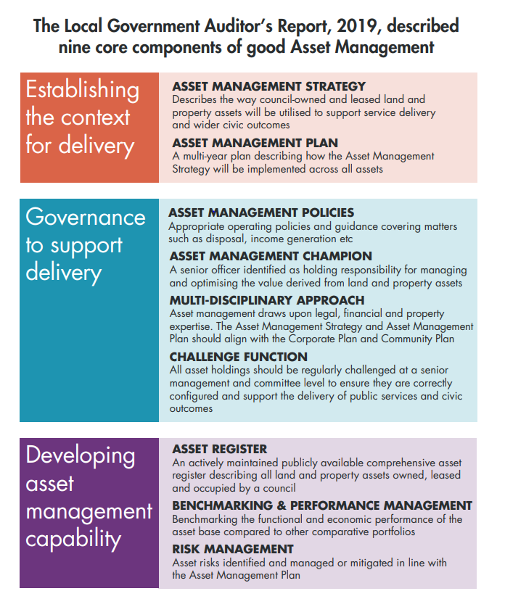

Source: Northern Ireland Audit Office and Strategic Investment Board (2021), A Strategic Approach to the Use of Public Sector Assets Good Practice Guide for Local Government in Northern Ireland.

5.2 Appendix 2:

Land and Property Governance Arrangements

Council’s Asset Management Strategy describes the Council’s strategic approach to the management of its land and property resources.

The Chief Executive or their authorised Officer has overall responsibility for making recommendation to Council on Land and Property matters.

The Strategic Director of Environment and Assistant Director of Property Services has responsibility for maintaining records for buildings and land and their acquisition, disposal or managed status.

Acquisition, disposal and management of property should be in keeping with the Council’s Property Asset Management Strategy, and also in keeping with legislation pertaining to the Acquisition and Disposal of public Land/Property.

Audit trails of all acquisitions and disposals will need to be maintained and accessible by internal/external audit to verify actions/values and giving detail as to how Council made the decision to acquire, dispose or manage its asset base.

No agreements, arrangements or otherwise in respect of land and property, whether
acquisition or disposal, sale or lease, permanent or temporary, should be entered
into without prior consideration having been given by SET; and following consideration of all issues by the SD of Environment. This will enable due diligence to be applied in the first instance, and prior to engaging legal services as part of the management approach of the Council Estate.

5.3 Appendix 3:

Asset Management Policies

The Council will develop and maintain Asset Management Policies and Procedures, covering asset management considerations. The Policies will aim to: reduce risk; aid delivery; bolster governance; improve efficiency and ensure that decisions relating to land and property assets are transparent and consistent. This will be supported by procedural development in relation to Strategic Asset Development.

A key role for the Policies and Procedures will be to:

- Periodically challenge the approach taken by the Council towards each individual land and property asset.

- Provide assurance that assets are being held and maintained to an appropriate standard.

Policies and procedures will provide a means through which Council will be able to effectively manage its land and property assets. They will ensure we manage our property portfolio effectively using best practice, adopting clear procedures to meet our strategic goals; developing clear reporting processes to involve and inform decision-making.

The policies will provide a consistent approach across Council Departments for the following:
- Acquisition of Land and Property.
- Disposal of Land and Property.
- Rental of Council Land and Property.
- Valuation Services.
- Asset performance.
- Sustainability.
- Risk management; etc.

To support the strategic approach to land and property matters the following will be developed:

- An Acquisition and Disposal Policy to include the purchase and sale process, the valuation process, and due diligence. Procedures will also be developed to outline the criteria for the identification for surplus and underutilised property, etc.
- Strategic Asset Management Procedures.

5.4 Appendix 4:

The development of an Asset Management Plan (AMP)

The development of an Asset Management Plan (AMP) is a logical follow-on from the creation of an Asset Management Strategy (AMS). It is a multiyear plan which describes how the Asset Management Strategy will be implemented across all assets. It translates the AMS into practical activities considering:

Source: Northern Ireland Audit Office and Strategic Investment Board (2021), A Strategic Approach to the Use of Public Sector Assets Good Practice Guide for Local Government in Northern Ireland.

The plan should as a minimum describe activities, such as: investment; divestment; funding; partnering arrangements; income generation; capital programmes; and community engagement. The AMP will have a strong emphasis on how the desired outcomes will be achieved.

The AMP will typically cover a three-to-five-year period. The emphasis will be on the actions and activities planned to move the asset base towards an optimum size, composition, risk profile, and configuration etc. It can also be thought of as a change plan, focusing on delivery, and is frequently articulated as:


Source: Northern Ireland Audit Office and Strategic Investment Board (2021), A Strategic Approach to the Use of Public Sector Assets Good Practice Guide for Local Government in Northern Ireland.
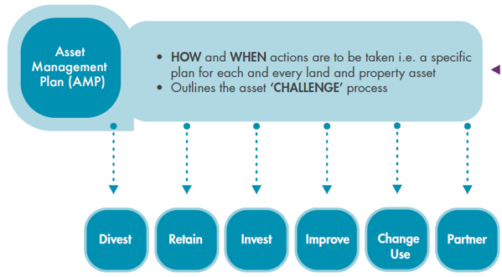

Source: Northern Ireland Audit Office and Strategic Investment Board (2021), A Strategic Approach to the Use of Public Sector Assets Good Practice Guide for Local Government in Northern Ireland.

