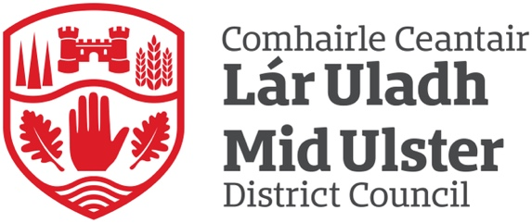

Mid Ulster District Council
Complaints Handling Data
1st April 2025 – 30th September 2025

Complaints Handling Reports
In accordance with guidance issued by the Northern Ireland Public Services Ombudsman (NIPSO), the Council adopted new Complaints Handling Procedures (CHP) on 1 January 2024.
These procedures provide a governance framework for the capture of complaints across Mid Ulster District Council. The Council is required to publish complaints data on a 6-monthly and annual basis.
All complaints are progressed in accordance with the new procedures, ensuring that the handling of complaints will be in line with statutory requirements established by the Public Services Ombudsman Act (NI) 2016.

1 April 2025 to 30 September 2025
Mid Ulster District Council is committed to providing a high standard of customer service to all its citizens.

‘We value complaints and use them to help improve our services’

For the 6-month period 1 April 2025 to 30 September 2025 Mid Ulster District Council received 46 Stage 1 complaints, with 3 that escalated to Stage 2.
Most of the 46 Stage 1 complaints fell under the category of “Inadequate quality or standard of service” (24%), with the remaining complaints categorised as detailed below:
Complaint Categories: | Percentage at Stage 1:
Inadequate quality or standard of service | 24%
Unreasonable delay in providing a service | 18%
Failure to properly apply law, procedure or guidance when delivering services | 17%
Failure to follow the appropriate administrative process | 12%
Conduct, treatment by or attitude of a member of staff or contractor | 15%
Disagreement with a decision (except where there is a statutory procedure for challenging that decision, or an established appeals process) | 14%

Complaints received for the period 1 April 2025 – 30 September 2025 were investigated in line with statutory guidelines and closed based on the following outcomes:

Complaint Outcomes
Upheld | 41%
Partially Upheld | 13%
Not Upheld | 46%

Complaints are received through a number of ways. The following data from 1 April 2025 – 30 September 2025 provides a breakdown of the channels used by citizens to engage with the Council when logging a complaint.

Channels
Email | 56%
Online Form | 21%
Phone | 19%
Letter | 2%
In person | 2%

Lessons Learned
The Council will systematically review and analyse complaints to ensure that lessons have been learned, services improved, and appropriate action taken.
Detailed below are examples of service improvements as a result of the administration of the complaints handling procedures:
- Improvement communication – ensure clear and consistent communication between staff and the public regarding event information and bookings.
- Staff reminders – issue reminders for staff on operational practices, including casual staff who are covering shifts.
- Regular monitoring and compliance of public facilities – ensuring signage is displayed, changing rooms are monitored, volume control is complied with.

For further information on our Complaints Handling Procedures please visit: https://www.midulstercouncil.org/complaints

