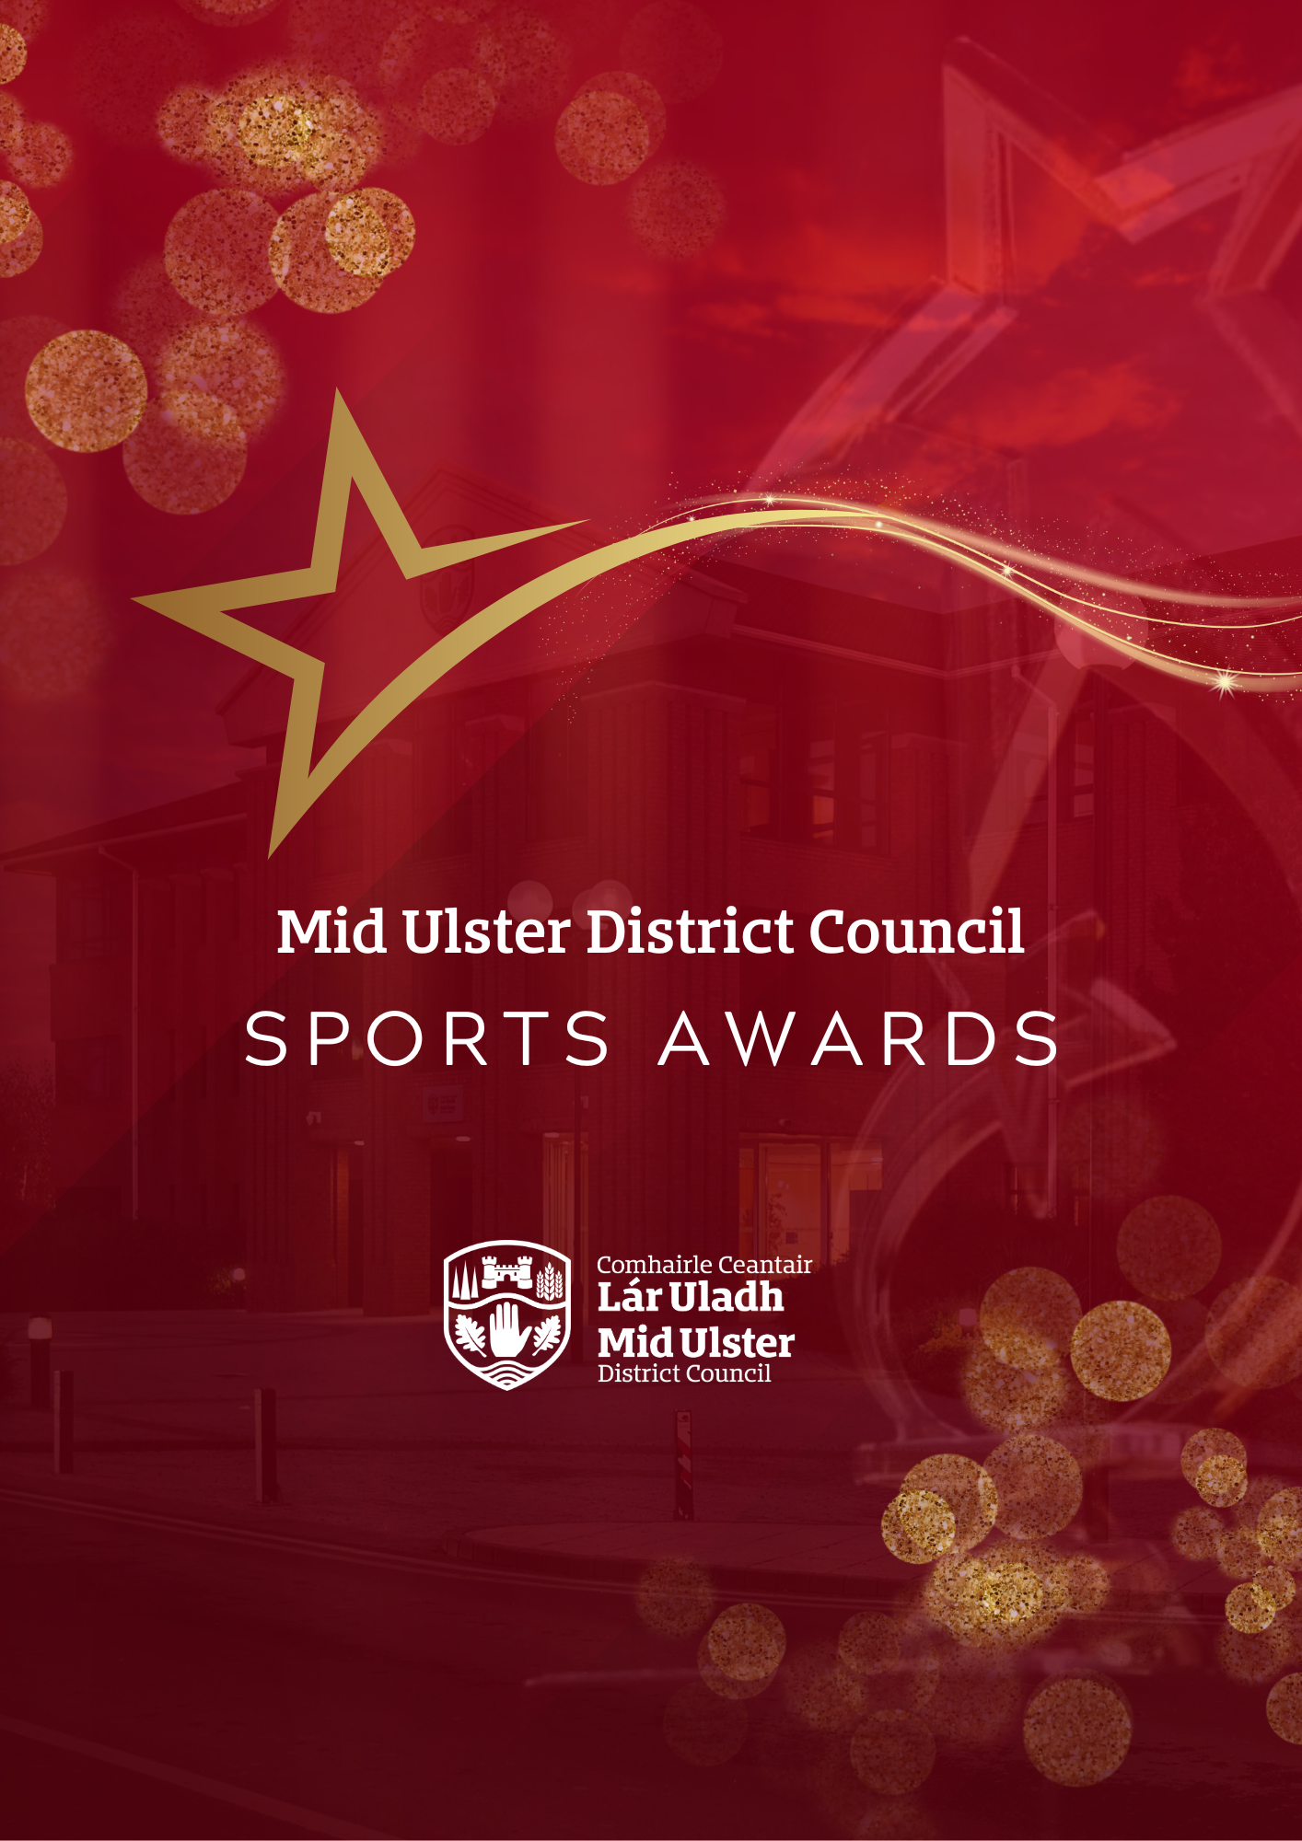****T

Guidance Notes

Mid Ulster District Council

Sports Awards 2025

Guidance Notes for

Mid Ulster Sports Awards 2025

|  |  |  |
| --- | --- | --- |
| **GUIDANCE FOR NOMINATORS**  **The Mid Ulster Sports Awards aims to recognise those people who have excelled in the world of sport and recognise the valuable contribution and time commitment of individuals and teams across the Mid Ulster District Council area.​**  Nominations are welcomed from sports clubs, physical activity groups, schools and members of the public across the nine award categories for teams and individuals, coaches, officials and volunteers.  It’s free and easy to nominate. Simply fill in and submit an online entry form right away.  **The shortlisted nominees for each category will be invited to attend the Mid Ulster District Council Sports Awards on Thursday 20 November 2025 in the Burnavon Arts Centre Cookstown where our overall winners will be announced.** |  | **NOMINATIONS**  **Nominations must be received by 17 October in order to be considered for the Mid Ulster Sports Awards 2025**.  All nominations received after that date will not be considered.  Please read the criteria carefully before making an application. If you feel that the team or individual meets with the criteria, then select the category that best applies to the organisation or individual you have in mind.  Please note the Judging panel may (at their discretion) change the category to the most appropriate one e.g. that best fits the nomination.  Judging will be a 2 stage process with Stage 1 Eligibility Assessment and Stage 2 Assessment Scoring.  Please ensure to complete your application as accurately as possible within the word limit provided.  **The decision of the judging panel is final and no correspondence will be entered into.** |

**NOMINATIONS**

1. Nominations are welcomed from sports clubs, physical activity groups, schools and members of the public across the nine award categories for teams and individuals, coaches, officials and volunteers.
2. All nominees must participate and/or reside within the Mid Ulster District Council area.
3. Nominations are confined to performance/achievements between

**1st January 2024 – 30th September 2025.**

1. The nominee must be involved in a sport whose governing body is recognised by Sport Northern Ireland, Sport Ireland, or UK Sport.
2. All teams/individuals can complete one nomination in each of the nine categories available.
3. Nominations will close at 12 noon on the 17th October 2025.
4. Mid Ulster District Council reserves the right to move nominees to other categories if they deem them to be more relevant or create new categories as required.
5. Nominations will be assessed by the MUDC Sports Awards Selection Committee which will consist of an independent representative from Sport Northern Ireland. Where necessary and appropriate the Committee will seek advice from other sources.
6. Detailed information should be provided about the nominees sporting performance and/or outstanding sporting achievements between

**1st January 2024 – 30th September 2025.** Please ensure to populate the nomination form with detailed information based on the published criteria specified in the category you have chosen as all nominations will be scored against each award category’s criteria.

1. Only information contained within the nomination form will be used for assessment.

**AWARD CATEGORIES**

|  |  |
| --- | --- |
| **CATEGORY** | **DESCRIPTION** |
| **Sports Person of the Year Award** | This award recognises a high achieving sports person (over 18). The Sports Person of the Year should have achieved at a high level, show strong leadership, set a good example, and uphold high behavioural and sporting standards. They should go above and beyond in support for, and participation in, their sport. Nomination forms should include details of all sporting achievements, including competitions and honours at club, county, regional, national, and international levels.  The form should include an indication of the nominee’s strong leadership, going above and beyond, level of commitment to their sport (training schedule, dedication), opportunities taken to develop and other contributions to roles such as mentor, coach, or club ambassador. |
| **Young Sports Person of the Year Award**  **(18 and under)** | This award recognises a high achieving sports person (18 and under). The Young Sports Person of the Year should have achieved at a high level, show strong leadership, set a good example and uphold high behavioural and sporting standards. They should go above and beyond in support for, and participation in, their sport. Nomination forms should include details of all sporting achievements, including competitions and honours at club, county, regional, national, and international levels.  The form should include an indication of the nominee’s strong leadership, going above and beyond, level of commitment to their sport (training schedule, dedication), opportunities taken to develop and other contributions to roles such as mentor, coach, or club ambassador. |
| **Sports Person of the Year Award (Disability)** | This award recognises sports people with a disability. Nomination forms should include details of all sporting achievements, including competitions and honours at club, county, regional, national, and international levels.  The form should include an indication of the nominee’s level of commitment to their sport (training schedule, dedication), challenges that have been overcome, opportunities taken to develop and other contributions to roles such as mentor, coach or club ambassador. |
| **Team of the Year Award** | This award recognises a successful sports team of the year in terms of performance and achievement. Nomination forms should specify the achievements of the team during the year, including any standout individual achievements, obstacles overcome and excellent co-operation in working towards a shared goal. Teams may have achieved excellence at club, county, regional, national, or international level. |
| **Youth Team of the Year Award (18 and under)** | This award recognises a successful youth sports team (18 and under) of the year in terms of performance and achievement. Nomination forms should specify the achievements of the team during the year, including any standout individual achievements, obstacles overcome and excellent co-operation in working towards a shared goal. Teams may have achieved excellence at club, county, regional, national, or international level. |
| **Club of the Year Award** | This award recognises success in all areas of a club.  The nomination form should highlight how the club has succeeded in performance and achievement, leadership, participation, sustainability and development and connection with the wider community. The Nomination Form should include details of a Club’s achievements in terms of teams and individuals, the range of demographics, level of activity, any new innovate developments, commitment to the continuous development of members, coaches, volunteers and opportunities for non-players and non-members to participate. |
| **Coach of the Year Award** | This category recognises unpaid coaches who have made an outstanding contribution to coaching. This can be either through getting more people involved in local sport, or by working with athletes at a high level and achieving club or athlete success working with potential recognition at national/international level.  Nomination forms should include details of the level and range of achievements, progress and development and commitment to coaching e.g. hours, mentoring, support provided. |
| **Volunteer of the Year Award** | This category recognises Volunteers who have given an invaluable contribution with their sport as an administrator, coach or official. A volunteer is described as someone who  does not get paid for their services but may be reimbursed for out-of-pocket expenses. Nomination forms should include details of the progress and development this volunteer has brought to the club and the range of achievements it has resulted in. |
| **Unsung Hero of the Year Award** | This category recognises an unsung hero. The Unsung Hero award celebrates volunteers who make a positive impact in their community by enabling participation in grassroots sports. This person has achieved great things yet is not normally celebrated or recognised.  Nomination forms should include details of the level and range of contributions to club life and connections with the wider community. |

|  |  |  |
| --- | --- | --- |
| **RETURN OF NOMINATIONS**  **Nominations can be made online at: midulstercouncil.org/awards**  If you are unable to submit an online nomination, you should contact the officer listed below.  Hard copy applications WILL NOT be accepted unless you have obtained prior permission from the officer below.  For more details on the Sports Awards you can contact:  Steven McElhatton  Email: Steven.mcelhatton@midulstercouncil.org  Phone: 03000 132 132  **Entries must be received by 12 noon on the 17 October 2025, applications after this date WILL NOT be accepted.** |  | **ASSESSMENT PROCESS**  Assessment will be carried out by the panel using a standard assessment process. Criteria for submitting an application to any category are as follows:  **STAGE 1 – ELIGIBILITY CHECK**  All nominations will be checked against criteria at Appendix 1 – this is a Pass or Fail on 4 areas. All 4 areas must be a pass in order to proceed to Stage 2 (assessment).  **STAGE 2 – ASSESSMENT**  Applications deemed eligible from Stage 1 will proceed to Stage 2 and will be scored against criteria specific to the Award Category they have been nominated to.  Answers will be scored based on the scoring matrix provided in Appendix 2. |

**APPENDIX 1**

**STAGE 1 – ELIGIBILITY CHECK**

|  |
| --- |
| **Name of Group/Individual:** |
| **Category:** |

|  |  |
| --- | --- |
| **CRITERIA** | ***Eligible? (Tick or X***  ***or N/A)*** |
| In the case of the “individual” category, self-nominations will not be accepted, nor will nominations from immediate family members. |  |
| All nominees must participate and/or reside within the Mid Ulster District Council area. |  |
| Nominations are confined to performance/achievements between 1st January 2024 – 30th September 2025. |  |
| The nominee must be involved in a sport whose governing body is recognised by Sport Northern Ireland, Sport Ireland, or UK Sport. |  |

**Eligible to proceed to stage 2? Yes/No (delete as appropriate)**

**APPENDIX 2**

**STAGE 2 – BASIC SCORING CRITERIA FOR RESPONSES**

|  |  |
| --- | --- |
| **ASSESSMENT** | **SCORE** |
| An **excellent** response which exceeds the general ethos and requirements as outlined in the award category description in a very comprehensive manner | 5 |
| A **good** response which meets the general ethos and requirements as outlined in the award category description in a comprehensive manner | 4 |
| A **satisfactory** response but lacking sufficient details and supporting evidence on some aspects | 3 |
| **Minimal / poor** information or inappropriately provided | 2 |
| The applicant **failed** to address the question | 1 |

**Mid Ulster District Council logo, a red and black shield with leaves and wheat

**