Appendix One

Mid Ulster District Council

Annual Self-Assessment Report 2024 – 2025

August 2025

Contents

Foreword

Section Number | Section Title and Sub Headings | Page Number
 | Foreword | 5-6
1.0 | Introduction | 7
2.0 | Strategic Context | 7
3.0 | General Duty to Improve and Council’s Hierarchy of Plans - Performance Management Framework | 8
 | General Duty to Improve | 8
 | Definition of Improvement with legislative Guidance | 8
 | What is improvement? | 9
 | Corporate Planning and Performance Framework | 10
 | Community Plan | 13
 | Corporate Plan | 16
 | Other Strategic Plans | 17
 | Corporate Performance Improvement Plan (PIP) | 17
 | Annual Directorate Service Plans | 18
 | Personal Contribution & Support Process | 18
 | Managing Risk | 18
 | Statutory Indicators and Standards and Self-Imposed Indicators and Standards | 19
 | Our Values | 20
4.0 | Developing our Improvement Plan Objectives | 21
 | Setting Our Improvement Objectives | 21
 | Consultation | 22
 | What the Consultation told us | 23
5.0 | Council’s Self-Assessment of Performance Improvement Objectives - Projects | 24
 | Improvement Objective One | 25
 | Improvement Objective Two | 41
 | Improvement Objective Three | 48
 | Improvement Objective Four | 58
6.0 | Council’s self-assessment of statutory indicators and standards 2024 to 2025. | 67
 | Statutory Indicators/Standards - (Set For Us) | 67
 | Economic Development Statutory Indicator – ED1 | 69
 | Planning Statutory Indicators | 71
 | Planning activity across Northern Ireland 2024/25 | 71
 | Planning – P1; Major applications processed from date valid to decision or withdrawn within an average of 30 weeks | 73
 | Planning P2 – Average processing time for Local planning applications from date valid to decision or withdrawn within an average of 15 weeks | 75
 | Planning P3 – The percentage (70%) of planning enforcement cases processed within 39 weeks. | 78
 | Waste Statutory Indicators | 80
 | Waste W1 – The Percentage of household waste collected by District Councils that is sent for recycling (including waste prepared for reuse) | 82
 | Waste W2 – The amount (tonnage) of Biodegradable Local Authority Collected Municipal Waste that is landfilled. | 84
 | Waste – W3: The amount (tonnage) of Local Authority Collected Municipal Waste Arisings | 86
7.0 | Benchmarking and Council’s self-assessment of self-imposed indicators and standards during 2024/25 | 88
 | Corporate Health Indicators (set by us) | 88
 | Benchmarking | 89
 | Prompt Payments- 90% of invoices paid within 30-day target | 89
 | Absenteeism – Percentage (%) Lost Time Rate sickness absence - (5% or less p.a.) | 92
8.0 | Overall Assessment for 2024 to 2025. | 97
9.0 | Have your say | 101
 | Appendix One – Corporate Statutory Health Indicators/Measures 2024 to 2025 | 102

Foreword
It is with considerable pride that I present this Annual Assessment Report for Mid Ulster District Council, covering the period 2024 to 2025. This report provides a comprehensive overview of our performance, with a specific focus on our statutory duty to secure continuous improvement under Part 12 of the Local Government Act (Northern Ireland) 2014.
The Council’s Annual Performance Self-Assessment Report is not intended to provide an exhaustive list of everything we have completed over the past year. It is intended to provide a summary and a range of different examples of work we have undertaken in relation to performance improvement in a visual and digestible way for our audiences.
The past year has been one of real progress, marked by our unwavering commitment to collaboration, and a proactive approach to enhancing public services. We have worked tirelessly in partnership with local citizens, community groups, businesses, schools and other statutory agencies recognising that the best outcomes are achieved together.
These partnerships have been fundamental in delivering joint environmental projects by focusing on reducing Council’s environmental impact and promoting sustainable local action. We have invested in our future, advancing our capital investment programme, which will contribute to the regeneration of our district through enhanced local facilities.
We have aimed to connect communities by using new technologies to empower our citizens and improve access to the services that matter to them, while supporting businesses to adopt new digital technologies to transform their business operations. We have also looked at developing plans to transform how Council operates in the digital world.
Clean, green and accessible public spaces are vital to daily life – places we all rely on every time we step outside our homes. This year, we continued to encourage collective responsibility for keeping our neighbourhoods well maintained, with targeted efforts to reduce litter, improve recycling behaviours and foster civic pride. Through collaboration with households, sports clubs, community groups, schools and businesses, we are supporting the sustainable stewardship of our shared spaces, ensuring they remain welcoming for everyone.
This report is a testament to our ongoing journey of improvement and the collective efforts of everyone involved. I commend the dedication of our staff, our partners, and the communities of Mid Ulster for their continued vital contributions.
__________________________
Councillor Frances Burton
Chair Mid Ulster District Council

1.0 Introduction

The purpose of this report is to present a summary of Council performance at the end of year 2024-25, based on Council’s progress against its Performance Improvement Plan (PIP) 2024 to 2025, statutory performance indicators, as outlined in the Local Government (Performance Indicators and Standards) Order (Northern Ireland) 2015, as well Corporate Health Indicators.

The PIP plan is published each year before the 30th of June, in order to comply with Part 12 of the Local Government (NI) Act 2014 (hereby referred to as The Act). An annual assessment report is also undertaken to comply with the Act and provides a retrospective review of the work Council had undertaken to improve its services. The annual assessment complies with departmental guidance under the Act and is published before the 30th of September each year.

Our work is scrutinised by the Northern Ireland Audit Office to ensure that we use public money effectively to deliver benefits to our communities (Annual Audit Reports are available to view on our website – refer to Performance section Northern Ireland Audit Office Report). We have ensured that this annual report presents progress and performance for the year in a fair and balanced way.

The four improvement objectives for 2024 to 2025 look at how we contribute to reducing activities that impact the environment; ensuring Mid Ulster is more connected digitally; as well as creating cleaner neighbourhoods and how we can continue to contribute to the ongoing regeneration of our district.

2.0 Strategic Context of 2024 to 2025.
The period of 2024 to 2025 was a year of significant change and ongoing challenge both globally and locally. On a wider stage the UK experienced a landmark political shift with a General Election in July 2024, which saw the Labour party form a new government. Across Europe the war in Ukraine remained a central concern, influencing energy policy and security debates, while the European Parliament elections in June 2024 signalled a notable shift in the political landscape.
Here in Northern Ireland, a major development was the re-establishment of our devolved government in early 2024. A persistent thread throughout this period has been the cost-of-living crisis, driven by high inflation and economic pressures that have challenged our communities and businesses. It is against this backdrop of political change, economic uncertainty, and continued social need that Mid Ulster has delivered in its improvement responsibilities, as detailed in this report. Our work has been guided by the need to be both responsive to these external forces and proactive in delivering for our local citizens, ensuring our services are as effective and resilient as possible.

3.0 General Duty to Improve and Council’s Hierarchy of Plans - Performance Management Framework.

3.1 General Duty to Improve
Legislation contained within Part 12 of The Local Government Act (Northern Ireland) 2014 (hereafter referred to as ‘The Act’), requires that all Councils are under a general duty, to make arrangements to secure continuous improvement in the exercise of their functions.

The Act sets out a number of Council responsibilities under a performance framework. This section highlights how Council has embedded its duty to improve within its performance management framework and governance arrangements.

3.2 Definition of Improvement within legislative Guidance

Improvement is defined in statutory guidance as ‘more than just quantifiable gains in service output or efficiency, or the internal effectiveness of an organisation. Improvement for councils should mean activity that enhances the sustainable quality of life and environment for ratepayers and communities’. Essentially, improvement is about making things better and our focus is on how we can deliver better services for the benefit of our residents and service users.

3.3 What is improvement?
Part 12 of the Local Government Act (NI) 2014, put in place a new framework to support continuous improvement in the delivery of council services, in the context of strategic objectives and issues that are important to those who receive the services. Councils are required to gather information to assess improvements in their services and to report annually on their performance against indicators, which they have either set themselves or that have been set by the Stormont Executive Departments.
The Act, is supported with guidance from the Department of Communities and “improvement” in the context of the Act means that Improvement is no longer limited to economy, efficiency and effectiveness but rather embraces the following:
- Making Progress towards a Council’s strategic objectives (as set out in the community plan)
- Improving the quality of services
- Improving the availability of services
- Improving fairness by reducing inequality in accessing or benefiting from services, or improving the social wellbeing of citizens and communities
- Exercising functions in ways which contribute to sustainable development.
- Improving the efficiency of services and functions
- Innovation and change, which contributes to any of the above objectives.
The Act specifies that the Council must make arrangements for the publication of:
- Its assessment of its performance during a financial year:
- In discharging its duty to make arrangements to secure continuous improvement
- In meeting its improvement objectives which are applicable to that year
- With reference to the statutory performance indicators and self-imposed indicators which are applicable to that year.

- Its assessment of its performance in exercising its functions during a financial year as compared with:
- Its performance in previous financial years.
- So far as it is reasonably practicable, the performance during that and previous financial years of other Councils.
Mid Ulster District Council is committed to driving continuous improvement and performance across all service areas within the organisation and that the best arrangements for delivering them are in place.

3.4 Corporate Planning and Performance Framework
A network of plans (key plans in a clear hierarchy) that work together to create a ‘line of sight’ to deliver key outcomes for Mid Ulster, informs the Council’s Strategic Planning framework (refer to diagram below 3.4.1 - Mid Ulster District Council’s Strategic Planning Framework).

The plans show the relationship between the long-term future of the area, the vision for the Council, mid-term plan of action, plan for Council finances, all the way down to what each Council service plans to achieve in the next year and how each employee understands how they contribute to the organisation achieving its goals and priorities.

Evidence linked to existing and forecasted data informs the Council’s policy framework, which in turn informs our planning process. It is important that elements within Council’s planning and reporting activities are monitored and reviewed within an annual cycle.

Planning is an essential component of good performance management and the delivery of effective and efficient services. It acts as a tool for making decisions about resource allocation and assists services/teams in staying focused on delivering ambitions, even during time of change.

The business planning process translates high-level objectives (e.g. Community and Corporate Plans) into management action linked to performance measures. This process is undertaken at all levels of the organisation, producing a hierarchy framework of plans that all feed up wards (the “golden Thread”) and are aligned to the Council’s overarching vision (as outlined in the corporate plan). The business plans for 2024 to 2025 were developed by Service Directors, with their teams and taken through each services’ respective committee for approval and Council for ratification.

Diagram 3.4.1 – MUDC’s Strategic Planning Framework
The Council’s performance management framework is set against the statutory background of Part 12 of the Local Government (NI) 2014 Act, where Council undertakes the following:
- Issue an Annual Corporate Performance Improvement Plan (PIP)
- Issue a Community Plan in conjunction with our partners
- Set objectives and targets, which make a difference to our customers, reflect their needs and expectations as well as values of the Council.
- Stretch and motivate our employees and partners.
- Convert top-level outcomes into specific actions at appropriate levels.
- Assign clear ownership and accountability.
- Measure and review overall council progress at least quarterly and take action to address shortcomings.
- Engage all areas of the Council in performance improvement
- Scrutinise what we do to ensure value for money.
We ensure through our performance management process that the Community plan outcomes and corporate plan priorities and annual improvement objectives (where relevant) are reflected through our service delivery and through our appraisal scheme, this is reflected for individual staff members through their personal development plans (refer to diagram 3.4.2 below- Mid Ulster District Council’s step approach to managing performance).
We rely on having good information on which to base our decisions on how to deliver our services more efficiently and effectively. Successful performance management is organised and structured to allow people to work together to do the right things. The diagram below outlines Mid Ulster District Council’s (MUDC) Strategic Planning Framework (Golden Thread)

Diagram 3.4.2- MUDC’s step approach to managing performance

3.5 Community Plan
This is a long-term strategic plan developed collaboratively by the Council in partnership with a wide range of people and organisations, from citizens, Community/Voluntary sector partners, private firms, and other statutory organisations. It outlines the shared vision, priorities, objectives, actions and desired outcomes for the wider community over a ten-year period, refer to table below (Mid Ulster’s Community Plan Revised Objectives and Actions). The Community Plan sets out the vision for improving economic, social, and environmental well-being of the district.
The progress and impact of the Community Plan are monitored through agreed indicators. Progress reports are provided in the Community Planning Performance Statement which is published every two years and through an annual report. Updates are also provided to the Community Planning Partnership Strategic Board, as and when required. Reports are presented to the Policy and Resources committee at regular intervals as and when required, providing feeding back to Members on activity/emerging activity.
Table 3.5.1 - Mid Ulster’s Community Plan Revised Objectives and Actions
Community Plan Theme | Community Plan Objectives and Actions
Themes 1. & 2.: Economic Growth & Infrastructure | Objective 1.1: Ensure that our economy is thriving, robust and able to withstand economic pressures  Action 1.1a: Develop and implement a strategy and plan to increase employability and labour market conditions in Mid Ulster  Action 1.1b: Identify and assist economic sectors which need support to develop and grow, become entrepreneurial and resilient and secure investment  Objective 2.1: Improve our infrastructure and connectivity  Action 2.1a: Support strategic schemes which deliver improved infrastructure, connectivity, travel and transport  Action 2.1b: Support the co-location of services, including regional services, in Mid Ulster and maximise opportunities to share resources and assets  Objective 2.2: Improve the quality and sustainability of our environment for our citizens and future generations  Action 2.2a: Mitigate against the impacts of climate change by developing opportunities to work together to reduce greenhouse gas emissions  Action 2.2b: Work in partnership to reduce dependency on landfill through increased recycling and recovery  Action 2.2c: Work in partnership with local communities to participate in place making, planning and regeneration initiatives.
Theme 3:  Education & Skills | Objective 3.1: Ensure that our citizens receive an education that helps them to reach their full potential, make the right career choices and participate in lifelong learning as they progress through life  Action 3.1a: Work in partnership to address educational underachievement  Action 3.1b: Work in partnership to develop and link skills to sustainable employment opportunities, support people to prepare for work and promote opportunities for lifelong learning.
Theme 4:  Health & Wellbeing | Objective 4.1a: Enable our citizens to live longer, healthier, and more independent lives  Action 4.1a: Work in partnership to identify and address areas for improvement in children and young people’s wellbeing and resilience  Action 4.1b: Deliver and improve safe, accessible and equitable high-quality health, wellbeing and social care services which meet the needs of Mid Ulster’s Citizens  Action 4.1c: Develop and deliver an Ageing Well and Age Friendly programme  Action 4.1d: Plan and prepare for the new Integrated Care System, addressing health inequalities and the wider determinants of health and wellbeing through a population health approach of prevention, early intervention, treatment and end of life care.
Theme 5:  Vibrant & Safe Communities | Objective 5.1: Reduce poverty and deprivation by targeting resources to the most vulnerable in Mid Ulster  Action 5.1a: Develop opportunities to work together to reduce poverty and disadvantage and improve social inclusion by identifying gaps in service delivery, pooling resources and directing support to the most vulnerable people in our District  Action 5.1b: Support the provision of social and affordable ‘homes for life’ which meet the needs of our residents  Objective 5.2: Ensure that Mid Ulster is safe, encourages respect for diversity and values community spirit  Action 5.2a: Work in partnership to keep people safe and prevent and reduce the impact that crime and anti-social behaviour has on individuals and communities  Action 5.2b: Work in partnership to promote and create opportunities to build peace in our communities  Action 5.2c: Shape and develop a capacity building programme for the community and voluntary sector.

3.6 Corporate Plan
Our Corporate Plan from 2024 to 2028, provides strategic direction for the Council of the next four years. It shapes our services and sets out objectives (i.e. *SMART objectives – refer to below), priorities, activities and performance targets and measures against which Council can gauge its success (i.e. achieve its strategic priorities). The plan also reflects the resource allocation decisions of the Council. The Corporate plan then provides a framework for departmental service plans, ensuring that everything we do is aimed at achieving objectives and better outcomes for our citizens and partners while achieving the vision for the district. Performance is tracked using key performance indicators (KPI’s) related to the Corporate Plan objectives. Regular progress reports are presented to Council, six monthly and annually.
* SMART acronym when applied to objectives within a performance framework, stands for: Specific: The objective is clear and well-defined. Measurable; Progress towards the objective can be tracked and measured. Achievable, the objective is realistic and attainable. Relevant; the objective aligns with broad goals and priorities and Time bound; the objectives have a defined deadline or timeframe. Using SMART objectives helps ensure that goals are clear, trackable, and are more likely to be achieved.

3.7 Other Strategic Plans
These are specific, focused plans that address particular areas of the Council’s responsibilities. An example of such a plan is the Local Development Plan, which directs future land use and development within a council area. It sets planning policies to guide decisions on applications and translates regional planning into local strategies, with community input. Other examples are Council’s Sustainability Strategy and Climate action plan. These strategic plans are integrated into Council’s performance management framework by providing specific objectives and measurable outcomes against which the Council’s performance is tracked, monitored, and reported, ensuring alignment with the overall strategic direction.

3.8 Corporate Performance Improvement Plan (PIP)
The purpose of the Corporate Performance Improvement Plan (PIP) is to enable the council to evidence it has discharged its duty to, “…make arrangements to secure continuous improvement in the exercise of its functions.” (Section 84 of the Local Government Act (NI) 2014). It sets out a number of Council responsibilities under a performance framework. The Act requires councils to set one or more improvement objectives each financial year and to have in place appropriate arrangements to achieve those objectives (SMART). Council ensures that the objectives are:
- Legitimate: making a demonstrable contribution to at least one (or probably more than one) of the aspects of improvement listed in the Act.
- Clear: setting out the visible improvement that citizens can expect
- Robust: with defined terms of success (whether quantitative or qualitative)
- Deliverable: with established links to individual service programmes and budgets; and
- Demonstrable: capable of being supported by objective (but not necessarily measured or quantitative) evidence
An Improvement Plan is designed to demonstrate to citizens and other stakeholders how we will deliver on this duty. Performance update reports are presented quarterly, and a supplemental annual report is also reported.

3.9 Annual Directorate Service Plans
Our Strategic Directors, assisted by Assistant Directors and Heads of Service develop annual service or business plans outlining the objectives (SMART) that are linked to the Community, Corporate, PIP and other Strategic plans. They outline the annual Directorate objectives, activities and measures alongside budgets, resources, as well as identifying the roles and responsibilities of each directorate.

3.10 Personal Contribution and Support Process
Is being embedded across the organisation and ensures that all staff have a “line of sight” as to how individual or team objectives contribute to their directorate objectives and the Corporate and Community plans. The Personal Contribution & Support Process (PC&SP) continues to form part of our performance improvement and personal development arrangements across the council. Managers and officers continue to be encouraged to engage in this process as part of their conversations, management, and personal development of their reporting staff.
3.11 Managing Risk
Effective risk analysis is fundamental to strategic and operational planning, empowering the Council to proactively identify and mitigate potential threats to service delivery and objective achievement. Integrated within the performance framework rigorous risk assessments by staff enable the development of targeted mitigation strategies, ensuring service resilience and supporting the attainment of council priorities. The establishment and integration of robust risk assessment into operational workflows falls under the purview of those responsible for ensuring service delivery and strategic alignment, while the independent evaluation and verification of these practices rests with those tasked with organisational oversight and control.
3.12 Statutory Indicators/Standards and Self-Imposed Indicators, Standards
In addition to the improvement, objectives and associated actions used to measure our performance, the Northern Ireland Government Departments have set a series of performance measures (indicators and standards) which the council will report on annually. Where relevant, the council’s improvement objectives incorporate statutory performance standards and indicators for Economic Development, Planning and Waste Management.

Arrangements for managing, improving and tracking Council’s performance in relation to set statutory indicators has been progressed through our service plans, which are developed on an annual basis and endorsed by Council, or if relevant may appear in the annual corporate performance Improvement plan as aligning with one of Council’s chosen Improvement objectives. Data is classed as management information, (provisional) unless otherwise stated as validated (e.g. in annual DfI Statistical Planning Report etc.)

Quarterly/six-month reviews and update reports relating to Council’s statutory indicator performance are collated and forwarded to our Senior Management Team, respective committees and Council (reporting and scrutiny arrangements). Unless otherwise highlighted in the annual corporate performance improvement plan, statutory performance indicators are managed at a directorate level. Performance progress against the indicators is submitted by Councils to the relevant regional body and validated data reports are issued showing comparisons across all of the eleven local Councils.

Where the statutory target is not met the need to improve in accordance with the general duty set out in the Act is considered, Council is also minded to set performance data within a context. It is essential to provide a clear and consistent context when discussing performance measures to ensure that they are relevant, reliable, and valid.
3.13 Our Values
Our core organisational value is integral to achieving council’s goals. They provide the foundation for our culture and directly shape our approach to performance improvement and management. By clearly defining and embedding these principles, we aim to create a consistent, ethical, and high-performing environment focused on continuous development and serving our community effectively. The following values outline the framework for this pursuit of excellence.
- Customer first – we will engage and listen to our customers to better understand what you want and need and offer excellent access to good quality services.
- Respect – we will celebrate diversity and treat everyone equitably and with respect.
- Excellence – we will continually improve our services and work towards the best Mid Ulster there can be.
- Honest and Trustworthy – we will be open and accountable in developing our plans and delivering services.
- Innovative – we will seek to make maximum use of technology and other opportunities to improve services in our district.

4.0 Developing Our Improvement Plan Objectives

4.1 Setting Our Improvement Objectives
The process of developing the Council’s improvement objectives involved engagement between Senior Management, Assistant Directors, Heads of Service and the Strategy and Engagement Team.
A self-analysis exercise was undertaken by Council to review the previous year’s draft improvement objectives to establish their continued relevancy for the period 2024/25. The exercise was undertaken in order to ensure that the improvement objectives were based on:
- A thorough, evidence-based understanding of the communities Council serves,
- Local needs and Council’s capacity to address those needs.
- Improvement objectives correspond directly with the council’s priorities for improvement in the hierarchy of plans, and
- The context of the current economy
- Short-, medium- and long-term needs of the Council
- Many drivers and enablers both external and internal relating to improvement

Senior management were content with the review of the proposed improvement objectives. The rationale for each improvement objective, associated links to the Community and Corporate Plan were considered and approved by elected members as a focus for continuous improvement at their Policy and Resources committee meeting 8th of February 2024 and thereafter were ratified at the February Council meeting.
The proposed improvement objectives would form the basis of Council’s performance improvement plan (PIP) for 2024/25, refer to table 4.1 below – Council’s Improvement Objectives 2024-2025.

Table 4.1– Council’s Improvement Objectives 2024-2025
Number | Objective
One | Mid Ulster District Council will seek to reduce the environmental impacts of our own activities and will contribute to the improvement of the wider environment through local action.
Two | We will ensure a more connected Mid Ulster where new technologies and ways of working, empower citizens to get the best services that matter to them.
Three | To create cleaner neighbourhoods, where everyone takes responsibility for their waste and the environment.
Four | We will contribute to the ongoing regeneration of our district by delivering a capital investment programme, enhancing facilities and opportunities for local people.

To lead the delivery of our improvement objectives council has established project teams to drive the objectives forward; under the direction of a Senior Responsible Officer (SRO) from Assistant Directors/Heads of Service, appointed by the Chief Executive.

4.2 Consultation
Consultation undertaken on our proposed improvement objectives, rationale for their inclusion and associated activities for the period of the plan, was undertaken from Monday 26th February to Friday 19th of April 2024 at 12 noon and focused on our proposed objectives for 2024/2025. Our consultation involved a survey made available for completion and submission online and by post to the council.
To ensure maximum engagement, the consultation process was promoted through a variety of communication channels including council social media outlets, internal staff meetings, and the council’s website. The outcome/findings of the public consultation were presented to Policy and Resources committee on the 9th of May 2024.

4.3 What the Consultation told us
- 89.29% of respondents agreed with objective one: - Mid Ulster District Council will seek to reduce the environmental impacts of our own activities and will contribute to the improvement of the wider environment through local action.
- 92.59% of respondents agreed with objective two: - We will ensure a more connected Mid Ulster where new technologies and ways of working, empower citizens to get the best services that matter to them.
- 100% of respondents agreed with objective three: - To create cleaner neighbourhoods, where everyone takes responsibility for their waste and the environment.
- 92.31% of respondents agreed with objective four: - We will contribute to the ongoing regeneration of our district by delivering a capital investment programme, enhancing facilities and opportunities for local people

With such significant support for the four proposed improvement objectives, together with additional commentary provided, the council has developed its 2024-2025 Performance Improvement Plan around them. When reviewed, respondent commentary did not warrant the removal, amendment to or addition to the objectives proposed. The additional commentary and views provided from consultees is informing our wider improvement activity across services.

5.0 Council’s Self-assessment of the Performance Improvement Objectives - Projects

5.1. Self-Assessment of Corporate Improvement Projects 2024/25
The following sections review and give a progress commentary under each of the Council’s four improvement objectives in tabular format with associated narrative. The improvement objectives, provides a summary of what the council sought to achieve, and how well the Council has performed.
The following tables also set out and refer to the improvement aspects, community plan and corporate plan themes, which align and link to the improvement activities/measures. The achievement status of each is presented on the basis of: Fully Achieved, Substantially Achieved, Partially Achieved, Not Achieved or Re-prioritised as explained below – refer to Legend below for self-assessment (evaluation) of Council’s four improvement project’s performance.

Legend for Self–Assessment (evaluation) of Council’s Improvement Project’s Activities/ Performance.
Evaluated As | Explanation
Fully Achieved | All actions and measures were achieved - (blue)
Substantially Achieved | Actions and measures mostly achieved, one or two falling marginally short of planned targets - (green)
Partially achieved | Some actions and measures were achieved- (yellow)
Not achieved | Actions and measures were not achieved as planned - (pink)
Re-prioritised | No longer deemed a priority by Senior Management in year (refer to individual contexts) - (lilac)

Improvement Objective One
5.2 Objective One: Mid Ulster District Council will seek to reduce the environmental impacts of our own activities and will contribute to the improvement of the wider environment through local action.
“Good primary objective providing it is realistically promulgated and all impacts considered and balanced.”

(Mid Ulster Councils Corporate Improvement Objectives Survey Report Excerpt; April 2024)

Lead Officer: Assistant Director Environmental Services.

Why have we chosen this Improvement Objective?
On a local level, Northern Ireland has passed its first Climate Bill, after it was voted through at the Stormont Assembly on 9th March 2022. The Bill commits Northern Ireland to a net zero greenhouse gas emissions target by 2050. The bill establishes a legal framework including five-year plans for emission cuts. The Bill would also create the role of a Climate Commissioner to oversee progress against targets¹.
On a global scale, climate change has been recognised internationally as the most important environmental challenge that we currently face. It is a large scale, long-term shift in the Earth’s weather patterns and average temperatures. The IPCC’s 2021 Climate Change Report regarding the physical science basis, states that, “Climate change is already affecting every inhabited region across the globe with human influence contributing to many observed changes in weather and climate extremes”².Scientific consensus recognises human activity³ as a major cause of recent unprecedented warming and climate projections show that past, current and future gas emissions will influence the climate for decades. The intergovernmental panel on climate change (IPCC) predicts increases in extreme weather events over the twenty first century and attributes this to a result of greenhouse emissions and rising surface temperatures.
The latest U.K Climate Change projections (UKC P18)⁴ predict that Northern Ireland will experience warmer, wetter winters and hotter drier summers by the 2050’s, with extreme weather events becoming more frequent⁵. We recognise the key role and contribution that the Council has in supporting and promoting local actions and local people, businesses, and partners in the move to a low carbon future.
Taking action to protect the environment for future generations is a priority for Mid Ulster and is recognised in the Districts Community Plan and Corporate Plan. We care about the environment and understand our legal duty to protect it. We seek to minimize the environmental impacts of our own Council activities and work with other partners and stakeholders to protect and enhance our local environment. Subject to procurement regulations, we can also choose to buy local produce which not only supports our local economy, it also reduces carbon emissions from freight transport and travel. Climate change is a collective issue, and we can all make changes to our lifestyles to reduce the impact on the environment.
- https://www.legislation.gov.uk/nia/2022/31/contents/enacted

- https://climate.nasa.gov/scientific-consensus/

- https://www.worldclimatesummit.org/

- https://www.metoffice.gov.uk/research/approach/collaboration/ukcp/download-data

- https://www.theccc.org.uk/wp-content/uploads/2016/07/UK-CCRA-2017-Northern-Ireland-National-Summary.pdf

- https://public.wmo.int/en/media/news/cop27-outcomes-emphasize-early-warnings-observations

Link to District Community Plan Theme and Outcomes:
Infrastructure - We increasingly value our environment and enhance it for our children
Link to Corporate Plan Themes:
Our Service Delivery- Achieve a 20% reduction in carbon emissions by March 2028 through implementation of our Sustainability Strategy and Climate Action Plan.
Our Service Delivery - Complete a Climate Change Adaptation Plan
Our Service Delivery - Achieve the Circular Economy Target to recycle 60% of municipal waste by March 2028
Our Service Delivery - Advance our vision to meet the strategic planning and wellbeing needs of our citizens by progressing the Local Development Plan 2030 Draft Plan Strategy to Public Inquiry Stage by March 2028
Leadership and Partnership in Local Growth- Visibly progress the Mid-South West Growth Deal initiatives.
Being the Best Council Possible: Increase staff engagement and wellbeing by 2028

Performance Improvement Aspects which this improvement objective aims to deliver against
Strategic Effectiveness, Service Quality, Sustainability, Service Availability, Fairness, Efficiency, Innovation

Table - Progress Made Against Improvement Objective One 2024 to 2025:

What are we going to do?  (Activities/Measures) | What we delivered | Achievement
- Increase the Council recycling rate to further boost the carbon reductions associated with recycling (target recycling rate 60% by March 2025). | In Q4 Recycling Rate was 55.63% giving an annual Recycling Rate of 58.3%. During the last two quarters, approximately. 6,500 tonnes of CO2e were offset in Q3, and appx. 6,400 tonnes in Q4, giving a total of approx. 29,000 tonnes offset during 24/25. New scheme of Household Waste Recycling Centre (HWRC) upgrade works planned across the district, including a new site in Maghera. This should allow for greater separation of materials for recycling and more recycling & reuse options at the smaller sites. Successfully obtained grant funding of £23,000 to install 3 no. information screens at the 3 main recycling centres and new vehicle livery promoting recycling and food waste composting. Reuse schemes in operation across the district for bikes, paint and school uniforms. | Substantially Achieved
- Manage Landfill Gas emissions at the Tullyvar, Magheraglass and Ballymacombs Landfill Sites (LFS) and seek opportunities for further renewable energy projects, i.e. opportunities for the installation of solar power capacity at Tullyvar and Magheraglass. | By quarter two both LFG sites at Tullyvar and Magheraglass were operational 80% of the time. It is good to report that £59,587.55 of income from the sale of electricity generated in the previous year with approx. £1.8M income in total since 2010.  A Feasibility Report by WDR & RT Taggarts on utilising Tullyvar LFS as the site for a solar PV farm was presented to the Tullyvar Joint Committee. Initial negotiations with RPS have focused on the sourcing additional biogas for the site rather than Solar in the short term to prevent undue disruption to landfill gas infrastructure. A further report for Magheraglass was also finalised in Q4 with a potentially smaller scale solar PV farm proposed that could be developed more quickly. | Substantially Achieved
- Increase participation in the Eco-Schools programme (no of schools registered), which encourages and directs young people to think about climate action including litter, recycling, energy saving, and water conservation. | In Q1 financial support for the programme was agreed with “Keep Northern Ireland Beautiful” (KNIB). Currently all 121 (100%) schools within Mid Ulster are registered on programme, by year end 58 schools (48%) had green flag status, compared to 45% in Q1. Seventy-two school visits/educational talks were conducted by recycling officers, and 48 community events were attended throughout the year. Eco schools green flag awards were held at Stranmillis College in June 2024 and a Youth Speak competition was held in April 2024 where 22 schools were in attendance with pupils giving talks on the topic of “Don’t mess up Mid Ulster”. | Fully Achieved
- Monitor and review air quality across the District to determine whether national air quality objectives are being met. Air Quality statistics to be compiled and produced as a Report for 2024. | In all a total of 576 of tubes were changed throughout the District over a 12-month period (measuring Nitrogen Dioxide at selected locations). The 2024 annual Updating and Screening Assessment Report was submitted in October 2024 and was approved and published on 20th March 2025 on https://www.airqualityni.co.uk. During the year there were two Stakeholder meetings which took place on 24th June 2024 and 20th January 2025. | Fully Achieved
- (Local Air Pollution Prevention and Control). - Environmental Health Services will control the environmental impacts of certain specified industrial activities through an industrial permitting process by scheduled inspections of permitted premises to ensure compliance with air emission targets as outlined in their Environmental permits | At the start of the year a total of 74 premises that had environmental permits issued by Council, with a target of ensuring inspection of 82 inspections planned for 2024/25). During the year there were 84 inspections completed. Records of visits maintained and the DAERA 2023/24 annual return was submitted | Fully Achieved
- Energy Efficiency in households - Number of homes helped to provide Energy Efficiency Advice to (target 250 homes) and provide a minimum of 20 awareness raising talks/evets over the year | During the year the team achieved 279 homes were helped in total by providing energy efficiency advice and during 2024/25 there were a total of 51 energy advice awareness raising talks/events/meetings delivered, surpassing the target of 20. | Fully Achieved
- Seek to bring recycling and biodiversity themes into creative art project targeting schools, disability groups and older people programmes. Target 6 schools participating across Mid Ulster – 150 students, 6 disability groups participating across Mid Ulster (50 participants) and 2 x workshops in Burnavon for Older people (30 participants) | In all 49 primary schools involved (from October - March 2025) in digital creative arts programme (a total of 1,276 students) involved. There were 23 groups, in a variety of adult day centres involved (228 participants) from November to March 2025). During May 2025 there was an exhibition of work in Burnavon., Cookstown. In October 2025, there were 4 workshops delivered celebrating Positive Aging month. Older people were involved in a variety of upcycling/recycling activities (48 in attendance). There was an additional one-day upcycling workshop offered as part of the Burnavon programme - upcycling clothing (10 attendees). | Fully Achieved
- Pilot Council’s Habitat assessment tool to use as an exemplar for Council managed assets /land. | All Council “pilot” sites (6 in total) surveys completed: Hill of the O'Neill and Ranfurly, Polepatrick, Carricknakielt Picnic site, Cookstown Main Council Office, Ballyronan and Dungannon Park in 2023/24 and in 2024/25 the Habitat Tool Guidance document was reviewed/revised with additional appendices and guidance notes now included post meetings, Meetings undertaken with works managers etc regarding recommendations for revisions to schedules of work on the ground, how this will be embedded has some 'slippage' and will continue into the new financial year. An initial Phase 2 six month “priority sites" list has been drawn up, with the view of a 'purposed student' who would be assisted by the biodiversity officer on a guided/mentor basis. There has been some slippage with a "purposed student" for all of 2025/26 year for this project did not come to fruition and remains a management consideration moving forward, this if realised should assist with 30 X 30 obligations (arising from NI Executive). Digital locations were taken during the habitat survey and additional digital "How to “notes have been developed for inclusion in the broader "habitat tool" and fieldwork methodology review and revision completed by year end. Meetings were held with staff on site (Polepatrick) and also with Communications/Marketing Manager- photos and videos (capturing biodiversity) from the site will be forwarded for upload through Council's Instagram account via WhatsApp from July. Production of bee homes underway. Biodiversity enhancement actions for pilot sites completed. | Substantially Achieved
- Introduce and pilot sustainability assessment (screening tool) for Capital projects | Sustainable NI (SNI) and Derry City & Strabane District Council have been awarded grant funding from Innovate UK Fast Followers Scheme to develop the tool and are progressing with this. Sustainability Compass screening tool now live with access provided to Council Officers in Q3 for testing and feedback purposes. SNI arranging Training for Q1 25/26 with use of the Tool to begin thereafter. Training to form part of the SNI free training offered to the Council in 25/26. | Partially Achieved
- Submit the Draft Plan Strategy for Independent Examination (IE), which will include policy to protect our environment e.g. including the Sperrins, Lough Neagh and Clogher Valley and; policy, which encourages more sustainable forms of transport, and reduces the need to travel by private vehicles. | Engagement with DFI officials in June 2024 to aimed to establish clear position. Legal opinion sought on the above and a further paper to be submitted to DFI Oct 2024. Engagement with members being planned to provide detailed current position following completion of above (anticipated June 2025). A further informal discussion paper sent to DFI in relation to Housing Growth Indicator (HGI - effectively our housing allowance for the plan period) figures and District allocation. Further discussions with DFI Team planned in April (ref 2 discussion papers) | Partially Achieved
- Research the application and introduction of alternative fuelled Vehicles/Diverse Plant (target two) into Council’s Fleet | Fuel usage continues to be monitored through reports. An HVO trial commenced 10th June and was to finish 10th December, instructions were issued from SMT on 22/11/24 to continue with trial at Magherafelt until further notice. From the scoping report another couple of areas for EV's were identified, these are being recommended for purchase in September Council meeting. Approval was given for the purchase of 3 more EV's, which have been purchased for fleet. | Fully Achieved
- Research and develop a Mid Ulster District Council’s Estates Carbon Management Plan ensuring 26 Display Energy Certificate assessments are completed and an annual building heating/electricity usage report undertaken | 27 No. Display energy certificates produced in June 2024. The certificates displayed in the relevant properties across the estate. The certificates are valid from June 2024 until June 2025. Northwest Energy used the data from the 27 No. D.E.C’s to report on carbon emissions. Reports completed September 2024. Gleeds have carried out the 10 decarbonisation surveys - Cookstown Council Offices, Bridewell, Ranfurly House, Burnavon, Dungannon Leisure Centre, Meadowbank, MUSA, Moneymore Recreation Centre, Seamus Heaney Homeplace and Cookstown Leisure Centre. Electricity Usage figures for the 19/20, 20/21, 21/22, 22/23 and 23/24 years now complete. | Fully Achieved
- Promote flexible working opportunities for staff – Hybrid/Agile Working Guidance note/protocol, gain Committee/Council approval, develop systems for capturing data ref staff commuting. | Work is on-going to review Council's Travel & Subsistence Policy (to support Council's Climate Change Plan to reduce Council's greenhouse gas emissions arising from business travel). Data requested in Q4 of staff business mileage undertaken in 24/25 yr will be reviewed in advance of Policies and Procedures Meeting in May 2025 includes review of Council's Travel and Subsistence Policy. Staff Survey in respect of staff commuting has been developed in conjunction with Environment Directorate in Q4 24/25 yr and is due to be issued to staff in Q1 25/26 yr. Council's Climate Change and Sustainability Development Strategy includes the reduction in greenhouse gas emissions from staff commuting. The responses to the staff survey will inform a review of Council's Flexible Working Arrangements re: the greater use of technology to reduce greenhouse gas emissions arising from staff commuting and inform Council’s climate change statutory reporting requirements in 25/26 yr. | Partially Achieved
- Progress to Stage 4 of the NI Climate Adaptation Planning Cycle – complete stage 3 & 4 of the “NIAdapts” Planning Toolkit and gain Council approval for Adaptation Plan | A combined 2nd and 3rd Adaptation workshops took place on the 29th of May 2024 with representatives from all Council departments. A draft risk register and Adaptation Plan have been developed and have been included as an addendum to the main sustainability strategy and climate action plan which was approved by the \Environment committee and Council in March 2025. | Fully Achieved
- Prepare a Climate Change and Sustainable Development Strategy and Action Plan | Work progressed on developing a questionnaire and communications strategy for the planned 12-week consultation launched on the 8th of October 2024, the consultation findings were reported to the Environment committee and Council in March 2025 and no major changes to the draft plan required and this being, so the Sustainability Strategy and Climate Action Plan was approved at Environment Committee and Council in March 2025 | Fully Achieved
- Research Environmental, Social and Governance ("ESG") principles in the context of the review of the Council's Procurement Policy. Consider whether and how same could be incorporated as to how the Council thinks ESG and buys/procures ESG | Initial training to staff was rolled out in Q3 where high level info on Act changes noted. A Report to Senior Executive Team (SET) was presented in October 2024 highlighting key changes to the Act. Specific training for contract managers on the Act (to include Social Value) was held in Q4 by Sustainable Northern Ireland. Sustainable Procurement will be taken forward in 25/26 as part of the review of the Policy | Substantially Achieved
- Prepare a benchmarking report by researching & benchmarking Mid Ulster District Council against other Northern Ireland and Republic of Ireland Councils with regards to resources devoted to Sustainability and Climate Change | Discussions in Q4 through Sustainable Development forums provided the necessary information on other Councils staffing and resources ref their progress towards Climate Change goals. A new role was created for a Climate Projects and Data Officer which is expected to be filled in Q1 2025/26. | Fully Achieved
- Support the appointed Net Zero Delivery Officer who will co-ordinate the regional development of both Council net zero action plan and industry-led, sector-specific Net Zero opportunity assessments and action plans that will support the Mid-South West (MSW) region in the transition to Net Zero. | Approximately 35 business leaders attended the Mid Ulster Net Zero Business Breakfast on 27/06/24. Carbon fit assisted in completing 3 Draft Net Zero Opportunity Assessment Plans. The Mid-Southwest (MSW) Toolkit is now in draft format. The number of businesses engaged was actioned through “cohorts”, 15 businesses were in Cohort, 25 businesses in Cohort 2 and 52 businesses in Cohort 3. A series of hosted quarterly business-focused Net Zero webinars to disseminate Net Zero learnings took place attended by 95 businesses across MSW and the Mid South West Conference was held on the 6th of March 2015 at the Glenavon Hotel Cookston. ; | Fully Achieved
- Investigate unused Council land with the potential to be transformed into Urban Green Spaces / Allotments or used for other biodiversity actions like tree planting, wetlands etc... | One additional site to be added this year for the applications for 2025-26, Manor Park to be included. All 6 sites awarded their green site award this year. Ballyronan, Davagh, Dungannon Park, Roundlake, Walled garden and Polepatrick. Four sites have now currently sections developed into green space areas for managed biodiversity areas -Glenone, Knockloughrim, Bellaghy, Ballyronan and Manor Park managed biodiversity areas. | Fully Achieved
- Develop a procurement specification to seek a competent supplier to scope out Mid Ulster for potential blue / green links (infrastructure), investigate potential landowner issues, etc... to aid the development of Active Travel (making journeys by physically active means, like walking or cycling) projects and potentially source external funding. | Stakeholder consultation workshops complete. Online public survey complete. Approval of stakeholder summary report completed. Refining potential schemes and prioritisation for masterplan drafted by consultant completed. The determination of land constraints for masterplan completed. Concept scheme designs finalised. Draft masterplan report issued for internal review. Senior Executive Team (SET) Workshop to review final masterplan booked in for April 2025. | Substantially Achieved
- Co-ordinate the development of an indoor leisure energy user group to identify energy saving opportunities (i.e. low and no-cost measures) across 5 indoor leisure centres: Greenvale Leisure Centre (LC), Cookstown LC, Dungannon LC, Maghera LC and Moneymore Recreation Centre: - | Facilities are now populating monthly data on energy usage at the five main sites. Student-placement is working through a feedback report on the initial 4yr data collected. The Waste & Sustainable Development. Manager is working with site Managers to ensure the accuracy of data being collected monthly. Site Management Teams will periodically review the "quick wins" & update the action plan e.g. harmonisation of pool water temperatures across sites. Investigation into the energy savings at Greenvale Leisure Centre, is still on-going. The working group will continue to meet every 5/6 months. Investigation into smart metre technology still on-going. | Substantially Achieved

Diagram - Number of Improvement Activities in CIP1 Project 2024 to 2025- End of Year Assessment Status
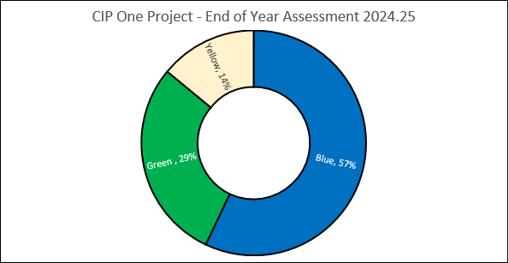
Improvement Objective Two
5.3 Objective Two: - We will ensure a more connected Mid Ulster where new technologies and ways of working, empower citizens to get the best services that matter to them.
“The ways of working need to involve non-techie people being able to access services and in a way that suits how we are in Mid Ulster”.

(Mid Ulster Councils Corporate Improvement Objectives Survey Report Excerpt, April 2024)

Lead Officer: Assistant Director Corporate Services and Finance.

Why have we chosen this Improvement Objective?
Tech’ change had accelerated during the pandemic; the rate of digital transformation has increased exponentially in part due to the speed of adapting to unexpected challenges. Organisations, their customers and stakeholders expect digital experiences to be more immersive, inclusive, secure, and simple to use than ever before. Technology change has always been about people, and in 2024, that will be truer than ever in the era of hybrid work.
The Council is aware that technology will be about the new ways in which we work, connect, create, and support one another—and how technology enables this. There is now an enhanced need to transform how organisations engage with customers through digital platforms. This increasing use of digital channels is here to stay. Citizens now have higher expectations of online council services and want a digital customer experience similar to that provided by retailers, banks and utility providers.

We want to harness the potential of digital design, data and technology to work efficiently, transform the relationship between residents and the Council, and make Mid Ulster a leading destination for sustainable growth, opportunity, and quality of life. To embrace such opportunities, we are developing a roadmap to define how our future use of technology and human resources will be optimised to enable the efficient delivery of our business and community priorities to the businesses and citizens of Mid Ulster.

Technology is only an enabler, transformation involves changing how we work, how we organise ourselves and how we serve our citizens. We will have real opportunities to radically rethink, and redesign our services, as we are move towards being a more agile and flexible organisation, with staff able to work from any location as we make more efficient use of physical space and mobile technology.

We can and will learn lessons from innovative digital practice utilised as a response to the Pandemic. More of our high volume, low contacts that we deal with, should be completed at our customer’s convenience, enabling Council staff to focus on more complex and sensitive enquiries that benefit from the human touch. All of this can help us manage the rising cost and demand pressures the Council is facing.

Whist we want everyone to become digital citizens; we recognise that not all residents have the means or skills to take up digital. The council aims to grow and develop its digital inclusion work to provide skills and confidence in this area for staff, and our customers will always be able to speak to a person when they need to, and the person they speak to will be able to provide improved customer service. We will not leave anyone behind; however, we must continue to maximise technology to drive better services and lower delivery costs.
As a Council, we already offer online access in a number of areas; however, we need to push further, faster with our digital approaches, data and technology, to ensure the district thrives through the fourth industrial revolution. The Council in order to make the right choices post-pandemic will need to think differently and crucially put citizens, data, insight, and technology at the heart of change.

Link to Community Plan Theme and Outcomes:
Economic Growth – We prosper in a stronger and more competitive economy

Links to Corporate Plan Themes:
Our Service Delivery: Support delivery of a strong business economy by fostering start-ups; creating growth and scalability opportunities; promoting jobs; and developing Mid Ulster as a vibrant tourist destination.

Our Service Delivery: Implement a Customer Experience Platform by 2026 and have it fully operational for two customer facing services by March 2028.

Being the Best Council Possible: Increase staff engagement and wellbeing by 2028

Performance Improvement Aspects, which this improvement objective aims to deliver against:

Strategic Effectiveness, Service Quality, Service Availability, Fairness, Sustainability, Efficiency, Innovation.

Table - Progress Made against Improvement Objective Two:

What are we going to do?  (Activities/Measures) | What we delivered | Achievement
1.Development of digital systems to support the delivery of Financial Services – (Phase 2) electronic cash receipting, back-office receipting /auto bank reconciliation, optimise budget holder functionality | Contracts/Sourcing modules configured; testing for Key Users commenced Q4 however Senior Executive Team (SET) asked that we pause its implementation due to audit rec on review of Contracts Register Policy and resourcing. Electronic Cash Receipting (ECR) Scoping session in Q4 - decided to delay front office ECR until Q3 25/26 due to Worldpay integration being available then and CiA changing for front office staff. Progress made on Supplier Set Ups moving to system, however, needed to purchase additional modules to progress this which happened end Q4 Finance staff using T1 University to look in to Auto Bank Reconciliation - came unstuck as we need T1 consultancy to map our file. Purchased ‘Ezescan’ module at end Q4 to move away from ‘Dragitin’. Discussions and demos with Fermanagh & Omagh District Council re Supply Set Up Forms and ABC council re ‘Eze’ scan journey in Q4 | Partially Achieved
2.. Research, develop and deliver a new staff intranet that is fit for purpose and suitable for integration within other online tools currently taking place | Intranet project approved by CEX 08/05/24, presented to Policy & Resources committee on the 09/05/24 and ratified by Council on the 23/05/24. Pre-quotation market testing completed. Meetings held with three specialist vendors, Initial drafting of spec and scope of works in progress. Procurement exercise complete. Vendor appointed for project starting April 2025 (Completion of project moved into Q1 and Q2 25/26) - implementing project plan as per vendor submission will complete project within this new timescale. | Substantially Achieved
- Implement Digital Infrastructure actions from Digital Transformation Strategy – implement fibre class network connectivity to each of our staff workspaces.  We will invest in the rollout, uptake and usage of our cloud based internal collaboration, communication and hybrid working tools [INTEGRATED SERVICES]. | All fibres connected SD WAN (56 in total). POC complete, busy and divert issues resolved. Jabber operational without VPN. Killymeal road agreed as primary site for deployment, Licensing allocated. Testing in Progress with Tiger Prism. Initial Teams testing complete. Additional Auto attendant options complete, Hunt group clean up  All Major SIPs migrated - Meadowbank and Maghera on IPT phone system. | Substantially Achieved
- Delivery of the Digital Transformation Flexible Fund (DTFF: NI programme led by Newry, Mourne & Down DC) a 3-year grant scheme aimed at supporting micro/small businesses to adopt advanced digital technologies to achieve business transformation by March 2026. | Continued to attend DTFF Operation Meetings. Call assessment panels continued throughout the year, with briefing workshops and promotion through the Council’s e-zine. During the year the following outputs were delivered: in Call 1 update - 1 MUDC business withdrew - 11 businesses offered grant  Call 1& 2 - 18 businesses offered funding. Call 3: 10 businesses offered funding. Call 1-3 - 28 issued Letters of Offe | Substantially Achieved
- Develop digital accessibility and digital inclusion by design guidance and training materials for Council’s transformational team. | Direct User feedback continues to be welcomed and is reflected in the updated guidance, as well as on an ad-hoc basis. Weekly Accessibility audits are currently being carried out weekly by Silk tide. This is coordinated and reviewed by the Council's Design Team. One supplier’s quotation for an accessibility check identified a possible duplication of duties within a current ICT contract. Consequently, their proposals were not progressed. | Fully Achieved
6. Procurement and initial implementation of Customer Experience solution for deployment across council services. | The procurement process was completed in late October and an Award of Contract paper prepared for the consideration and approval November 2025 P&R Committee. The completion and Award of Contract:  This was on track to be considered by Members for approval and to be awarded by November 2025 Council. Council management determined that the procurement process cease/be abandoned as a system is no longer a requirement for Council. (SET - being determined that it is no longer required). The following had been undertaken to date: Establish Cross-Departmental implementation group: This was established and initiated however no longer required as the procurement has been abandoned. Commence yr. 1 implementation: this had not been commenced as the system had not yet been procured. With procurement abandoned this will not proceed. Embed 3 services in year 1 (missed bins, dog licencing and complaints handling): Preparatory work had been undertaken on this with specific reference to process mapping and enabling processes for the procured solution. With procurement abandoned this will not proceed as no longer a requirement for Council. | Re-prioritised

Diagram - Number of Improvement Activities in CIP2 Project 2024 to 2025 - End of Year Assessment Status
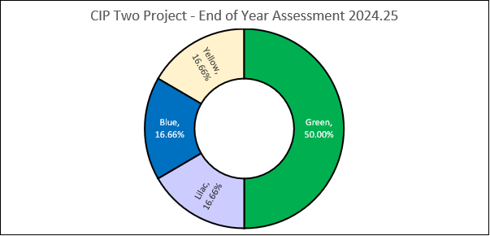
Improvement Objective Three
5.4 Objective Three: To create cleaner neighbourhoods, where everyone takes responsibility for their waste and the environment

“Target roadside litter throughout the Council area. Our roadsides are a disgrace, and the litter must be a negative impact to selling the area for any and all purposes. Collecting litter is fine but education on 'taking it home' and' binning it' has to be the crucial message. Pride in the area!””

(Mid Ulster Councils Corporate Improvement Objectives Survey Report Excerpt, April 2024)

Lead Officer: Assistant Director, of Health, Leisure and Wellbeing

Why have we chosen this Improvement Objective?
The World Health Organisation, (WHO), outlines, the various ways the natural environment can positively affect human health and well-being, as natural areas offer opportunities for physical activity, social contacts and stress reduction ^{1.} We all use public spaces every time we leave home. These include the footpaths and streets we walk or drive along each day, the parks our children play in and the outdoor areas we go to exercise or relax in. Many of our daily decisions and activities are influenced by our perceptions of the quality and cleanliness of the public areas we encounter.

The importance of clean, green and blue (our rivers, canals, loughs etc.) spaces, parks, cannot be underestimated. Many benefits derive from a pleasant environment. Post pandemic we now realise how important it is for us to have easy access to open space for recreation and exercise. The importance of safe, accessible and well-connected green and blue spaces for improving quality of life has never been more pertinent, and for those without gardens the value of these spaces is amplified.

Good quality parks and attractive open space contribute economic benefits to towns and villages. As Mid Ulster competes with others to attract growth, tourism and inward investment a clean, green and pleasant environment plays an important role in marketing the District as a place to live in, move to and visit. Businesses are drawn to places with good quality environment as this in turn attracts customers, employees and services into the local area. In addition, well maintained towns and villages has a positive impact on commercial and domestic property values.

Regionally and locally increases in obesity, are linked to more sedentary lifestyles including lower levels of outdoor activity. Patterns of exercise in adults are set early in life, so obesity and inactivity in childhood can led to poor health in later years. Good quality public open space is required to encourage healthier lifestyles by providing opportunities for walking, cycling and other outdoor pursuits, as well as being beneficial to mental well-being.

Clean and well-maintained play areas, parks and open space provide important beneficial opportunities for children to learn and develop (their social and emotional development) and stay healthy. Apart from access, the quality of green space is crucial too. Quality of facilities – including toilets and cafes; regular maintenance; organised activities can help ensure a green space supports the wellbeing of its citizens equally.
Clean neighbourhoods engender social pride, add vibrancy, and reduce crime and anti-social behaviour, all of which are essential to the development of strong prosperous neighbourhoods. Anti-social behaviour can be seen through dog fouling, littering, abandoning vehicles, graffiti, and fly tipping etc. We are very much aware that many of our clean and green services are demand led, whilst much of this demand is inevitable, it is also clear some of it is avoidable.
We want to be clear about our service promises, standards, and the response times we aim to achieve to ensure our communities understand what levels of service they can expect. On its own the Council cannot deliver a cleaner and greener environment for residents. We want to work collaboratively, with residents, communities, visitors and businesses and through active citizenship we hope to see reduced demands on our services and more residents taking greater pride in and ownership of their local environment. This is more necessary then ever as overall public sector expenditure reduces at an unprecedented rate, combined with the economic fallout from the pandemic and current inflation in the economy.
- https://www.un.org/en/chronicle/article/green-spaces-invaluable-resources-deliveringsustainable-urban-health

Link to Community Plan Theme: Infrastructure- We increasingly value our environment and enhance it for our children.

Link to Corporate Plan Themes:
Our Service Delivery: Increase customer satisfaction and participation in our leisure, outdoor recreation and arts, culture and literary facilities by March 2028
Our Service Delivery: Co-design and deliver accessible community-based leisure and outdoor recreation facilities and programmes that meet our citizens’ needs

Performance Improvement Aspects, which this improvement objective aims to deliver against
Strategic Effectiveness, Service Quality, Service Availability, Fairness, Sustainability, Efficiency, Innovation

Table - Progress Made against Improvement Objective Three:

What are we going to do?  (Activities/Measures) | What we delivered | Achievement
- Continuation of an enhanced anti-littering enforcement approach (Phase 2) – to include: ensure 85% of reported stray dog requests responded to within 3 working days and 85% of unwanted dogs responded to within 5 working days. Extend “Don’t Mess up Mid Ulster” to Coalisland Town Centre, Tobermore Road/Station Road Lop Magherafelt, Gulladuff/Mayogall Road, Sweep Road/Killymoon Street walk, Cookstown. Undertake discussions with other Councils with view to taking part in joint procurement exercise for Clean Neighbourhood Enforcement services | During Q1 98% of stray dog requests were responded to within 3 days & 100% of unwanted dogs were responded to within 5 days. In Q2 90% of stray dogs were responded to within 3 working days & 100% unwanted dogs responded to within 5 days. During Q3 95% of stray dog complaints were responded to within 3 days & 100% of unwanted within 5 days. The final quarter in the year saw 95.6% of all stray dog complaints responded to within 3 days and during this quarter (and the previous Q3), saw the Neighbourhoods & Licensing team shift focus to secure compliance with the new XL bully legislation (enacted and implemented in year). The “Don’t Mess Up Mid Ulster was extended to 4 additional areas, with new signage and regular patrols from Q2 onwards, as well as monitoring visits to hotspot areas and staff had various engagements with dog walkers. By Q3 it became clear that a joint procurement exercise with other Councils would be delayed due to the initial partner Councils moving in a different direction. | Substantially Achieved
- Support and promote local community clean-ups and events (target 60 of clean-ups supported in year e.g. Big Spring Clean organised by schools, businesses, community groups and sports clubs). Target of 3,000 litter pickers loaned to local groups and 5,000 litter bags lifted. Target of ten additional “Adopt a Spot” registrations. Bi-annual e-mails to 121 schools within the district to raise awareness of Big Spring Cleans and local community clean up events. GIS mapping complete for MUDC litter bins by March 2025. | E-mails sent to all 121 schools in September 2024. At the end of the year 2,536 litter pickers had been loaned to groups as well as 4,011 bags of litter lifted. During the year there were 54 clean ups undertaken. The targets for litter picking and the number for clean-ups was missed by appx 15% most likely due to the uncertainty of the continuation of the “Adopt-a-spot” programme by Keep Northern Ireland Beautiful (KNIB) (was discontinued due to funding constraints by Q3) and the lower level of funding communications around this year’s events. All litter bins now mapped onto GIS and any new bins recorded going forward. | Substantially Achieved
- Co-ordinated litter/ recycling educational programme in place for participating schools. Target of 80 education visits to primary/secondary schools, promoting littering/recycling message. Secure funding of £21,000 to Live Here Love Here (with 50%- £10,500 funnelled into small rants for MUDC area. Target of 100% of schools enrolled in Eco schools programme. With 5 additional green flags awarded and hold and “Eco Speak” school competition with” Don’t Mess Up Mid Ulster”. | During the year there were 72 school visits undertaken, promoting littering and recycling to both primary and secondary pupils. The small grants funding scheme awarded £15,271.74 to 12 groups. Recycling officers also attended community events with information stand and games throughout the year. Over the year, 100% of District schools remained enrolled in the Eco Schools programme and it is good to report there were 12 new Green Flags awarded in year. The Youth Speak competition was held In April 2024 and 22 schools attended. | Substantially Achieved
- Develop, manage and deliver a marketing and communication activity plan 2023/25 (high profile campaigns) aimed at reducing littering and awareness of dog fouling across the district. | Throughout the year there were various campaigns run across Council communication channels, which included: Eco Schools (St Ciaran’s & Sperrinview), Big Spring Clean Up, 5 Do’s to reuse, Food Waste Action week, A better way your blue bin recycling, Recycling as part of Mid Ulster Family Fayre and recycling event at Moy Park, awareness of XL Bully legislation, School Uniform Recycling, FSA food standard hygiene rating, Emergency Preparedness – 30 days/30 ways, Chewing Gum Taskforce, Gas Safety week and Fairtrade fortnight, Halloween and Christmas Recycling, Responsible Dog Ownership . Awareness around prosecution/compliance such as sheep worrying (prosecution), and a local business banned from selling tobacco products/nicotine inhaling products. | Fully Achieved
- Develop extended coverage of Forest Schools programme (FSP) across all seven District Electoral Area's (DEA's) - DEA's are Carntogher, Clogher Valley, Cookstown, Dungannon, Magherafelt, Moyola, Torrent in Mid Ulster District | During the year, 5 schools completed FSP & 4 sessions over the summer, in quarter three; 15 schools completed 3 sessions each and in the last quarter 15 schools completed 12 lessons each with Manor Park hosting 45 pupils, Ballyronan 85, Dungannon Park 98 and Knockmany 151. Invitation has been sent out in March 2025 for the 2025/2 school year for Dungannon Park and Knockmany | Substantially Achieved
- Continue to raise Parks and Open Green Spaces management standards across Council Properties by attaining one additional Green Flag/Blue Standard award by 2024/25. | All Green flags have been awarded for 2024/25, plus one Blue flag. Manor Park to be added into Green flags application for 2025/26 - Six completed. In Q4, Beechway, Castledawson, Coolnafranky, Donaghmore, Lisnahull and Ratheen. A committee report was presented for leases at Glenone, Clady, Boyne Row and Beechway and presented for Council approval. Pitches and Recreational Strategy Feasibility Development Grant pitches and Infrastructure Development Grant awarded in Q4 and the final draft being reviewed and due for completion March 2025. As part of the MUDC Play strategy 6 projects have been completed up to the end of 2025. Final draft of the Active Travel Strategy was going through its final review in Q4. Data is also now currently being collected for footfall increase, as well as baseline data through the MUDC pitch strategy for green/blue spaces | Substantially Achieved
- Produce a Work Plan to support the need to address dereliction and vacancy across the district (subject to commitment with key government departments such as DfC, DAERA etc.) and apply to the Department of Communities for capital funding for “Phase 2” of town spruce up scheme. | In June 2024 an application was submitted to DfC to the value of £178,528 for the delivery of the Town “Spruce Up” scheme phase 2. Phase 1 is currently being delivered to the sum of 200£k, and by Q4 letters of offer had been extended to 17th May 2025, and the same extension date for Phase 2 for £173,528. During Q1 a meeting was held with MUDC elected members in May 2024 to receive presentations ref current work/projects and budgets, this was the first step in developing partnership working in relation to dereliction and vacancy. By Q2 a follow up meeting was held with DfC on the 18th of September to learn and benchmark best practice from other councils. Independent architects were appointed for Phase 1 and phase 2 of the “Spruce Up” scheme. By Q4, 57 schemes within Phase 1 had been completed to the value of £153, 791.99 and by the end of the year 2024/25, Phase 2, 30 schemes had been completed to the value of £95,928.14. Underspend within phase 1 has been approved and reallocated tot eh purchase of litter bins and weed scrubber to the value of £24,925.00. | Substantially Achieved
- To research, develop and embed a Council-wide volunteer framework which includes a policy,  procedures and guidance documentation to support the implementation of the policy by 2024/25 | The task and finish group to support the lead officer met 4 times over the year with the final meeting advising that the Senior Executive Team (SET) had provided policy ownership tot eh Community Development section of the Communities and Place Directorate. Scoping was completed and the framework was finalised and approved (at the January 2025 Policy and resources committee meeting) and thereafter ratified by Council. The Council also became a member of Volunteer NOW. Linkages were made from the task and finish group lead with the Councils Communications team regarding how to inform the public about volunteering opportunities (a volunteering webpage has been developed on Council’s website). A policy pilot is being led by Outdoor recreation and a relevant briefing session is scheduled to be held with relevant officers in May 2025 and will also be included in future policy briefing sessions for managers. | Fully Achieved

Diagram - Number of Improvement Activities in CIP3 Project 2024 to 2025 - End of Year Assessment Status
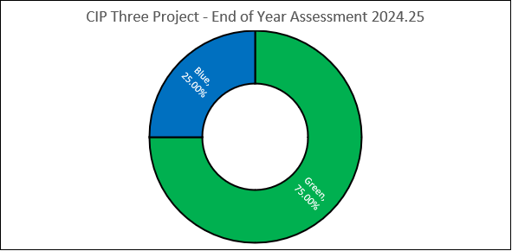

Improvement Objective Four
5.5 Objective Four: We will contribute to the ongoing regeneration of our district by delivering a capital investment programme, enhancing facilities and opportunities for local people.

“Delivering a capital investment programme, enhancing facilities and opportunities for local people provides the opportunities for the Council to enhance the accessibility of facilities through the District, thus future proofing for an ageing population and expanding the footfall to facilities that can increase their level of appeal via implementing accessible practices within the built environment”.
(Mid Ulster Councils Corporate Improvement Objectives Survey Report Excerpt, April 2024).

Lead Officer: Head of Technical Services

Why have we chosen this Improvement Objective?
The additional challenges facing Mid Ulster’s most vulnerable communities due to the longer-term impacts, arising from the Pandemic and the current economic instability caused by inflation, means there has never been a more important time to strengthen the economic, social, and physical wellbeing of our places, lasting effects will be felt for many years to come. We must look to a period of recovery post pandemic and to the economic recovery out of inflation. The Council’s capital programme of local projects will maintain our ongoing support for vibrant, accessible village/ town centres, open spaces and communities.
Regeneration is a long-term process and is delivered through a wide range of projects, programmes, partnerships, and infrastructure initiatives. Since the late 1990s, policymakers have recognised the wider social factors that affect the success of regeneration schemes, but this is even more vital in the current economic climate.

Infrastructure is a valuable and efficient economic stimulus. Every £1 of investment in infrastructure generates a potential further £2.70¹ due to economic multiplier effects. Making the most of existing social capital and providing opportunities for local people to be involved in regeneration is a vital part of making the best use of limited resources.

As a Council we support locally developed place-based regeneration projects, we continue to invest in Mid Ulster, as well as providing essential services paid for by your rates. Our Capital investment programme is our commitment to addressing the economic downturn and making the district a better place to live, work and invest. The programme includes major schemes to boost the economy, create jobs and improve the quality of life for our citizens.
Quality of place matters in economic, social, cultural and emotional terms. A sense of place helps establish strong social infrastructure which supports people to improve their prospects and maximize their potential. We are taking a “Whole District” approach creating places that are attractive, well-designed and well managed. Our approach focuses on tailored solutions for settlements within the district and also business locations.

We recognise our major assets as those that have the potential to deliver the greatest impact. Building on and investing in these assets alongside complementary interventions will release the district’s potential for growth and connect areas of growth with deprived places in need of generation. By following a planned phased approach across the District, we will be able to deliver greater impact for each locality, using the resources available to the best effect.
^{1.} Further detail can be found here:
Infrastructure as a stimulus – laying the foundations for the new normal | Institution of Civil Engineers (ICE).

Link to Community Plan Theme: Economic Growth - We prosper in a stronger and more competitive economy.

Link to Corporate Plan Theme:
Our Service Delivery: Build on our place-shaping capital investment programme to develop new, and enhance our existing, physical assets.

Being the Best Council Possible: - Increase staff engagement and wellbeing by 2028

Performance Improvement Aspects of this improvement objective aims to deliver against?
Strategic Effectiveness, Service Quality, Sustainability, Service Availability, Fairness, Efficiency, Innovation.

Table - Progress Made Against Improvement Objective Four:
What are we going to do?  (Activities/Measures) | What we delivered | Achievement
- Undertake the Project management of Council's current committed live Capital Works Programme 2023 - 2027 with an indicative spend < £26m. Projects include:  - 2 Waste Infrastructure Projects; - final closure works at Ballymacombs Landfill and potential development of a Dry Recyclables Facility (MRF).  - 2 Public Realm - Contractor appointed for construction of Maghera Public realm scheme, Magherafelt Public Realm scheme under consideration with funders.  - 13 Major Projects - (over £250K): Thomas Clarkes GAC, Connecting Pomeroy , Gortgonis Health & Well Being Hub enabling Works, Dgn Railway Park completed RIBA stage 2 , MUSA Sports 3G & Running Track to be on site , Maghera Wetland Park, Active Travel Projects (Clogher), Small Settlement Programme( Moneymore, Bellaghy (Hunters Park), Castledawson, Clady, Coalisland to be designed and constructed and works to Castlecaulfield and Moy to be developed) , Civic Offices remedial works, Forest Improvements at Drumcairn and Derrynoyd, Design works for Cookstown, Dungannon depot replacements.  5 Minor Projects - (under £250k): Ballsaggart Lough/ Dgn Park Lake Reservoirs, Murley Road Footpath, Greenvale LC Repairs, Burnavon Theatre Upgrades, Aughnacloy Changing Room repairs | Capital reports are presented on a monthly basis to the Environment Committee and include IST Capital reports, ICT Capital reports and Scoping Projects reports. Residents have been updated in terms of Projects being listed on web page - see link:  https://www.midulstercouncil.org/your-council/investing-in-mid-ulster  plus, monthly updates on media YouTube channel see link  https://www.youtube.com/playlist?list=PLzfkoqzAiZjXfCcqEJ_5ANIV9g3HNRrPW  Refer to Summary of Progress of Capital Works section below | Substantially Achieved
- Develop a versatility matrix and learning and development plan for Capital Service team by April 2025. | Team Have developed a working document regarding CAD and Contract Management training requirements, this has been forwarded to Learning & Development Manager for comment and action to move this forward, Capital. Meeting held with L&D Manager in August to agree specification for NEC Contract Management training, and co-ordination of training in progress by Q4. Current seeking quotes from suppliers. Training date TBC subject to appointment of supplier. CAD training requirements ingoing with staff. Meetings held with Performance & Quality Officer (PQO) September 10th and 15th October for intro to versatility matrix process/process mapping. Staff member left and awaited newly appointed Capital Contracts Manager in post by Q4. | Partially Achieved
- Ensure members of the public are kept informed of the progression of Council's Capital Projects rolling programme, via updates across communication channels. | Meeting to take place in August with the Marketing team to agree and confirm information outlet for completed project and information on capital projects sent to Marketing and Comms when they become available. New Capital Contracts Manager maintains contact meetings with Marketing Manager on completed and ongoing contracts to progress. BI-Monthly TS teams meetings scheduled for the first Tuesday of the month with rolling agenda. Development of capital programme operating manual is ongoing - Capital Contracts Manager to meet with PQO to review, date TBC. Update meeting with Marketing Manager to be scheduled for to progress marketing protocol and potential for digitisation. | Partially Achieved
- Review and revise the Standardised accessibility and inclusivity guidance materials for councils' capital projects | Direct feedback from User Groups scheduled to be collected and collated. Feedback has been sought and collated, this information is now reflected in the final guidance document. The updated version will be re-circulated and added to the intranet. Accessibility audits were scheduled to be collated and collected by Q3, and 3 projects were identified i.e. the guidance has been applied on a number of current design projects e.g. Gortgonnis. Additional onsite audits will be completed as the projects progress and eth guidance has also been implemented with associated tendering processes. | Fully Achieved

Diagram - Number of Improvement Activities in CIP4 Project 2024 to 2025 - End of Year Assessment Status.
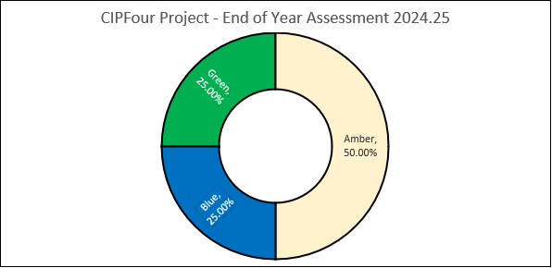
Summary of Progress Capital Works Programme During 2024 to 2025
Waste Infrastructure
In relation to Waste Infrastructure projects, it is good to report that Ballymacombs Landfill site has been capped and closed in 24-25 year. The Dry Recyclables Facility (MRF) still at development stage along with other Partner Councils with no development planned for 24-25.

Public Realm
Maghera Public Realm has been completed in July 2025 and is currently in defects period. Magherafelt Public Realm whilst still listed in the Capital Framework is under review for funding partners. The Pomeroy Public Realm Scheme (under the Connecting Pomeroy Project) defects period expired in November 2024, and the scheme has now been fully adopted by DFI.
Major Projects -
Thomas Clarkes GAC hub defects period ended in August 2024 and is now complete. Within the overall Connecting Pomeroy suite of Projects, Pomeroy Plunkett's GAC defects period ended in February 2025. The new Church of Ireland Community Building defects period ended in December 2023, the QEII Primary School defects period ended in August 2024 and the Presbyterian Carpark and MUGA defects period ended in November 2024. Gortgonis Health & Well Being Hub- scheme design requirements under consideration by client team and public consultation completed. Education Authority progressing Gael School development through legal agreement with Mid Ulster District Council. Dungannon Railway Park scheme design requirements under consideration by client team for budget confirmation and public consultation. A new ICT Team is currently being engaged. MUSA Sports 3G & Running Track was progressed to RIBA Stage 5 which commenced on site in February 2025, completion due November/December 2025. Maghera Wetland Park - RIBA Stage 2 Feasibility Report completed in February 2024. Estimated construction costs for the project being finalised to enable project to move to the next stage i.e. RIBA 3+ Stage Planning Approval - subject to Levelling Up Fund completion. Delivered by SIB Team. Maghera Business Park is still in the DFI Planning System. Awaiting a Planning Decision. Delivered by SIB Team.
Active Travel (Clogher) -subject to land ownership and legal discussion underway prior to implementation (proposed completion March 2026).
Under the Covid Small Settlements Scheme: Moneymore defects period ended December 2024, Castledawson IST tender for contractor complete August 25. Clady progressed to RIBA stage 5, practical completion met, snags to complete. Coalisland Canal – public consultation completed tender awarded for construction, due to start on site September 2025. Design Team appointed for Moy, concept complete and awaiting Planning decision. Castlecaulfield tendered for contractor appointment. Bellaghy Hunters planning approval received July 2025. Detail design and tendering for contractor, legals to be finalised. Drumcairn and Derrynoid Forest Improvement project defects period ended June 2024, currently in dispute. Civic offices remedial works, design works for Cookstown and Dungannon Depot replacements are under review for development, planning consultation in progress to be delivered by SIB Team.
Minor Projects
Ballysaggart Lough car park completed, Murley Road Footpath complete and Burnavon Theatre upgrade completed and off project list. Greenvale LC Repairs ICT team was appointed in June 2024 and now progressing to RIBA Stage 5.
Aughnacloy Changing Room repairs - options for repair under consideration under the Pitches Strategy funding of Mid Ulster District Council. Reservoirs - Ballysaggart and Dungannon Park, consultants appointed to develop both sites. Land ownership issues under review for Ballysaggart. Dungannon Park planning now approved with first phase works due to complete August 2025.

6.0 Council’s self-assessment of statutory indicators and standards 2024 to 2025.

Statutory Indicators/Standards - (Set for Us)
Under the Local Government (Performance Indicators and Standards Order (Northern Ireland) 2015, statutory performance indicators and standards have been set as part of the performance improvement arrangements for district councils (i.e. set for us). Performance measures have been specified for the functions of economic development, planning and waste management.
The aim of the performance measures is to promote the improvement of service delivery. The information is currently collated by the Department for the Economy, Department for Infrastructure and DAERA (Department for Agriculture, Environment and Rural Affairs) respectively and published on their websites. Once released to Council, this information is published for citizens and other stakeholders to assess Council’s performance in these areas. Mid Ulster District Council’s 2024 to 2025 performance against these indicators (progress and trend/direction of travel) are outlined in the following section, also included is performance benchmarking data relating to the other 10 Northern Ireland Councils; where available.

The table below outlines how the statutory indicators and standards performance progress is analysed using a R. A.G (red, amber, and green) i.e. Status-reporting framework.

Table - R-A-G Reporting Status Framework
Status evaluated by colour as | Explanation of RAG colour status
Green | Met or exceeded target
Amber | Missed target narrowly
Red | Missed Target Significantly  .

Trend
Trend or the Direction of Travel - the direction of travel demonstrates if performance has improved, declined, or been maintained relative to the previous year:

- Performance improved ⬆
- Performance remained the same ⬅➔
- Performance declined ⬇

6.1 Economic Development Statutory Indicator
ED1 – Numbers of jobs promoted through business start-up activity
The purpose of Performance Indicator ED1: The number of jobs promoted through business start-up activity (Business start-up means the delivery of completed client led business plans under the Department of the Economy Regional Start Initiative or its successor Programmes). The programme is the first stop for entrepreneurs in Northern Ireland and provides individuals who wish to start a business with support in the production of their own business plans and in registering for self-employment. Experienced business advisors operate locally through Council partners.

The Department for Communities launched a consultation on The Local Government (Performance Indicators and Standards) (Amendment) Order (Northern Ireland) 2022, which in part reviewed the standards for each Council from the original standards developed in the 2015 Order (legislation). Mid Ulster’s existing standard was for 210 jobs promoted through business start-up activity; post the consultation this was amended to 153 jobs promoted per annum through business start-up activity.

A new Northern Ireland Entrepreneurial Support Service (Go Succeed) was introduced in November 2023, this replaced the “Go for It” programme which ran until the end of September 2023.

Analysis: More is better
DfE have advised the new agreed amended lower Statutory target of 153 (jobs promoted) for Mid Ulster (had been agreed July 2023). During 2024 to 2025 Mid Ulster promoted 99 jobs, this is lower than amended standard of 153. The following however, should be noted; the 'Go Succeed' Service, designed to provide start up support, only being operational from mid-December 2023, due to delays procuring the new regional Contractor and mobilising the new Contract delivery process and CRM system.

To date, data on Business Plans approved is only verified by Belfast City Council (BCC) to February 2025. DfE have advised this measure and Performance Indicator is currently under review by Department for Communities (DfC) and the Department of the Economy (DfE). BCC (as lead Council) have been engaging with DfE on behalf of Councils reference the new Service and briefing them on the progress. DfE are content to work with Councils to develop new, more appropriate Performance Indicators for the Service, other than Jobs, and advised that they are aware of the; "…. background to the development of the ESS and issues around the targets. Our position remains the same as you’ve set out below. We understand that there is likely to be a gap in delivery which will impact upon achievement of targets, this is essentially unavoidable. While we would encourage councils to work to minimize any impact arising from the gap in provision, we accept that targets may not be achieved in full".

The Contract Management Team (BCC) liaise regularly with the Contractor (ENI); enquiry levels from service commencement in December 2023 are good. Given the context above it is difficult to draw comparisons with Council’s previous years ED1 performance data.

Action Plan:
On 31st July 2025, Belfast City Council (‘BCC’ lead Council for “Go Succeed”) circulated the 2024/25 data which showed Mid Ulster had promoted 99 jobs (indicative as final 12-month data not yet verified) based on the number of completed Business Plans. These figures to 28th February 2025 have been confirmed by BCC, the figures for March 2025 are based on Contractor activity reports, and verification of these will not be completed by BCC until the end of August, however, it is unlikely there will be significant variation from those noted in the Table below.

Northern Ireland Councils’ ED1 Performance Data during 2024 to 2025
Across the eleven Northern Ireland Councils 1,636 jobs were promoted during 2024 to 2025 (refer to table below ED1 jobs promoted 2024/25), this is increased from the previous year’s job promotion total of 1,102 jobs and 2022/23’s total of 1,625.
A representative of Belfast City Council (Lead Council) has informed all Councils that the final ED1 figures will be verified and reported to DfE by September 2025.

Table - Northern Ireland Councils ED1 - Jobs Promoted Achieved through Business Start Up 2024 to 2025
 | Actual BPA | Actual Jobs | Total BP Target | Statutory Target (2023 order) | Variance BP | Variance Jobs
Antrim & Newtownabbey | 247 | 148 | 128 | 80 | 119 | 68
Ards & North Down | 206 | 124 | 197 | 123 | 9 | 1
Armagh Banbridge & Craigavon | 228 | 137 | 291 | 182 | -63 | -45
Belfast | 326 | 196 | 520 | 325 | -194 | -129
Causeway Coast & Glens | 240 | 144 | 205 | 128 | 35 | 16
Derry & Strabane | 292 | 175 | 224 | 140 | 68 | 35
Fermanagh & Omagh | 228 | 137 | 272 | 170 | -44 | -33
Lisburn & Castlereagh | 213 | 128 | 186 | 116 | 27 | 12
Mid & East Antrim | 241 | 145 | 178 | 111 | 63 | 34
Mid Ulster | 165 | 99 | 245 | 153 | -80 | -54
Newry Mourne & Down | 341 | 205 | 277 | 173 | 64 | 32
Totals | 2,727 | 1,636 | 2,721 | 1,701 | 6 | -65

6.2 Planning Statutory Indicators
Planning Activity across Northern Ireland 2024 to 2025
The Department for Infrastructure (DfI) publish planning statistics in their annual Northern Ireland Planning Report¹. The DfI’s annual statistical bulletin 2024 to 2025, states that in year there were 9,716 planning applications received in Northern Ireland (NI) by councils and the Department in 2024/25; a decrease of 3% from the previous financial year (10,025).

Graph – Planning Applications received by NI Councils 2023/24 to 2024/25
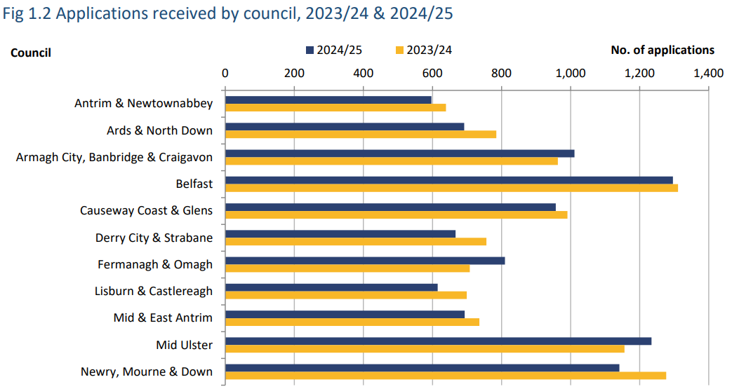
Planning activity statistics | Department for Infrastructure
Across councils the number of decisions issued during 2024/25 ranged from 1,302 in Belfast (accounting for 14.0% of all decisions across NI) to 578 in Derry City and Strabane (6.2% of all decisions). The majority of Councils (6) reported a decrease in the number of applications decided in 2024/25 when compared with the previous year, with the greatest decrease recorded in Derry City and Strabane (-26.1%). Five councils reported an increase over the year, with Lisburn and Castlereagh reporting the largest increase (+19.5%). The table below outlines MUDC’s 2023/24 - 2024/25 statutory planning results.
Table – Mid Ulster District Council’s three statutory planning statistics results for 2023/24 and 2024/25

P1 – Major applications processed from date valid to decision or withdrawn within an average of 30 weeks
Purpose of Performance Indicator: Planning Department deals with Major Planning applications faster - An application in the category of major development within the meaning of Planning (Development Management Regulations (NI) 2015(a). Major developments have important economic, social and environmental implications.
The majority of major applications are multiple housing, commercial, government and civic types of development. A total of 161 major planning applications were received in Northern Ireland, up from the previous year (154). During 2024/25, 172 major planning applications were decided; down from the 144 decided in the previous year. The approval rate for major applications decided upon in Northern Ireland during 2024/25 was 97.7%.
From 1 July 2015, pre-application community consultation became a pre-requisite to a major application. This means that major applications will not be accepted until they have gone through this minimum 12-week process and notice has been submitted to the council or Department. DfI states that “the impact of this requirement should be borne in mind when considering the longer-term trend in major applications received, particularly when considering quarterly data”^{1.} The graph below outlines Councils Average processing times of major applications from 2015 to 2025, where the standard is within 30 weeks.
Graph – Mid Ulster District Council Average Processing Times for Major Applications 2015 to 2025

Analysis: Less is better

The average processing time in weeks for Mid Ulster’s Major development applications in 2024/25 was 71.4 weeks, which was a slight increase in time to process from the previous year of 68.1 weeks (2023/24), and still did not meet the standard. The average processing time as reported in 2024/25 for major planning applications across all 11 Councils is 39.6 weeks. Mid Ulster received fifteen major planning applications and approved 18 during the year, (15 were approved in the previous year 2023/24).

Action Plan:
Measures to improve the consultation response times of statutory consultees is on-going and internal practices will continue to be monitored and reviewed.

Northern Ireland Councils’ Performance Data during 2024 to 2025
The number of major applications received across Councils in 2024 to 2025 ranged from thirty in Belfast to four in Ards and North Down. Four Councils recorded decreases in the number of major applications received in 2024/25 compared to 2023/2024, while Mid Ulster Council stayed the same from the previous year.

Four Councils reported increases in the number of major applications received over the year, with the greatest increases recorded in in both Lisburn & Castlereagh (up from 8 to 15) and Newry & Mourne saw a rise from 8 (2023/24) to14 (2024/25). Comparable performance with other Northern Ireland Councils is outlined in the chart below which is published by the Department of Infrastructure.

The average processing time for major applications brought to a decision or withdrawal during 2024/25 was 39.6 weeks across all Councils. This represents an improvement of 6.9 weeks compared to the average processing time in 2023/24 (46.5 weeks).

Graph - Average processing time of major planning applications by NI Councils 2023/24 and 2024/25.
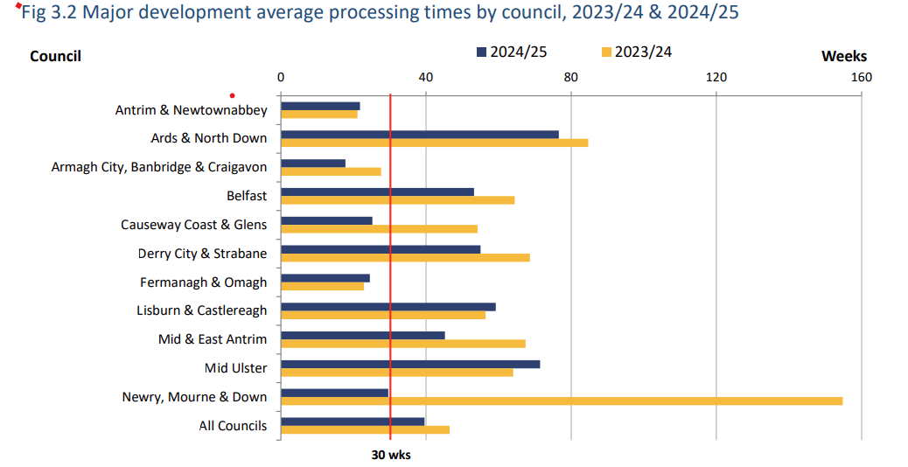
Planning activity statistics | Department for Infrastructure

Planning P2 – Average processing time for Local planning applications from date valid to decision or withdrawn within an average of 15 weeks.

Purpose of Performance Indicator: Local applications mean an application in the category of local development within the meaning of the (Development Management) Regulations (NI) 2015, and any other applications for approval or consent under the Planning Act (NI) 2011 (or any orders or regulations made under the Act). Local Development planning applications are mostly residential and minor commercial applications received and determined by a Council. The time taken to process a decision/withdrawal is calculated from the date on which an application is deemed valid to the date on which the decision is issued, or the application is withdrawn.

The average processing time in weeks for Mid Ulster’s local development applications in 2024/25 was 16.5 weeks, which is a very minimal increase in time to process from 16.1 weeks in 2023/24. The total number of local Mid Ulster applications received in 2024/25 was 1,234 increasing slightly from 1,156 the previous year. Mid Ulster District Council received the second highest (1,234) number of applications in 2024/25, after Belfast which received (1,296). Antrim and Newtownabbey received the least number of local applications 597.

Graph – P2 - Mid Ulster District Councils Average processing times of local applications from 2015 to 2025, where the standard is within 15 weeks.

Analysis: Less is better
Standard of 15 weeks was not achieved; however cognisance should be made of the introduction and rolling out of the new bespoke Mid Ulster Planning Portal, which impacted the performance of local applications.

The planning section also underwent a re-structure during the year. There has been a minimal increase in processing time from the previous year, which saw processing time take 16.5 weeks in 2024.25, (an increase of processing time by 0.4 weeks from 2023.24)

Action Plan:
The Head of Local Planning will oversee and review of Local applications in Quarter One 2025/26 moving forward. Staff will have to work diligently to try and ensure processing times are within the 15-week standard.

Northern Ireland Councils’ Performance Data during 2024 to 2025

The average processing time for local applications brought to a decision or withdrawal during 2024/25 was 19 weeks across all councils. This exceeds the 15-week target and represents a slight decrease from the previous financial year (20 weeks). Three of the 11 Councils met the 15-week target in 2024/25, namely, Mid and East Antrim (5.8 weeks), Antrim and Newtownabbey (12.8 weeks) and Fermanagh and Omagh (10.2 weeks).

The number of local applications received during 2024/25 was 9,595, a decrease on the previous year of 9,868. The overall Northern Ireland approval rate for local applications was 94.4% in 2024/25, similar to the rate reported in 2023/24 (95.4%).

Graph - Average Processing time of Local planning applications NI Councils 2023/24 to 2024/25
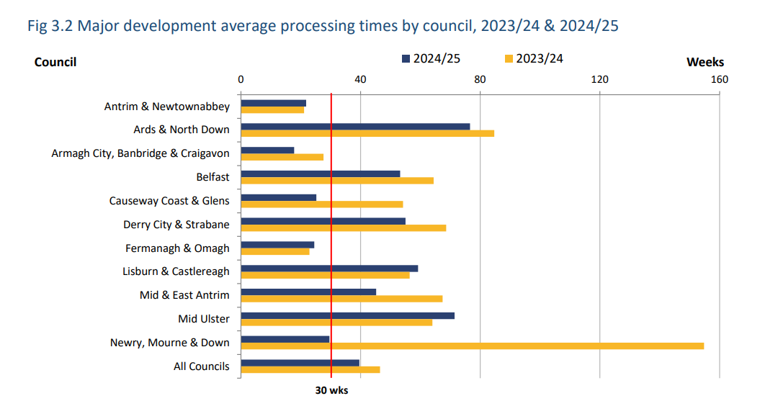
Planning activity statistics | Department for Infrastructure

Planning P3 – The percentage (70%) of planning enforcement cases processed within 39 weeks.

Purpose of Performance Indicator: Planning Department bring more enforcement cases to target conclusion within 39 weeks. Enforcement cases are investigations into alleged breaches of planning control under Part 5 of the Planning Act (NI) 2011 (or under any orders or regulations made under the Act.

An enforcement case is opened when there has been an alleged breach of planning control. An enforcement case is concluded when one of the following occurs: a notice is issued; legal proceedings commence; a planning application is received; or the case is closed.

The time taken to conclude an enforcement case is calculated from the date on which the complaint is received to the earliest date of the following: a notice is issued; legal proceedings commence; a planning application is received; or the case is closed.

Graph – P3 The percentage of Enforcement cases processed within 39 weeks in Mid Ulster District Council 2015 - 2025

Analysis: More is better
During 2024 to 2025 Council achieved 51% of enforcement cases concluded within 39 weeks, a decrease from 58% achieved in 2023 to 2024. This, does not meet the statutory target of 70% of cases concluded. Five of the Councils did not achieve the standard in 2024/2025.

Action Plan:
The Planning Team have undergone a re-structure during 2024 to 2025. The New Planning Service Lead – Strategic Planning has looked at the whole team Group meeting to focus on all current Enforcement, cases to be held September 2025.

Northern Ireland Councils’ Performance Data during 2024 to 2025
During 2024 to 2025, across all Councils 70.7% of enforcement cases were concluded within 39 weeks. This represents a decrease from the rate recorded on 2023/24 (76.4%) and met the statutory target of 70%. Six of the 11 Councils met the target in 2024/25: one less than the previous year. The number of enforcement cases closed during 2024/25 was 2,673; down by 4.4% over the year from 2,796.

Graph - The percentage of enforcement cases concluded within 39 weeks by Northern Ireland Councils 2023/24 and 2024/25
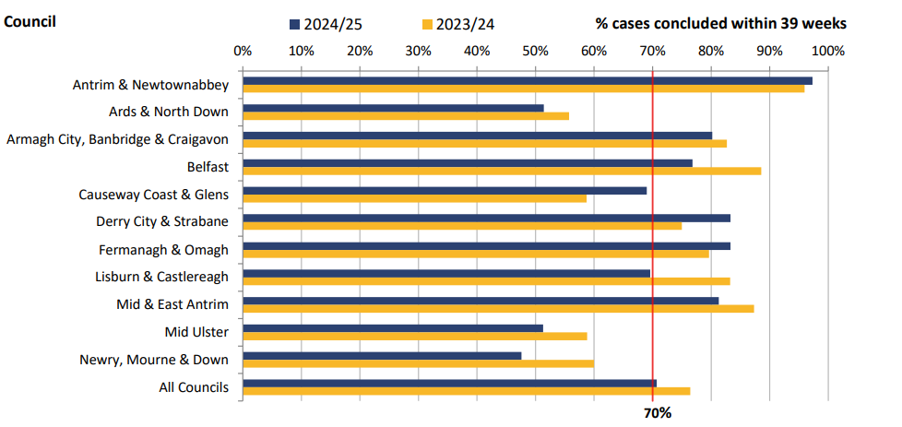
Planning activity statistics | Department for Infrastructure

6.4 Waste Statutory Indicators
The Council has a statutory duty to make quarterly returns to the NI Environment Agency in respect of waste arisings managed by the Council. The results for all eleven Northern Ireland Councils are published quarterly by statistics and analytical services branch – DAERA.

Finalised data for 2024/25 are scheduled to be published in November 2025 (annual report) and will supersede previously published data from the four quarterly returns for that financial year.

Data contained in the quarterly and annual reports are published primarily to provide an indication of the progress towards achieving waste strategy targets. They allow for the assessment of the performance of the councils and waste management groups in Northern Ireland in managing waste arisings, recycling, composting and landfill. The proportion of waste collected by each council broadly reflects the population within the councils.

The Landfill Allowance Scheme (NI) Regulations 2004 (as awarded) placed a statutory responsibility on councils in each scheme year, to landfill no more than the quantity of biodegradable waste for which they had allowances. The scheme concluded at the end of 2019/20 financial year; however, the continued monitoring of biodegradable waste is required for existing target commitments which specify that it must be reduced to 35 per cent of the total amount (by weight) of biodegradable municipal waste produced in 1995.

The year end result for 2024/25 contains *12-month figures which are provisional data. As already stated, an annual report with fully validated figures for 2024/25 is scheduled to be published in November 2025.

Targets for household recycling, remain at the 2019-20 level of 50%, however these have been superseded by the Waste (Circular Economy) (Amendment) Regulations (Northern Ireland) there will be an interim target of 55% for the recycling of municipal waste by 2025.

Targets for biodegradable waste that is sent to landfill, were set within the Northern Ireland Landfill Allowance Scheme (NILAS) which remain set at the level (set for Council) in 2019-20, due to the scheme no longer being in place.

Future targets are expected to be set at 10% of the total amount of generated municipal waste by 2035, which is also subject to the enactment of the Waste (Circular Economy) (Amendment) Regulations (Northern Ireland). which will increase by 2035 to 65%.

The latest validated annual report with finalised figures (2023/24) is available from the DAERA website.

Northern Ireland local authority collected municipal waste management statistics 2023/24 annual report | Department of Agriculture, Environment and Rural Affairs

Table – Mid Ulster’s Three Statutory Waste Indicator results for 2023/24 and 2024/25

*Provisional data

Waste W1 – The Percentage of household waste collected by District Councils that is sent for recycling (including waste prepared for reuse)
Purpose of Performance Indicator: The percentage of household waste collected by district councils that is sent for recycling (including waste prepared for reuse). It is to meet Statutory Targets – Households Waste is as defined in Article 2 of the Waste and Contaminated Land (NI) Order 1997 (a) and the Controlled Waste and Duty of Care Regulations (NI) 2013 (b).

Failure to meet statutory waste targets could result in infraction proceedings and fines. The graph below represents the percentage of household waste collected by Mid Ulster District Council that is sent for recycling (results 2016 – 2025 - provisional)

Analysis: More is better
This is the latest in a number of impressive, continued successes for the district in terms of its waste management performance. Mid Ulster is consistently in the top quartile of the table for its household recycling rate, most recently achieving the highest household recycling rate of all 11 councils here for the 2024 to 2025 period with 59.0% and sits well above the Northern Ireland average of 51.5% (provisional data).

These are great achievements; they reiterate the extremely positive position of the Council in terms of waste management and highlight the dedication of our waste teams and demonstrates the terrific work being done by residents in Mid Ulster in terms of their continued and unwavering recycling efforts.
Action Plan:
Standard achieved. Maintain management.

NI Councils 12-month provisional figures household waste collected that was sent for recycling rate by Council 2024/25 (provisional) and validated data 2023/24 is highlighted in the 4 quarterly graphs below.

Graph - W1 NI Councils percentage of household waste collected that was sent for recycling 2023/24 & 2024/25

Provisional Q1 Results | Provisional Q2 Results
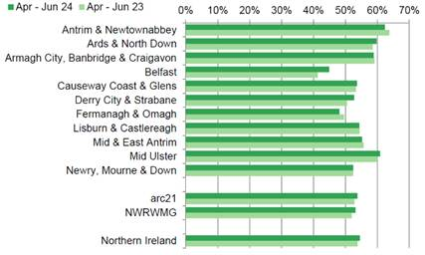 | 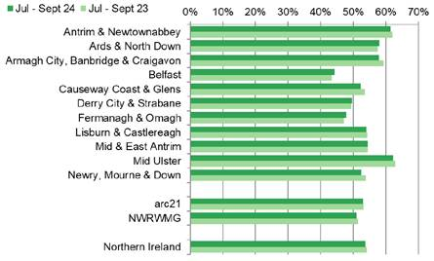
Provisional Q3 Results | Provisional Q4 Results
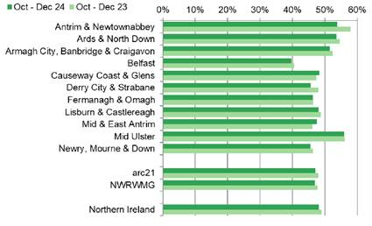 | 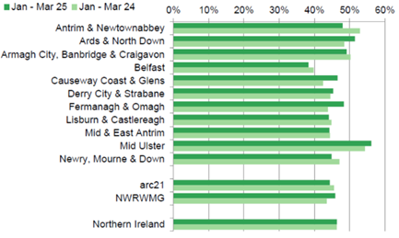

Waste W2 – The amount (tonnage) of Biodegradable Local Authority Collected (LAC) Municipal Waste that is landfilled.
Purpose of Performance Indicator: Meet Statutory Targets (scheme concluded 2019/20) - Local Authority collected Municipal Waste as defined in section 21 of the Waste Emissions Trading Act 2003 (c).

Analysis: Less is better
The landfill rate exhibits seasonality and the April to June and July to September quarters tend to have lower rates than October to December and January to March. The seasonality stems from the higher level of compostable garden waste arising during spring and summer.

The statutory requirement for all Councils to provide households with a container for food to enable separated collection has been attributed to the long-term drop-in landfill rates. Mid Ulster’s provisional figure for 2024/25 sits at 11 tonnes LAC that was landfilled, this is less than last year’s cumulative rate of 369 tonnes in 2023/24 (less is better). The graph below highlights the amount of biodegradable Local Authority Collected Municipal Waste that was landfilled by Mid Ulster District Council from 2016 to 2025.

Graph – W2 Amount of biodegradable LAC municipal waste that was landfilled by Mid Ulster Council from 2016 to 2025

Action Plan:
Awaiting further advice on new standard

Northern Ireland Councils’ Performance Data during 2024 to 2025
The total amount of biodegradable local authority collected (LAC) municipal waste sent to landfill for all eleven Councils during 2024/25 was 72,249 (provisional*) a decrease from last years’ figure of 95,504 tonnes in 2023/24.

Mid Ulster had the lowest incidence of reported biodegradable LAC municipal waste sent to landfill of all the eleven Northern Ireland (NI) Councils at 11 tonnes (provisional).

The 4 quarterly graphs below outline the amount of biodegradable LAC municipal waste (tonnage) that was landfilled by Northern Ireland Councils in 2023/24 and 2024/25.

Graph – W2 the amount of biodegradable LAC municipal waste (tonnage) that was landfilled by Northern Ireland Councils in 2023/24 and 2024/25*

Provisional Q1 Results | Provisional Q2 Results
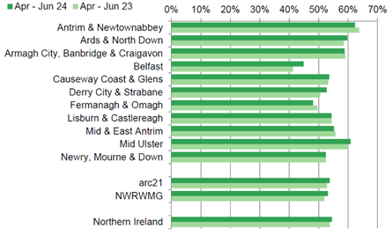 | 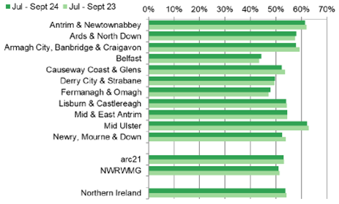
Provisional Q3 Results | Provisional Q4 Results
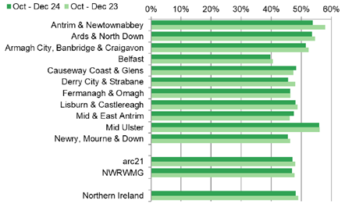 | 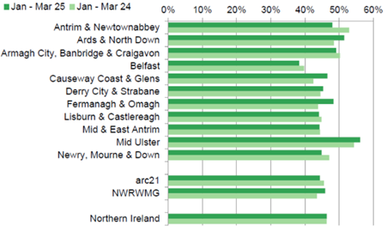
*Provisional data
Waste – W3: The amount (tonnage) of Local Authority Collected Municipal Waste Arisings.
Purpose of PI: Meet Statutory Targets - Local Authority collected Municipal waste arisings is the total amount of local authority collected municipal waste, which has been collected by a district Council. The graph below highlights the amount of tonnage of Mid Ulster’s collected Municipal waste arisings from 2016 to 2025.

Graph W3 – The amount (tonnage) of Mid Ulster District Councils Collected Municipal Waste Arisings 2016 – 2025.

Analysis: Less is better
There are many factors which can affect waste arisings, the majority of which is household waste, and includes: individual household behaviours, the advice and collection services provided by a council, the state of the economy and the weather conditions during the year. During 2024/25 in Mid Ulster there were 84,184 tonnes of waste arisings (provisional figure), which is more than the previous year’s total of 82,075 in 2023/24.

Action Plan:
No set standard. Maintain management.

Northern Ireland Councils’ Performance Data during 2024 to 2025
During 2024 to 2025 (provisional data), the total amount (tonnage) of local authority collected (LAC) municipal waste arisings was 1,010,322 tonnes. According to NISRA “…the proportion of waste collected by each council broadly reflects the population within the councils”. Mid Ulster District Council reported 84,184 over the year which was the 8th highest of the 11 Councils and lower than the NI average of 90,971 tonnes.

W3 - Amount (Tonnage) of LAC Municipal Waste Arising by NI Councils 2023/24 and 2024/25 per Quarter

Provisional Q1 Results | Provisional Q2 Results
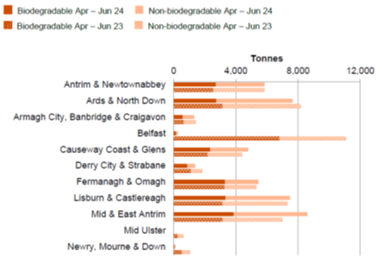 | 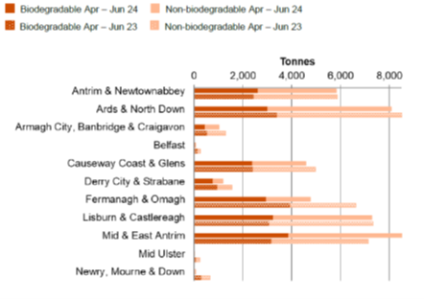
Provisional Q3 Results | Provisional Q4 Results
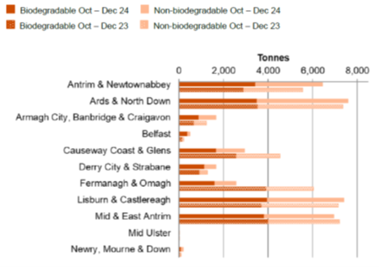 | 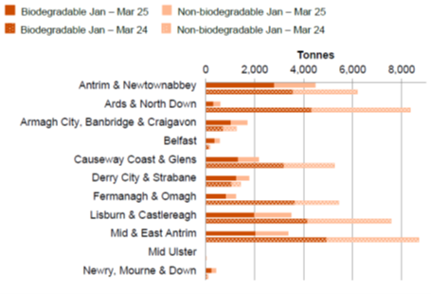

7.0 Benchmarking and Council’s Self-assessment of Self-imposed Indicators and Standards During 2024 to 2025

7.1 Corporate Health Indicators (Self-imposed - Set by us)
During the start of 2016/17, Mid Ulster District Council in the absence of an agreed region wide local authority performance management framework, decided to concentrate on ensuring the data quality of three of its proposed “set by us” or “self-imposed” performance indicators. The three original indicators were prompt payments; freedom of information requests (FOI) responded to within 20 days and percentage lost time rate (relating to sickness absence).

At its meeting in November 2017 the Council’s Policy and Resources committee approved a further suite of “Corporate Health Indicators”. The indicators provide a barometer of how the Council is doing across its services, in effect a summary of how the Council is performing across eight key areas. The key performance indicators were placed within the following themes: economy, waste management, Council facilities, better responses, resident satisfaction, staffing, engaged workforce and finance. Due to the rapidly changing macro and micro environments, these have now been replaced with work around the review of Council’s Corporate plan priorities, objectives and measures

During 2023/24 Council undertook an extensive review and consultation regarding the development of a new Corporate Plan for 2024 to 2028, new Corporate Health Indicators/Measures have been developed. The performance measures align to Council priorities and objectives and are responsive to the dynamic nature of Council service provision and work and the changing needs of our communities. The newly developed indicators/measures (some of which are developing baselines) will feature in Council improvement and reporting moving forward (refer to Appendix One).

As outlined previously, Council is required statutorily to compare its performance for the 2024/25 year to that of previous years, legislation also requires Council, so far as reasonably practicable, to report their performance against other councils in the exercise of the same or similar functions.

7.2 Benchmarking
To date there is no agreed overarching Northern Ireland Local Government Performance Management Framework; however, two additional performance measures are utilised to benchmark performance within the 11 Northern Ireland Councils, namely Prompt Payments and Absenteeism.

The Department of Communities requests information from councils at the end of each Quarter on the processing of invoices (as detailed in the circular LG 19/2016 Prompt Payment Guidance). Comparative analysis is published on council performance to show members of the public how promptly invoices are paid for each of the council areas; further information is available at: Publications | Department for Communities (communities-ni.gov.uk)

The Northern Ireland Audit Office collate and report on all Northern Ireland Councils’ absenteeism figures -refer to the Local Government Auditor’s Annual Report, further information is available at:
NI Audit Office Report - Local Government Auditor Report 2024_0.pdf

Performance progress in this section also follows that described in the section outlining Council’s self-assessment of statutory indicators and standards i.e. RAG (red, amber, green) status framework as well as the Performance direction of travel relative to the previous year.

7.3 Prompt Payments- 90% of invoices paid within 30-day target Purpose of Performance Indicator: Prompt payments speed up cash flow from the public sector to its suppliers, particularly SME’s. Council recognises that late payments are a key issue for business, especially for smaller businesses as it can adversely affect their cash flow and jeopardises their ability to trade and we recognise that as a public body we should set a strong example by paying promptly.

This indicator allows Council to have a “signal” that it has an effective prompt payment system delivery, has in place a clear framework for managing prompt payments, in order to support an environment in which businesses flourish. Given the impact the cost-of-living crisis has had on the economy this indicator has become even more important in protecting jobs and local businesses.

Analysis: More is better
Mid Ulster has consecutively year on year remained one of the fastest payers of invoices to businesses within all eleven Councils. on average in 2024/25 it took Mid Ulster 6 days to pay suppliers¹ (an improvement from 6.5 days in 2022/23 and down from 8.75 days to pay suppliers in 2021/22), this equates to Council paying 99.87% of invoices (exceeding the internal target of 90% of invoices paid within 30 calendar days) and 97.78% of invoices within 10 working days (an improvement from 2022/23 of 97.4%), with a total amount paid of £44,725,681.16 in 2024/25.

The average amount of days to pay a supplier across all 11 Councils in 2024 to 2025 was 13.23 days (an improvement from the previous year of 14.71 days). Mid Ulster has also consecutively hit the target since 2016; Council has exceeded the target and improved on its days to pay suppliers. Council and its Finance team are to be commended on their duty to ensure our businesses were paid for work or services they had supplied to Council.

Our incredible small businesses will be vital in supporting many hundreds of livelihoods across the district, particularly in the current cost of living crisis. The graph below represents Mid Ulster District Council’s (MUDC) achievement of percentage payment invoices within 30 days (90% paid within 30 days) 2016 – 2025.

¹ https://www.communities-ni.gov.uk/sites/default/files/2025-05/government-prompt-payments-24-25-ytd.pdf

Graph – MUDC percentage of prompt payments within 30 days (standard 90%).2016 – 2025

Action Plan:
Standard achieved. Maintain management.

Northern Ireland Councils’ Performance Data during 2024 to 2025
Mid Ulster has consistently been able to pay invoices quickly. In total the Council paid 17,534 invoices during 2024/25. Fermanagh and Omagh Council paid less invoices during the year 15,682 however it took on overage 8.5 days to pay an invoice (compared with Mid Ulster’s 6 days).
The table below shows Northern Ireland Councils compliance with prompt payments (30 calendar days average to pay 80% invoices) 2023/24 to 2024/25. Derry & Strabane Council during 2024 to 2025 took 19.39 days to pay an invoice (NI average 13.23 days).
Mid and East Antrim paid 94.30% of their invoices within 30 days (NI average is 91.3%) and Derry and Strabane Council paid 39.08% of their invoices within 10 working days.

Graph – NI Councils compliance with prompt payments (30 days average to pay 80% invoices (2023/24 to 2024/25)

7.4 Corporate: Absenteeism – Percentage (%) Lost Time Rate sickness absence - (5% or less p.a.)
Purpose of Performance Indicator: The Lost Time Rate (LTR) shows the percentage of total time available that has been lost due to sickness absence during a certain time period. The indicator is based on full time equivalent (FTE) employees and is useful as a general measure of the significance of sickness absence levels for an organisation.

This measure will be one indicator that allows Council to have a “signal” that it has an effective absence policy, has in place a clear framework for managing sickness absence, while setting out reporting mechanisms, states the attendance levels expected, uses monitoring arrangements, trigger mechanisms, effective roles and responsibilities, as well as ensuring management commitment. The lost time rate is useful as a general measure of the gravity of sickness absence levels for an organisation. Teams or departments, who want to ascertain whether or not there are absence issues in certain areas, can also use this measure.

Without staff that are well and at work, Mid Ulster District Council could not deliver quality and effective services to businesses, residents and our partnerships throughout the district. We need to ensure that staff are provided with an environment and opportunities that encourage and enable them to lead healthy lives and make choices that support their wellbeing, this will be our guiding principle.

The CIPD¹ states that everyone in the workforce, at all levels, feels the impact of ill health and sickness absence as it significantly affects organisations performance, productivity and workforce output. This in turn affects the level and quality of services provided to customers, both internal and external.

It makes business sense to support those who are ill and help them get back to work and to emphasise the importance of tackling health through good employment practices and pro-active well-being employer support, to encourage good occupational health management and to transform opportunities for people to recover from illness while retaining their jobs. This aligns with the Mid Ulster Community Plan outcome of, “We are better enabled to live longer and healthier more active lives”. Employee absence is considered to represent one indicator of employee health and well-being (Mc Hugh² 2001a) and how well managed and efficient the organisation is; that is the ‘health of the organisation’ (HSE³ 2002).
1. Chartered Institute of Personnel Development (2006a) Absence management: annual survey report. London. Chartered Institute of Personnel and Development.
2. McHugh, M (2001a) Employee absence: an impediment to organisational health in local government, The International Journal of Public Sector Management, 14:1, .43-58
3. Health and Safety Executive (2002) Survey of Occupational Health Support. HSE Contract Research Report 445/2002, London. Health & Safety Executive

Analysis: Less is better

In the last quarter of the year (Quarter Four – Q4) the percentage lost rate was 7.46% which was higher than Q3 at 6.79% and is much higher than quarter four in 2023/24. The percentage lost due to employee sickness absence in the financial year 1 April 2024 – 31 March 2025 was 6.50%, which is an increase from the previous year 2023/2024 of 5.65%. The estimated full time equivalent (fte) days lost due to employee sickness absence in 2024 – 2025 was 15.38 days.

It is important to note that whilst Council focuses on sickness absence figures, we also acknowledge that 637 employees had no sickness absence (this compared to 414 for the previous year). The three highest causes of sickness absence 2024/2025 are: Stress, depression and fatigue 19.73% (2248.65 days lost and 86 instances). Musculoskeletal Disorders 17.08% (1946.37 days lost and 98 instances) and “Other” 14.45% (1647 days lost and 124 instances). Stress, depression and fatigue remain the number one reason for absence, we continue to support staff through early intervention, well-being meetings and associated services.

It also is important to note that Long term sickness equates for large proportion of the Sickness absence within Council. We have recently procured an additional counselling resource which will provide onsite clinics to staff to access. This in addition to our current coaching and counselling provided by Westfield Health. We also continue to promote the Council’s “Stay Well hub”, which is a great resource for staff to access.
Graph – Mid Ulster District Council’s % Lost Time Rate (Sickness Absence) 2016 - 2025
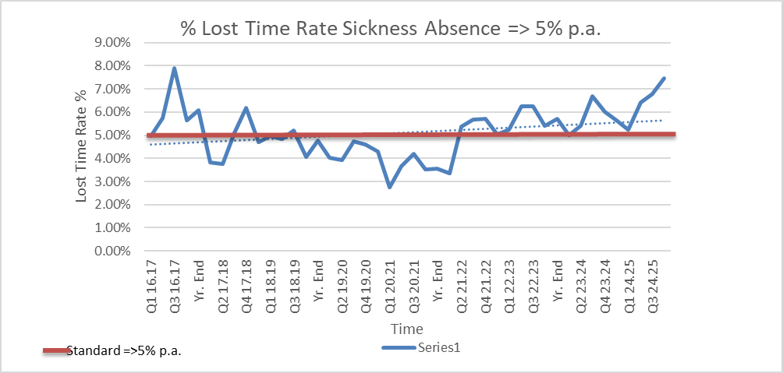
Achieved
It is also helpful to realise the average number of working days lost per employee or full time equivalent from the new Council forming in 2015 until 2025 - see graph below (this had previously allowed for benchmarking with other Councils against this performance measure).

Graph - Mid Ulster District Council the Average Number of Working Days Lost from 2015 to 2025.
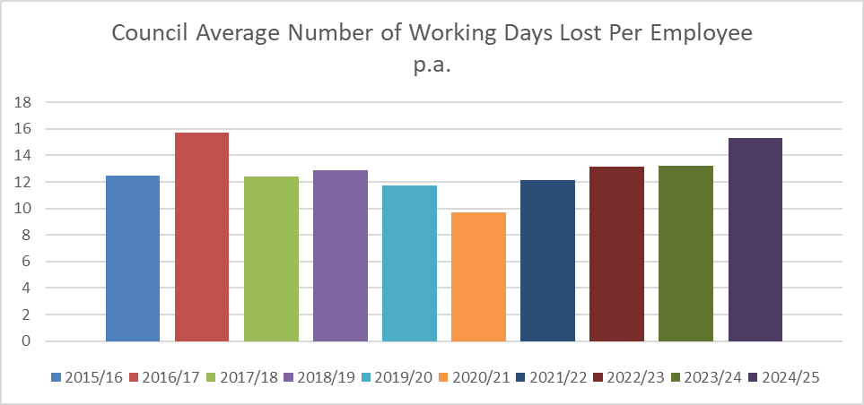

Action Plan:
The Health and Wellbeing Committee have developed a Strategy within 2024/25 year. They are meeting regularly, and are planning a series of events and initiatives, that will help promote health and wellbeing, with the aim of improving the health and wellbeing of all our staff. The committee have planned a Staff Health Check Fair (including health checks & information sessions) throughout the year and have planned a Women’s Health morning in October 2025.
Human Resources have completed absence management training across all directorates, which equip all new and experienced Managers/Supervisors with the skills and knowledge they need to effectively and confidentially deal with and manage sickness absence across their team(s) and sites. To create a consistent approach to absence management across the Council as a whole.

Northern Ireland Councils’ Performance Data Average Number of Working Days Lost Per Employee for 2022/23 & 2024/25.
The average numbers of days lost per employee performance data for all eleven Northern Ireland Councils is still not available for 2024 to 2025. Reflecting on the figures collated from the 11 Councils in the Local Government Auditors report, demonstrates that Mid Ulster recorded 15.38 days lost per employee in 2024-2025.
In overall terms, the average 16.9 days absence per council staff member in 2022-23 as reported by Local Government Auditor is much higher than the 11.0 days in 2020-21. This rising post-pandemic trend is also apparent across the vast majority of the 11 councils. Mid Ulster District Council has been an increase year on year over the past number of years; however, we continue to closely monitor and actively manage sickness absence levels to achieve improved efficiency across Council.
Graph – No. of days lost per staff member NI Councils- sickness absence per year 2022- 2023.
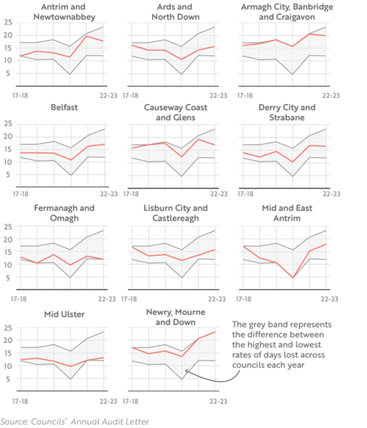

NI Audit Office Report - Local Government Auditor Report 2024_0.pdf

8.0 Overall Assessment for 2024 to 2025

This report is an opportunity to reflect on what has been achieved in respect of performance improvement in the last twelve months, and how we have continued to support our residents, and businesses in 2024/25. Northern Ireland continued to face significant cost of living pressures throughout 2024/25. With many households across the district experiencing reduced disposable income, ongoing increases in energy costs, and associated negative impact on financial wellbeing and mental health. It provides context to understanding the pressures on Council services and community needs. Performance improvement efforts remain realistic and aligned with the challenges faced by residents, guiding effective planning and resource allocation.
This report demonstrates that Mid Ulster Council focused on improving its services, by enhancing new digital technology provision to better serve residents, realising and committing to reducing Council’s environmental impacts, and assisting with regenerating the district through infrastructure projects as well as creating opportunities for cleaner neighbourhoods.
Council also welcomed citizen as well as business engagement, which supported the drive for meaningful improvements, laying a solid foundation for future optimised services. This goes to the heart of everything we do, by working together, with our local businesses, voluntary and community sectors as well as our public sector partners.
Mid Ulster District Council has continued to achieve robust performance results across many areas including waste performance data, maintaining excellent household recycling rates, has reduced biodegradable (LAC) municipal waste that is landfilled from the previous year. During 2024/25 there was an increase in waste arisings from the previous year, as previously stated there are many contributing factors which can affect waste arisings such as, the state of the economy, weather conditions, household behaviours etc. during the year.
Mid Ulster has consecutively year on year remained one of the fastest payers of invoices to businesses within all eleven Councils. The Council has continued with its speed of payment of invoices again, on average in 2024/25 it took Mid Ulster 6 days to pay suppliers of works and services. Paying promptly shows respect to our suppliers and treats them as Council would wish to be treated. It is particularly important where our suppliers are small businesses where late payment can be hugely damaging for them and indeed for all suppliers in the current cost of living crisis coupled with higher interest rates.

Although there has been an improvement in reducing the percentage lost time rate (LTR) due to employee sickness absence in the financial year 2023/24. The cumulative total for 2024/25 was 6.50% (LTR), a slight increase from the previous year 2023/2024 of 5.65%. It’s important to note that Long Term Sickness equates for a large proportion of the sickness absence. Human Resources continue to make this area a priority ensuring absence management training for managers /supervisors across all directorates in year. This in turn equips new and experienced Managers/Supervisors with the skills and knowledge they need to effectively and confidentially deal with and manage sickness absence across their team(s) and sites, to create a consistent approach to absence management across the Council as a whole.

In relation to the statutory jobs promoted target of 153 (jobs promoted) Council attained 99 (jobs promoted -performance in 2024/25), however cognisance needs to be taken regarding the introduction of a new Northern Ireland Entrepreneurial Support Service (Go Succeed) designed to provide start up support, only being operational from December 2023, due to delays in procuring the new regional contractor and mobilising the new Contract delivery process and CRM system.

The Department for Infrastructure (DfI) continues to state that key events in 2022 still continue to impact on planning activity in 2024 to 2025. When interpreting the performance of the three statutory planning performance standards (i.e. average processing time for major and local applications as well as the percentage of enforcement cases processed within 39 weeks). During 2024/25 year the figures for major applications, local applications and enforcement have slipped slightly, from the previous year. There is an increased focus on Major applications performance having re-established a dedicated Major applications team as of October 2024 which will comprise of two officers.
The four improvement projects were reviewed at the end of the third year (2023 to 2024); and work was undertaken to ensure their continued validity into 2024 to 2025. These four corporate improvement projects have now been completed with most of the improvement activities either being fully or substantially achieved in year.
We have seen major solid progress in a number of key capital building programmes/projects, these have been made against a continued challenge in inflationary levels, which in turn has led to an increase in cost of construction materials.
Mid Ulster District Council developed a new Corporate Plan for 2024 –2028 which incorporated a new suite of measures. We have recently completed our Year 1 assessment of progress, with some of the key highlights attached in Appendix One under each of our Corporate Planning themes. Some of the key highlights include

Theme 1: Our Service Delivery – Year 1 Highlights
- Our Sustainability Strategy & Climate Action Plan and associated performance reporting framework received final Council approval in March 2025.
- 22 capital investment projects committed and a total capital investment expenditure of £9,615,745 during the 12-month period.
- With an emphasis on improving our Customer Experience, we developed a customer satisfaction survey, which was piloted for our Registration Service. The Service scored 9.9 out of 10 from respondents in Year 1. We plan to extend this to other services across the organisation.
- 1,452 business were supported through our extensive Economic Development programme.
- There were 1,127,815 visitors to our 19 council attractions over the 12-month period.
- 277,398 people used our Leisure Centre and Outdoor Recreation facilities.

Theme 2: Leadership and Partnership for Growth
- The Mid-South West Growth Deal is a multi-million-pound funding package designed to boost the economy by investing in infrastructure, innovation, digital capacity, tourism and skills development. Three Strategic Outline Cases have been completed, and Heads of Terms were signed in November 2024 to allow projects to move to Outline Business Case stage. CAFRE has commenced internal work developing an Outline Business Case for the RAPIC project and Invest NI has agreed to lead Outline Business Case development for an Innovation Investment Park.

Theme 3: Being the Best Council Possible
- Our Corporate Health and Wellbeing Strategy, which will include baseline evidence gathering around staff satisfaction and wellbeing, has been developed.
- All mentors on our new Apprenticeship programme have been trained. Six apprenticeships have commenced, and all apprentices are progressing well.
- Our Cash at Bank balance at year end was £46.75million.
- There were no reportable data protection breaches.
- Over the 12month period, 96% of Freedom of Information and Environmental Information Regulations requests (joint average) were responded to within 20 working days.
- We had no successful (above threshold) legal challenges to Council’s Procurement exercises.
In looking ahead to the future, we have taken a long view, to a regenerated district with, vibrant communities in healthy, green spaces, local economic growth through capital programmes (growing local jobs and opportunities), and public services fit to meet the challenges of the future. We have developed 3 new objectives moving forward as part of our new Performance Improvement Plan for the incoming year.
This report fulfils our statutory duty to report on our performance, and despite growing challenges, the Council’s aim remains unchanged – to be at the heart of the local community, making people’s lives better by achieving positive outcomes for all of our communities.

9.0 Have Your Say
We welcome your comments or suggestions at any time of year. Mid Ulster District Council is committed to improving its services and is keen to hear from the community on what it has to say. We welcome your comments or suggestions at any time of the year. There are a number of ways in which to influence Council decision-making.

You can get involved and participate in consultations being conducted by, or on behalf of the Council. Meetings of the Council and its Committees are open to the public, with the exception of those times when sensitive or confidential issues need to be discussed. That is why we want to hear what you think about our performance and what we can do to improve. Please join us on the journey by sharing your thoughts.

If you have any comments, would like any further information, or would like a copy of this plan in an alternative format please contact

Strategic Services and Engagement Team
Council Offices
Circular Road
Dungannon BT71 6DT
Telephone: 03000 132 132

Email: info@midulstercouncil.org

 |  |  | APPENDIX ONE
Corporate Plan 2024-2028 Progress Reporting |  |  | Progressing as expected / on target
 |  |  | Not progressing as expected / not on target
 |  |  | Baseline Setting
 |  |  | Not Commenced / Not Available
 |  |  | Complete

Theme 1: Our Service Delivery
Objective |  | Status @ End of Year 1 | Notes
1.1 | Achieve a 20% reduction in Council’s carbon emissions by March 2028 through implementation of our Sustainability Strategy and Climate Action Plan
1.1 | % reduction in operational emissions by March 2028 |  | The Sustainability Strategy & Climate Action Plan and associated performance reporting framework underwent a 12-week public consultation, receiving final Council approval in March 2025. Corporate Improvement Plan 3 incorporates many of the actions from the main Climate Action Plan and has now also been finalised with the goal of achieving a 20% reduction by 2028
1.2 | Complete a Climate Change Adaptation Plan by 2025
1.2 | Climate Change Adaptation Plan completed by 2025 |  | Climate Change Adaptation Plan was given final approval by Council in March 2025 and contains 22 actions to help Mid Ulster adapt to a changing climate
1.3 | Achieve the Circular Economy Target to recycle 60% of municipal waste by March 2028
1.3 | % of municipal waste recycled by March 2028 |  | Validated figures for the final quarter of 2024/25 are not available yet. However, figures for the 2024 calendar year confirm 57.83% of municipal waste has been recycled
1.3 | Statutory Waste Performance Standards and Indicators met |  | All statutory waste indicators have been reported / met
1.4 | Build on our place-shaping capital investment programme to develop new, and enhance our existing, physical assets
1.4 | # of capital investment projects committed between 2024 and March 2028 |  | 22 capital investment projects committed
1.4 | #£ capital investment spent over the period |  | Total capital investment expenditure for 12-month period = £9,615,745

1.5 | Implement a Customer Experience Platform by 2026 and have it fully operational for two customer facing services by March 2028
1.5 | Customer Experience Platform implemented by 2026 |  | Tender process undertaken but award not made due to cost implications. Other options to be considered
1.5 | Customer Experience Platform fully operational for two customer facing services by March 2028 |  | As above however, efficiencies and service improvements achieved through use of Gov.Notify free text messaging service for dog licence renewals in Dungannon, with roll out to Magherafelt and Cookstown planned
1.5 | Increase in customer satisfaction for service accessibility and response |  | Customer satisfaction survey developed & piloted for Registration, scoring 9.9 out of 10 from respondents so far. Propose extending to other services e.g. Leisure, Arts. Customer Services Policy revised & aligned to Customer Care Charter, next step team briefings across the organisation.
1.6 | Support delivery of a strong business economy by fostering start-ups; creating growth and scalability opportunities; promoting jobs; and developing Mid Ulster as a vibrant tourist destination
1.6 | # of jobs promoted through business start-up activity |  | 163 Business Plans verified from April 24 - Dec 24. The Lead Council (BCC) issued 12-month data in April 2025, comprising actual vouched activity to Dec 2024 and projected activity (unverified) Jan-Mar 2025, so the figures provided are not final as yet (estimated completed by June 2025). As of 30 May 2025, Jobs promoted is 98: 55 under target.
1.6 | # of businesses supported through growth orientated scaling programmes and events (including tourism) |  | 1,452 business supported through the following: LMP Employer Toolkit 1-1 (22); LMP Employer Training and Support Events (114); Go Succeed Mentoring (435); Go Succeed Grants (175 funded); Digital Transformation Flexible Fund (28); MSW Net Zero Programme (10); Town Business Spruce-Up Scheme (85); Rural Business Support Programme (155); Tourism Events (428 through events/programme)
1.6 | # of visitors (footfall) to Council visitor attractions |  | 1,127,815 visitors to 19 council attractions over the 12-month period
1.7 | Work collaboratively with central government to align existing community development and support programmes and implement our Community Development Strategy and Action Plan by March 2028
1.7 | Community Development Strategy and Action Plan implemented by 2028 |  | Extensive internal & external engagement and research completed. Consultant's recommendations for ‘Transforming Community Support and Investment in Mid Ulster’ presented and under consideration
1.7 | # of programmes integrated |  | Next step to consider development of an Action Plan
1.7 | #% of CVS organisations satisfied with the Strategy outcomes |  | Measurable once outcomes are defined
1.7 | # of Government Departments committed to the alignment throughout the process |  | 2 out of the 3 Government Departments approached supportive of the alignment - DfC & TEO
1.8 | Redirect wealth and public spending into communities by promoting a Community Wealth Building approach to local economic development
1.8 | Community Wealth Building Framework and Action Plan implemented by 2028 |  | CWB Good Employment Charter developed, adopted by Council & included in LMP’s Employer of Choice Toolkit. Draft Community Asset Transfer Guidance developed
1.8 | Amount of social value generated per £ invested |  | New software purchased to calculate the value of Council investments. Officers working to incorporate this into new investments

1.9 | Increase customer satisfaction and participation in our leisure, outdoor recreation and arts, culture and literary facilities by March 2028
1.9 | % increase in participation across each service area |  | Leisure Centre and Outdoor Recreation Users = 2,277,398
1.9 | % increase in participation across each service area |  | SHHP footfall = 62,273; paying customers = 27,289
1.9 | % households in Mid Ulster with accessible natural space within 400metres (*PfG Cleaner Environments: Outdoor Recreation) |  | 2024: 21.5%
1.9 | % participating in sport and physical activity in Mid Ulster (*PfG Healthier Lives: Sports and Physical Activity) |  | 22/23: 68%  23/24: 67%
1.9 | % engaging in arts and cultural activities in Mid Ulster (*PfG Brighter Futures: Arts and Cultural Activity) |  | 22/23: 76%  23/24: 77%
1.9 | Increase the number of Mid Ulster Council Green Flag sites |  | 24/25: 7 sites @ Roundlake, Polepatrick, Maghera Walled Garden, Hill of the O’Neill, Dungannon Park, Davagh Forest, Ballyronan Marina
1.9 | Maintain a 5* Trip Advisor rating or improve a 1*-4.5* rating |  | Burnavon 4.5* (23 reviews)
1.9 |  |  | Hill of the O'Neill & Ranfurly House 4.9* (83 reviews)
1.9 |  |  | SHHP 4.9* (185 reviews)
1.9 |  |  | Dungannon Park 4.5* (115 reviews)
1.9 |  |  | Pomeroy Forest Trip Advisor account to be set up when new Manager in place. Google Review rating of 4.8* (23 reviews)
1.10 | Co-design and deliver accessible community-based leisure and outdoor recreation facilities and programmes that meet our citizens’ needs
1.10 | % of citizens satisfied with their involvement in the co-design process |  | Baseline measure selected: Community involvement in the Underutilised Pitches Expression of Interest for Leasing programme (linked with CWB Community Asset Transfer process)
1.11 | Advance our vision to meet the strategic planning and wellbeing needs of our citizens by progressing the Local Development Plan 2030 Draft Plan Strategy to Public Inquiry Stage by March 2028
1.11 | LDP Draft Plan Strategy progressed to Public Inquiry Stage by March 2028 |  | No decision from DfI on progressing the Draft Plan Strategy to Independent Examination however engagement continues with DfI re progress toward a decision
1.12 | Listen to and reflect the needs of our citizens in shaping the Planning Service
1.12 | # of improvements identified by Planning Service users implemented by March 2028 |  | Issues identified through the Planning Agents' survey 2023 informed the current roll out of Planning Service IT module upgrades. Uniform & Public Access upgrades complete. DMS & TLC imminent. Public Access User Guide to be drafted, finalised and published on Council's Website. Preparatory work ongoing for a MUDC specific validation checklist
1.13 | Exceed statutory planning targets during the life of the Corporate Plan
1.13 | Statutory planning targets met |  | Local applications 24/25 figures available July 25
1.13 | Statutory planning targets met |  | 11.1% major applications meeting statutory target (unvalidated figures)

Theme 2: Leadership and Partnership for Growth
Objective |  |  | Notes
2.1 | Visibly progress the Mid-South West Growth Deal initiatives
2.1 | # of MSW Growth Deal Strategic Outline Business Cases (SOCs) approved by March 2028 |  | 3 SOCs completed and Heads of Terms signed in November 2024 to allow projects to move to OBC stage
2.1 | # of MSW Growth Deal Outline Business Cases (OBCs) approved by March 2028 |  | CAFRE has commenced internal work developing OBC for RAPIC project. Following representation, Invest NI have agreed to lead OBC development for an Innovation Investment Park
2.1 | # of MSW Growth Deals - Full Growth Business Deal Cases (FBCs) progressed by March 2028 |  | No projects at FBC stage
2.2 | Actively participate with other partners to substantially progress the co-ordinated management of Lough Neagh
2.2 | # of engagements with other bodies responsible for the co-ordinated management of Lough Neagh |  | Lough Neagh Partnership SLA 2024/25 in place and Council match funding provided to LNP for the LN Heritage Resilience Plan
2.3 | Collaborate with local and regional governments and jurisdictions to improve the services we deliver to our citizens and advocate on their behalf
2.3 | # of advocacy engagements with local and regional government ministers and officials |  | 17 engagements over the year with DfI; DoF; DE; DoH; NIFRS; NIHE; NI Water; Northern & Southern HSC Trusts; Tourism NI
2.3 | # of cross-cutting strategic collaborative working opportunities developed |  | Total : 17 developed (includes 12 from 1st 6 months report): F&ODC Collaborative Procurement Residual Waste Treatment Contract (value £50m+); Homebawn; DS3 PeacePlus Programme – ICBAN; Maghera Regeneration Programme; Sliabh Beagh Project (Shared Island scheme); Mid-South West (MSW) Growth Deal (5 projects); Digital Transformation Flexible Fund; A5 Western Transport Corridor; Sperrins Partnership (AONB); Lough Neagh Partnership (Heritage Resilience Plan / Lough Neagh Action Plan); Lough Neagh Rescue (LNR); Mid Ulster Labour Market Partnership (LMP); Mid Ulster Local Economic Partnership(LEP); Coalisland Town Forum; Cookstown Town Forum; Maghera Town Forum; Magherafelt Town Forum
2.4 | Continue to engage and work alongside our Community Planning partners to deliver Mid Ulster Community Plan outcomes and have a new Plan in place by 2028
2.4 | # Community Planning Partnership meetings facilitated |  | 4 meetings facilitated for the period (target: minimum of 2 per year)
2.4 | New Community Plan in place by 2028 |  | Preparatory work to commence 2026
2.4 | % living in absolute poverty (before housing costs) (*PfG Equal Society: Income Deprivation) |  | 19/20 - 22/23 = 14%
2.4 | Households spending 30% or more of their income on housing (*PfG Better Homes: Housing Costs as a Proportion of Income) |  | 19/20 - 22/23 = 7%
2.4 | Loneliness often, always or some of the time (*PfG Caring Society: Loneliness) |  | 22/23 = 16%  23/24 = 11.7%
2.4 | Life satisfaction average score in Mid Ulster (*PfG Brighter Futures: Life Satisfaction) |  | 22/23 Average score 7.8 out of 10  23/24 Average score 8 out of 10

Theme 3: Being the Best Council Possible
Objective |  |  |  |  | Notes
3.1 | Increase staff engagement and wellbeing by 2028
3.1 | % days lost to sickness |  |  |  | 6.5% average over the year
3.1 | % staff satisfied with their job |  |  |  | Staff satisfaction and wellbeing survey will form part of the evidence base for the Health and Wellbeing Strategy. Strategy finalised in the next quarter
3.1 | % of staff who feel their wellbeing has improved |  |  |  | As per above re survey
3.1 | % staff turnover |  |  |  | 6.7% average over the year
3.1 | % staff completing mandatory learning and development training |  |  |  | Mandatory training compliance @ end of year 75%
3.2 | Implement a Workforce Plan to attract and retain the top talent we need to deliver our services
3.2 | Workforce Plan implemented in 2026 |  |  |  | To be drafted, finalised and approved by 31 March 26
3.2 | % staff progression across the organisation |  |  |  | 7 employees (recorded as promotions) over the year
3.2 | # of apprenticeships successfully completed by March 2028 |  |  |  | All mentors trained, 6 apprenticeships commenced and progressing well
3.2 | # externally recognised awards achieved by March 2028 |  |  |  | 23/24 - 8 (baseline)  24/25 - 16
3.3 | Remain a financially sustainable and viable Council that takes a prudent approach to spending public money
3.3 | £ cash balance maintained within the Council’s pre-established cash limits |  |  |  | Cash at bank balance Year End 24/25 = £46.75million
3.3 | £ loans outstanding – remain within Council’s operational & authorised borrowing limits |  |  |  | Loans at Year End 24/25 = £3.1 million
3.3 | Medium Term Financial Plan & associated prudential indicators developed and reviewed |  |  |  | On track
3.4 | Ensure our Governance Framework is appropriately integrated within our service delivery models
3.4 | Annual unqualified independent audit certificate |  |  | 2023/24 financial statements certified without qualification
3.4 | # of reportable data protection breaches |  |  | None
3.4 | >80% of Freedom of Information and Environmental Information Regulations requests responded to within 20 working days |  |  | Average over 12-month period = 96%
3.4 | # of successful (above threshold) legal challenges to Council’s Procurement exercises |  |  | None
* | Programme for Government Wellbeing Framework statistics have been included in this report. This data is gathered by NISRA from a variety of sources, including other bodies and organisations external to Council. This data is useful to us as it helps build an overall picture of how Mid Ulster is progressing on a number of key issues that matter to our citizens

